“Sodium chloride, also known as common salt, table salt, or halite, is a chemical compound with formula NaCl.” --Source: http://www.chemistrydaily.com/chemistry/Sodium_Chloride

OTHER HEALTH TIPS: For those who aspire to a low-sodium diet, you might try Potassium Chloride, which is a chloride salt with no sodium -and a slightly sharper taste. Yes, this is not poison. Also, for those who understand the dangers of cows’ milk, there are other alternatives, and no, they don’t taste like dirt: “Soybean” milk & CALCIUM-FORTIFIED Orange Juice. I’m not advocating or pushing any one name brand or supermarket: These brands are available at places like Publix, Winn-Dixie, and Super Wal-Marts.
(Editor: Gordon Watts, GordonWayneWatts.com / GordonWatts.com click the 'Health' link)
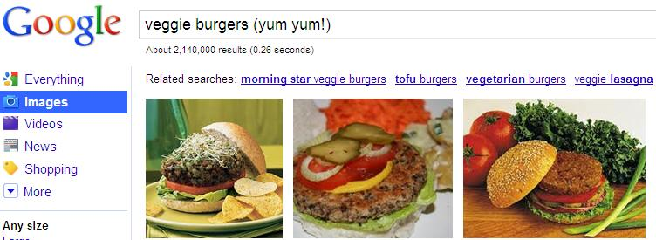
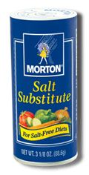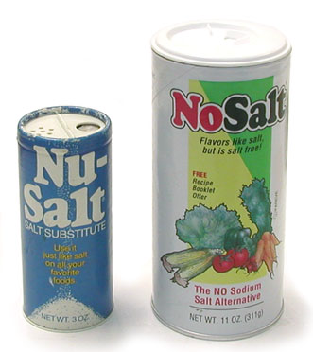
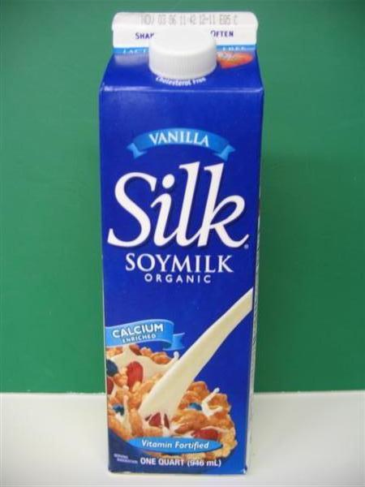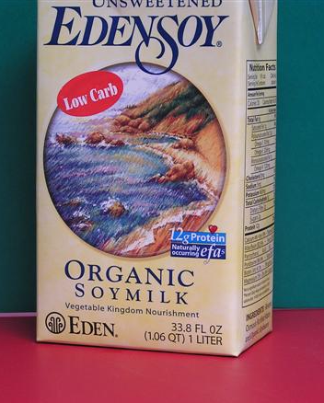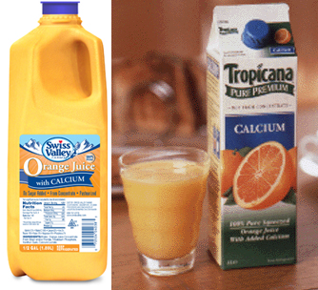

“A potassium chloride product* designed for persons on a doctor-recommended sodium restricted diet. Use for cooking and at-the-table seasoning.
*Remember to consult a physician before using any salt substitute.”
Source: http://www.mortonsalt.com/products/foodsalts/salt_sub.htm
“Salt substitutes vary in their composition, but their main ingredient is always potassium chloride. For example, the listed contents of the Nu-Salt are: potassium chloride...”
Source: http://www.orau.org/PTP/collection/consumer%20products/lowsodiumsalt.htm
“Silk Organic Soymilk - Vanilla - Quart”
Source: http://shopuncleharrys.dukestores.duke.edu/index.php?main_page=product_info&products_id=4618
“Edensoy Organic Soymilk - Unsweetened low carb - 1 Liter”
Source: http://shopuncleharrys.dukestores.duke.edu/index.php?main_page=product_info&products_id=954
Sources for the Orange Juice pics:
http://www.swissvalley.com/products/nutrition.cfm?page=nondairy&id=811&cat=5
http://www.new-nutrition.com/newspage/pepsico03.htm
Time Magazine headlines of 30 October 2000: “EARLY PUBERTY Why Girls Are Growing Up Faster: "Is it hormones [in food or milk]...How parents and kids are coping” pp. 66-74.

“With breast cancer rates continuing to rise in the United States and Europe, researchers have begun to look toward Asia for insights as to why Asian women on the whole have much lower incidence of this devastating disease. Specifically, the age-adjusted death rates due to breast cancer from 1990-1993 were 3.3 times lower for Japanese women than American woman and 4.5 times lower for Chinese women compared to American women.” (Parker SL, Tung T, Bolden S, Wingo P: Cancer statistics, 1996. Ca: a Cancer Journal for Clinicians. 1996;46(1):5-27.) according to: http://www.medsch.ucla.edu/som/ddo/biolchem/nut-1998/ByteV4N1/v4n1rood.html#1 .
Gordon's comments: I was personally disturbed by these allegations concerning milk. {I admit that I wasn't totally convinced about this. And, I admit that I was probably wrong in assuming that milk, eggs, meat, & other animal products were a dietary requirements or healthier than the lack. But, about the only good thing I can think about milk for human is the hormones that will 'pump you up.' Stronger, yes, but more healthy? Probably not, just as with steroids!} **While the library here at FSU where I was a student didn't have the American Journal of Epidemiology after about 1994 or so, I was able to find relevant data in the scientific literature. Some allegations made by the Anti-Dairy Coalition above haven't been verified by me, but see below for selected quotes and their references.

“Because there is clinical and experimental evidence that galactose may be toxic to ovarian germ cells, the authors sought to determine... The authors found significant correlations among these variables such that fertility at older ages is lower and the decline in fertility with aging is steeper in populations with high per capita consumption of milk and greater ability to digest its lactose component.” (Cramer, D.W., H. Xu, and T. Sahi. Adult Hypolactasia, Milk Consumption, and Age-Specific Fertility. American Journal of Epidemiology 1994. Vol. 139. No. 3 p.282, Abstract near top of page.) Translation: They found that the more milk a country drunk, the more infertility problems its women had. I saw the two graphs. {OK: finally some new info: scroll down a little bit to see these graphs.}

They were pretty convincing for me. The two graphs were such that: (1) the more per capita usage of milk a country had, the faster the women declined in fertility. And: (2) the more people who were "lactose intolerant" (couldn't drink milk), the LESS the decline in fertility, thus suggesting that milk usage was bad & the lack thereof was good.
“Mettlin and Piver (1) recently reported that increased risk for ovarian cancer associated with [happening together with] milk consumption was confined to consumers of whole milk, rather than skim milk... [However, we found that u]se of more than one serving per day of skim (or low fat) milk was associated with an increased risk for ovarian cancer.” (Cramer, D. W. and B.L. Harlow. Commentary: Re: "A Case-Control Study of Milk Drinking and Ovarian Cancer Risk". American Journal of Epidemiology 1991. Vol. 134. No. 5 p. 454, quotes from first two paragraphs.) Translation: They both found links between milk use and ovarian cancer; they disagreed, however, as to which type of milk was the problem.

“This was a 12-year prospective study among 77 761 women... In our cohort [group], women consuming greater amounts of calcium from dairy foods had modest but significantly increased risks of hip fracture while no increase in fracture risk was observed for the same levels of calcium from nondairy sources. ... With a fourfold difference in calcium intake between the 10th and 90th population percentiles, it seems unlikely that the lack of association between dairy calcium and fracture risk in our cohort can be due to insufficient variation in diet. Misclassification of calcium intake could attenuate [weaken] association, but it would not explain the positive association observed between dietary calcium and hip fractures." (Feskanich, D., ScD; W.C. Willert, MD, DrPH; M.J. Stampfer, MD, DrPH; and, G.A. Colditz, MD, DrPH. Milk, Dietary Calcium, and Bone Fractures in Women: A 12-year Prospective Study. American Journal of Public Health June 1997. Vol. 87 No. 6 p. 992 Abstract Methods and p. 996: 6th and 7th paragraphs, respectively.) Translation: The problem was so obvious that even reporting errors by those who filled out questionnaires would not worry these scientists.
MILK and HEART DISEASE: The Studies
"Milk and milk products gave the highest correlation coefficient to heart disease, while sugar, animal proteins and animal fats came in second, third, and fourth, respectively." – A Survey of Mortality Rates and Food Consumption Statistics of 24 Countries, Medical Hypothesis 7:907-918, 1981

"In reality, cow's milk, especially processed cow's milk, has been linked to a variety of health problems, including: mucous production, hemoglobin loss, childhood diabetes, heart disease, atherosclerosis, arthritis, kidney stones, mood swings, depression, irritability, and allergies." – Townsend Medical Letter, May, 1995, Julie Klotter, MD

"More patients who had suffered a myocardial infarction had elevated levels of antibodies against milk proteins than was found in a comparable group of patients without coronary heart disease."
– Davies, Antibodies and Myocardial Infarction, The Lancet, ii: 205-207, 1980

"Milk consumption correlates positively with cholesterol levels in blood as well as coronary mortality. In comparisons between 17 countries, there is a good correlation between national cholesterol levels and mortality from ischaemic heart disease." – European Journal of Clinical Nutrition, 48:305-325, 1994

"Although studies point out strong negative correlations between wine consumption and heart disease... six countries with the highest mortality show no correlation at all. Finland ranks highest of all in milk consumption, wine consumption and mortality from heart disease." – The Lancet, I, 1017-1020, 1979

"Milk and many components of milk (butterfat, milk protein, calcium from milk, and riboflavin)... were positively related to coronary heart disease mortality for all 40 countries studied." – Circulation 1993; 88(6):2771-2779

"For ischemic heart disease milk carbohydrates were found to have the highest statistical association for males aged 35+ and females aged 65+. In the case coronary heart disease, non-fat milk was found to have the highest association for males aged 45+ and females aged 75+, while for females 65-74, milk carbohydrates and sugar had the highest associations...animal proteins contribute to homocysteine production; however, milk more than meat lacks adequate B vitamins to convert homocysteine to useful products. Lactose and calcium in conjunction with homocysteine from consumption of non-fat milk may also contribute to calcification of the arteries." – Altern Med Rev, 1998 Aug, 3:4

"Animal food-groups were directly correlated to mortality from coronary heart disease, defined as sudden coronary death or fatal myocardial infarction and vegetable food-groups (except potatoes) as well as fish and alcohol were inversely correlated with CHD mortality. Univariate analysis showed significant positive correlation coefficients for butter (R = 0.887), meat (R = 0.645), pastries (R = 0.752), and milk (R = 0.600) consumption, and significant negative correlation coefficients for legumes (R = -0.822), oils (R = -0.571), and alcohol (R = -0.609) consumption. Combined vegetable foods (excluding alcohol) were inversely correlated (R = -0.519), whereas combined animal foods (excluding fish) were directly correlated (R = 0.798) with coronary heart disease death rates." – Eur J Epidemiol, 1999 Jul, 15:6, 507-15

Two Connecticut cardiologists, Oster and Ross, demonstrated that cow proteins survive digestion. Oster and Ross pointed the finger of blame at the homogenization process. They discovered the presence of an enzyme, bovine xanthene oxidase (XO), which, in theory, should not have survived digestion, but, in actuality, did. The XO Factor was identified as the element that destroyed one-third of the cellular material in atrial cells of 300 heart attack victims during a five-year study. Oster and Ross's observation was subsequently confirmed by a team of scientists at the University of Delaware who hypothesized that small quantities of this enzyme from milk, absorbed over a lifetime, might hold destructive biological significance, which includes, of course, the heart disease mentioned above. – THE SOLUTION TO ONE PROBLEM: By returning to the days when cream once again rises to the top of the bottle, dairymen would eliminate the artificial mechanism by which milk proteins survive in such great quantity. Many scientists have considered innumerable factors in explaining increased rates of cancers and heart disease. Homogenization has not been given the blame, nor the attention that it merits. (Source: Anti-Dairy Coalition)

PROBLEM: "Americans are living longer than ever, but not as long as people in 41 other countries...Dr Christopher Murray, head of the Institute of Health Metrics and Evaluation at the University of Washington, said: "Something's wrong here when one of the richest countries in the world, the one that spends the most on health care, is not able to keep up with other countries." I cite my sources:
* "US tumbles down the world ratings list for life expectancy," The Guardian, Monday August 13, 2007 - http://www.guardian.co.uk/world/2007/aug/13/usa.ewenmacaskill
* "US Slipping in Life Expectancy Rankings: US Slipping in Life Expectancy Rankings; Other Nations Improving Health Care, Nutrition," By STEPHEN OHLEMACHER, Associated Press Writer, WASHINGTON, August 12, 2007 (AP) - http://abcnews.go.com/Health/PictureOfHealth/wireStory?id=3471026
* "US Slipping in Life Expectancy Rankings," By STEPHEN OHLEMACHER, The Associated Press, Sunday, August 12, 2007; 5:02 AM - http://www.washingtonpost.com/wp-dyn/content/article/2007/08/12/AR2007081200113.html
* "U.S. life span shorter," By Stephen Ohlemacher, Associated Press Writer | August 11, 2007 - http://www.boston.com/news/education/higher/articles/2007/08/11/us_life_span_shorter

SOLUTION: We need to strongly consider Dr. Jay Dennis’ call to FAST and PRAY → fasting research:

(#1.) "These results suggest that total caloric intake may modulate the rates of cell death and proliferation in a direction consistent with a cancer-protective effect in DR mice and a cancer-promoting effect in AL mice." from: http://ehpnet1.niehs.nih.gov/docs/1998/Suppl-1/307-312james/abstract.html
(#2.) "9. Weindruch, R. and Sohal, R. S. (1997) Caloric intake and aging. N. Engl. J. Med. 337, 986-994." from: http://www.smu.edu/~biology/sohal.html
(#3.) "13.Dhahbi, J.M., Tillman, J.B., Cao, S., Mote, P,L., Walford, R.L., and Spindler, S.R.: Caloric intake alters the efficiency of catalase mRNA translation in the liver of old female mice. J. Gerontol. 53A: B180-185, 1998." from: http://www.walford.com/bio.htm See also: http://cnas.ucr.edu/~biochem/faculty/spindler.html for this quote.
(#4.) "A UCR researcher finds a connection between decreased caloric intake and increased life span." from: http://www.ucr.edu/SubPages/2CurNewsFold/Magazine/April99/eat.html
(#5.) "We have known for many years that reduction of caloric intake by up to 40% over that of the normally fed diet, while also maintaining essential nutrients and avoiding malnutrition, is the only intervention that will extend the maximum life span of animals from many different genera." from: http://www.ssc.wisc.edu/aging/pugh.htm
(#6.) "Caloric Restriction, or reducing the caloric intake by 30 to 50 percent, has increased both the average and maximum lifespan in rats and mice more than 30 percent. The animals receive enough nutrients but weigh considerably less than their non-restricted counterparts. Studies have also shown that the rodents are healthier, with lower blood pressure and a postponement of age-related declines in muscle mass, immunity and other areas." from: http://www.buffzone.com/extra/last-rights/23future.html
(#7.) "Recent Research Shows Lower Calorie Diets are Associated with Longer Life" from: http://www.clos.net/caloric_restriction.htm
(#8.) "Harman: It was first shown in the mid-1930s that reducing caloric intake would increase both the average and maximum life spans and decrease disease incidence. I believe that this result was due to decreased free radical damage owing to decreased oxygen utilization. Glycosylation may play a minor role in this effect as glucose levels go down when calories are restricted." from: http://www.healthy.net/asp/templates/interview.asp?PageType=Interview&ID=175
(#9) Researcher, Gordon Wayne Watts, BS Biological and Chemical Sciences (FSU, 2000) thinks that the reason reducing caloric intake helps increase life span is quite simple: When the human body is not overloaded with food, it can more easily get rid of bodily waste products –and thus, we have the body’s cells able to reproduce and heal in a cleaner chemical environment. www.GordonWayneWatts.com/consumer.html or www.GordonWatts.com/consumer.html

PASTOR JAY’S CALL TO FAST IS CORRECT – Reduce those calories without fear! -- Jesus ASSUMED you would fast – Jesus didn’t say “if” you fast – He said “when” you fast:
16Moreover when ye fast, be not, as the hypocrites, of a sad countenance: for they disfigure their faces, that they may appear unto men to fast. Verily I say unto you, They have their reward. 17But thou, when thou fastest, anoint thine head, and wash thy face; Matthew 6:16-17 (Holy Bible, KJV)

ONE-PAGE summary - Selected Bible verses regarding eating meat and drinking milk vs. vegetarian diet

The “original” diet ONLY fruits and vegetables, because that was the healthiest:
29 And God said, “See, I have given you every herb that yields seed which is on the face of all the earth, and every tree whose fruit yields seed; to you it shall be for food.
30 Also, to every beast of the earth, to every bird of the air, and to everything that creeps on the earth, in which there is life, I have given every green herb for food”; and it was so. --Genesis 1:29-30, NKJV

Although God allowed eating meat, that was not the optimal plan:
13 Where am I to get meat to give to all these people? For they weep all over me, saying, ‘Give us meat, that we may eat.’ 31 Now a wind went out from the LORD, and it brought quail from the sea… 33 But while the meat was still between their teeth, before it was chewed, the wrath of the LORD was aroused against the people, and the LORD struck the people with a very great plague. --Numbers 11, verses 13, 31, and 33, NKJV

Indeed, the actual truth is that eating meat and drinking cows’ milk is less healthy than a strictly vegetarian diet. Since this actual scientific research is true, it is scriptural!
“Finally, brethren, whatsoever things are true, whatsoever things are honest, whatsoever things are just, whatsoever things are pure, whatsoever things are lovely, whatsoever things are of good report; if there be any virtue, and if there be any praise, think on these things.” --Philippians 4:8, KJV (emphasis added for clarity)
QUESTION: "Isn't meat eating allowed by Colossians 2:16: 'Let no man therefore judge you in meat, or in drink, or in respect of an holyday, or of the new moon, or of the sabbath days:' ?"
ANSWER: "All things are lawful unto me, but all things are not expedient: all things are lawful for me, but I will not be brought under the power of any." (1st Corinthians 6:12; cf: 1st Corinthians 10:23) Paul won't be brought under meat's compelling spell. Will you?

Four Reasons to not eat meat or drink milk from cows:
1) Not at all healthy (although I admit I sometimes succumb, when a veggie burger is nowhere in sight!)
2) Vegetarian diet tastes better than carnivore and milk (taste is a matter of opinion, but sticking my mouth up to a cow’s udder seems rather gross to me)
3) Kinder to animals: “A righteous man regards the life of his animal…” Proverbs 12:10, NKJV
4) It is more economical to get your calories directly from the fruits and veggies, because when feeding animals, some of the caloric energy of that (expensive!) food is lost in things like production of bone, gristle, hooves, waste, and other inedible products. In fact, for every 1,000 calories of grain you feed an animal, you are lucky to get maybe 100 calories of actual meat or milk. Here’s the science:

Yes! It's true. From the discipline of Ecology in Biology, we find that it takes approximately 1,000 calories of grain to produce 100 calories of meat, milk, whatever from the ecosystem right below it! I cite for my reference: BIOLOGICAL SCIENCE 5TH EDITION by KEETON & GOULD: (ISBN: 0-393-96223-7) {William T. Keeton; James L. and Carol Gould} Publishers: W. W. Norton & Company, New York and London. pp. 1156-1157:
"...[O]nly a fraction of the energy at one trophic level can be passed on to the next. This fraction varies from a high of about 35 percent for the most efficient ... to below 0.1 percent...Given the inefficiency of the energy transfer from one trophic level to the next, it might seem that the earth could support more humans if we all stopped being omnivorous, and lived on a wholly vegetable diet instead of the combined animal and vegetable diet..."

Sometimes only prayer AND fasting is the ONLY solution: (Words of our Lord/Saviour/King, JESUS in red)
Matthew 17:21 (Holy Bible, NKJV) “However, this kind [of demon] does not go out except by prayer and fasting.”
Mark 9:29 (Holy Bible, NKJV) “So He [JESUS] said to them [the disciples], “This kind [of demon] can come out by nothing but prayer and fasting.”
Matthew 6:16-17 (Holy Bible, KJV) “Moreover when ye fast, be not, as the hypocrites, of a sad countenance: for they disfigure their faces, that they may appear unto men to fast. Verily I say unto you, They have their reward.”
Jesus said, “WHEN you fast,” not “IF you fast”, therefore fasting is a command, not an option. (Jesus would not ask us to fast if it were impossible. However, you should research it first, and maybe even take a laxative before fasting, to push out heavy toxic wastes first so garbage won't get stuck in your stomach when you begin fasting.)
SUMMARY: “What? know ye not that your body is the temple of the Holy Ghost which is in you, which ye have of God, and ye are not your own?” --1st Corinthians 6:19, KJV

