Top references-Published works re. Student Debt background. * Bottom refs document M.Rubio bullying D.Ross (when they were in the Fla. House)

“A Polk Perspective: Fix our bankrupt policy on student debt,” by Gordon Wayne Watts / Guest columnist, The Ledger, August 4, 2016 [700-words]
- https://www.TheLedger.com/opinion/20160804/a-polk-perspective-fix-our-bankrupt-policy-on-student-debt
- https://www.GordonWatts.com/tips/TipToHelpTrumpWin-HiRez-8.5x14.pdf
- https://www.gordonWAYNEwatts.com/tips/TipToHelpTrumpWin-HiRez-8.5x14.pdf

The column references THIS Tele-TownHall meeting:
[Note: The Ledger believed my claims of what I recall Congressman Ross promising, but
would not publish until I documented my claims with verified sources that could be cited.]
- https://www.youtube.com/watch?v=D7Z9wWWjTJo [Left-click to Watch]
- https://www.facebook.com/GordonWayneWatts/videos/10207696141426468 [Left-click to Watch these – right-click to save (below)]
- https://GordonWatts.com/FannyDeregulation/DennisRoss-TeleTHM-Wed21May2014_WMV.wmv [28.8 MB, right-click to save these]
- https://GordonWayneWatts.com/FannyDeregulation/DennisRoss-TeleTHM-Wed21May2014_WMV.wmv [28.8 MB]
- https://GordonWatts.com/FannyDeregulation/DennisRoss-TeleTHM-Wed21May2014_WMV_mobile-phone-mpeg4.mp4 [17.6 MB]
- https://GordonWayneWatts.com/FannyDeregulation/DennisRoss-TeleTHM-Wed21May2014_WMV_mobile-phone-mpeg4.mp4 [17.6 MB]
- Right after my Aug. 04, 2016 Guest Column, “Ross Introduces Student Loan Repayment Bill,” PRESS RELEASES, Washington, September 27, 2016, https://DennisRoss.house.gov/news/documentsingle.aspx?DocumentID=398516 –apparently, in response to my column. The following year... Viz: “Ross Reintroduces Student Loan Repayment Bill,” PRESS RELEASES, Washington, January 26, 2017: https://DennisRoss.house.gov/news/documentsingle.aspx?DocumentID=398554
- H.R.615 — 115th Congress (2017-2018), Student Loan Repayment Act of 2017, Sponsor: Rep. Ross, Dennis A. [R-FL-15] (Introduced 01/23/2017) Cosponsors: (0)
- H.R.6191 — 114th Congress (2015-2016), Student Loan Repayment Act of 2016, Sponsor: Rep. Ross, Dennis A. [R-FL-15] (Introduced 09/27/2016) Cosponsors: (0)
- [While we're on the subject of documenting stuff] → To be fair to Rep. Dennis Ross regarding the “social media blocking” incident, I document that he unblocked us BEFORE he knew I had written and embarrassing letter to the editor: https://www.GordonWatts.com/Twittergate.html or https://www.gordonWAYNEwatts.com/Twittergate.html thus proof he wasn't 'reacting' to my letter –and, see below, a screenshot of my retraction letter to The Ledger: not published, but I did do my part to send the letter, and also publish on my own site & elsewhere. Note to self: I also recall that he wasn't mad at me over this, and also continued to call on me in Town Halls, even knowing I likely would ask tough questions.

“Beware the debt trap,” by Gordon Wayne Watts, LETTERS, The Tampa Tribune, October 18, 2009 [377-words]
- https://www.tbo.com/list/news-opinion-letters/beware-the-debt-trap-62424
- https://www.GordonWatts.com/FannyDeregulation/TampaTrib10-18-2009.jpg
- https://www.gordonWAYNEwatts.com/FannyDeregulation/TampaTrib10-18-2009.jpg

“Allowing Student Loans Increases the Cost of Education at All Levels,” LETTERS, by Gordon Wayne Watts, The Ledger, June 3, 2011 [299-words]
- https://www.theledger.com/opinion/20110603/allowing-student-loans-increases-the-cost-of-education-at-all-levels
- https://www.GordonWatts.com/FannyDeregulation/LetterLedgerFri03June2011.jpg
- https://www.gordonWAYNEwatts.com/FannyDeregulation/LetterLedgerFri03June2011.jpg

“Ross Has Heavy Hand Online,” LETTERS, by Gordon Wayne Watts, The Ledger, Jan 24, 2013 [247-words]
- https://www.TheLedger.com/article/LK/20130124/News/608070720/LL/
- https://GordonWatts.com/DennisRoss-on-HigherEd/HeavyHandArchive-resolved/Heavy-Hand-Letter-Screenshot_PDF.pdf
- https://gordonWAYNEwatts.com/DennisRoss-on-HigherEd/HeavyHandArchive-resolved/Heavy-Hand-Letter-Screenshot_PDF.pdf

“Higher-Ed Tuition Costs: The ‘Conservative’ view is not on either extreme,” OpEd, by Gordon Wayne Watts, The Register, Monday, 28 September 2009 [2,095-words]
- https://GordonWatts.com/Higher-Ed-Tuition-Costs.html
- https://gordonWAYNEwatts.com/Higher-Ed-Tuition-Costs.html
- https://ThirstForJustice.net/Higher-Ed-Tuition-Costs.html
- http://Gordon_Watts.Tripod.com/Higher-Ed-Tuition-Costs.html

“Why College Prices Keep Rising,” by Alan M. Collinge (** StudentLoanJustice.org), Forbes, March 19, 2012 [966-words]
- https://www.Forbes.com/sites/peterjreilly/2012/03/19/why-college-prices-keep-rising
- https://www.GordonWatts.com/#alan [Special to The Register, Republished with permission]
- https://www.gordonWAYNEwatts.com/#alan [Special to The Register, Republished with permission]
- ** Alan Collinge is the founder of StudentLoanJustice.org. He has written numerous articles, and editorials on the topic, and also, in 2009, published the exposé “THE STUDENT LOAN SCAM: The Most Oppressive Debt in U.S. History–and How We Can Fight Back,” available at Amazon and other fine booksellers. He was selected as one of seven "Financial Heroes" by CNN/Money Magazine in December 2008, and has been featured in Wikipedia, on CBS's 60 Minutes, Forbes, and The New York Times, and is a regular guest on Coast to Coast: AM, hosted by George Noory (formerly by Art Bell).
- https://en.Wikipedia.org/wiki/StudentLoanJustice.org
- https://www.CoastToCoastAM.com/guest/Collinge-Alan/51913
- https://www.imdb.com/name/nm5162620/
- https://www.CbsNews.com/news/sallie-maes-success-too-costly/
- https://www.NYTimes.com/2008/08/24/business/24loans.html
- https://money.CNN.com/galleries/2008/news/0812/gallery.heroes_zeros_2008/5.html
- https://www.Amazon.com/The-Student-Loan-Scam-Oppressive/dp/0807042293
- http://www.ScaredToDebtMovie.com
- http://StudentLoanJustice.org

This documents former Fla. Speaker of the House, Marco Rubio bullying Dennis Ross, former Fla. Lawmaker:
“Throughout his term as a member of the Florida House of Representatives, Dennis distinguished himself as a strong proponent of conservative principles and was well respected by members of both parties. In 2007, Dennis, along with Rep. Don Brown, were the only two legislators to vote against the property insurance bill that made Citizens the largest property insurer in Florida. For voting against his party and with his free market principles, Dennis was stripped of his Chairmanship and many said his career was over. But Dennis is a conservative leader, not only of independent thought but of independent action as well.”
- Source: Dennis A. Ross, BIOGRAPHY, Emphasis in bold for clarity –not in original –page viewed multiple times, circa early November 2018, https://DennisRoss.house.gov/biography
- Accord: https://www.Facebook.com/dennis.ross.376/info/?tab=page_info
- Accord: http://www.GOP.gov/member/dennis-ross
- Contra: “Rubio refuses to say if he ousted lawmakers,” Posted by Gary Fineout on Thursday, Jan. 25, 2007 at 11:26 AM, Miami Herald, https://MiamiHerald.typepad.com/nakedpolitics/2007/01/rubio_refuses_t.html

“He also allowed state Senate Democrats considerable influence over the legislative process and then demoted the two Republican committee heads, Don Brown and Dennis Ross, who voted against the measure.” ** Source: “Marco Rubio's Insurance Spin: As speaker of the Florida House of Representatives, he ignored warnings that expanding the two taxpayer-backed funds would expose Floridians to fiscal risks when a big storm hit,” By Mary Kissel, The Wall Street Journal, December 15, 2011 * http://www.WSJ.com/articles/SB10001424052970204026804577100502969224024

“[Florida Speaker of the House, Marco] Rubio, R-West Miami, removed two Republican lawmakers from their leadership positions after they voted against the insurance package the Legislature approved in its just-completed special session. The bill passed the House 116-2. [line-break] Reps. Don Brown of DeFuniak Springs and Dennis Ross of Lakeland were forced to give up their posts as council chairmen -- the small group of legislators who make up most of the speaker's inner circle. Rubio replaced them with GOP Reps. Ron Reagan of Bradenton and Charlie Dean of Inverness. [line-break] In a three-sentence statement, Rubio said Brown and Ross "offered" their resignations. But Ross said he offered his only after the speaker told him to, and that Rubio did so because of his insurance vote. Brown would not discuss the matter.” Source: “Speaker's moves leave a bad taste,” by John Kennedy and Jason Garcia, Tallahassee Bureau, The Orlando Sentinel, Jan. 28, 2007
- https://www.OrlandoSentinel.com/news/os-xpm-2007-01-28-capview28-story.html
“TALLAHASSEE -- House Speaker Marco Rubio forced a pair of lawmakers from their leadership posts Wednesday, two days after they voted against a high-profile insurance package.

Rubio removed Rep. Don Brown, R-DeFuniak Springs, as chairman of the House Jobs & Entrepreneurship Council, and Rep. Dennis Ross, R-Lakeland, as chairman of the Safety & Security Council. The two also were stripped of seats on the powerful Rules & Calendar Council, which controls which bills make it to the House floor.” ** Source: “Speaker dumps pair for dissent: The only 2 `no' voters on the insurance bill lose their leadership posts in the House.,” By Jason Garcia and John Kennedy, Tallahassee Bureau, The Orlando Sentinel, January 25, 2007
- http://Articles.OrlandoSentinel.com/2007-01-25/news/INSURE25_1_ross-insurance-committee-rubio

“When former Republican state Rep. Dennis Ross of Lakeland formally kicked off his campaign for the U.S. House of Representatives on Thursday on the east side of Lake Mirror in Lakeland, a man with a Hawaiian shirt stood quietly in the audience with a smile on his face.

He was former state Rep. Don Brown, a DeFuniak Springs Republican and the only man other than Ross to stand up to House leadership in 2007.

That was when the 120-member House, with the two exceptions, blindly approved Gov. Charlie Crist’s property insurance plan that Brown and Ross said would put all Floridian insurance holders - property, auto, etc. - at risk for billions of dollars in special assessments in the event of a catastrophic hurricane strike.

Ross and Brown also said it would drive private insurance companies from the state and place more burden on the state insurer of last resort, and thus the taxpayer.

Both men were sacked by then-Speaker of the House Marco Rubio from their committee chairmanships in the Florida House for their stand against the 118 lemmings in the House.

Bills sought by Ross that had nothing to do with insurance were killed by Rubio as punishment for his independence.

State Farm is the most recent and largest of the private insurance firms proving Ross and Brown right on their second point that the state’s policies would drive major private property insurers from the state.”
Source: “Ross and Friend, Brown, Stood Alone,” by Bill Rufty, The Ledger, March 1, 2009
- https://www.theledger.com/article/LK/20090301/news/608130074/LL/

“...[T]he book, according those who have seen advance copies, will leave out some of the details of a key incident in Rubio’s career in the Florida Legislature when he acted less like a limited-government conservative and more like those who believe strong government action is sometimes necessary for the public good...But, as [Gary] Fineout [an Associated Press reporter] noted, the book [by Marco Rubio] omits any reference to two lawmakers who objected to the House’s decision to back the plan and were later punished by Rubio for opposing the bill.

Those two lawmakers were state Reps. Dennis Ross, R-Lakeland, who is now a congressman, and Don Brown, R-DeFuniak Springs, an insurance agent who has since left the Legislature...Although it allowed Citizens’ rates to be rolled back and temporarily frozen, Brown said the legislation put the state and its taxpayers in a “very, very dangerous position” if Florida were hit by a major storm season again...For their defiance, Ross and Brown were punished by Rubio. They lost their chairmanships of House councils and Brown lost his role as a member of Rubio’s leadership team.”
Source: “Rubio book skips role in controversial Citizens' moves,” by Lloyd Dunkelberger , Herald-Tribune, Friday, June 15, 2012
- http://Politics.HeraldTribune.com/2012/06/15/rubio-book-skips-role-in-controversial-citizens-moves/

PRESS INQUIRY: [the lawmakers about whom we write CAN'T say they weren't given a fair chance to respond to my concerns with either (1) proof I'm wrong or (2) an apology & assurances (backed up with action; legislation to correct) that they'll make corrections – lastly, (3) if neither of these happen, I am not wrong to hold them accountable in the Free Press of the News Media introduce (Cc's to Fla. Gubernatorial candidates in the “typo correction” follow-up)
- https://GordonWatts.com/DennisRoss-on-HigherEd/WATTS_Press-Inquiry_PDF.pdf
- https://GordonWatts.com/DennisRoss-on-HigherEd/typo_WATTS_Press-Inquiry_PDF.pdf
- https://gordonWAYNEwatts.com/DennisRoss-on-HigherEd/WATTS_Press-Inquiry_PDF.pdf
- https://gordonWAYNEwatts.com/DennisRoss-on-HigherEd/typo_WATTS_Press-Inquiry_PDF.pdf

New section: to be fair, we document Sen. Marco Rubio (R-FL) teaming up with Sen. Elizabeth Warren (D-MA) to file a bi-Partisian Senate bill that would make it illegal for states to strip a driver's licensessffddddd – crap! Spell-check is not workling...

anyhow... moving on...

The bill would make it illegal (prevent) states from stripping drivers' license or professional (medial, chiropractor, truck driver, etc.) licenses from people solely for defaulting on collegiate loans. References:

- https://www.Rubio.Senate.gov/public/index.cfm/press-releases?id=9C6B8783-2AEF-4039-9F31-87659328FD13
- https://www.Warren.Senate.gov/newsroom/press-releases/warren-rubio-introduce-bill-to-protect-jobs-for-workers-who-fall-behind-on-student-loan-payments
- http://www.TampaBay.com/florida-politics/buzz/2018/06/14/once-wrong-on-issue-rubio-now-wants-to-protect-students-who-cant-pay-back-student-loans/
- https://www.NyTimes.com/2018/06/14/business/rubio-warren-student-loans.html
- Rubio was honest – and brave – enough to admit that he was one wrong on this issue: https://Twitter.com/marcorubio/status/1007261293932371969 [[""B While in #Florida legislature I voted for a bill that allowed state to suspend professional licenses of those who defaulted on student loans. I WAS WRONG. Today I filed a bill with @SenWarren to fix this. How can they pay back if they can’t work? #Sayfie""]]

He was also wrong to bully Rep. Ross and Rep. Brown for voting to get the Fla. Tax$$ off the hook for the stupid (and risky) reinsurance bill, and I am in the know that he privately apologised for it, but has – as yet – neither publically apologised, nor made good on repairing the damage done, namely now that Ross is a U.S. Congressman, he is afraid to get the U.S. Tax$$ off the hook for making or backing (guaranteeing) collegiate loans.

- https://www.congress.gov/bill/115th-congress/senate-bill/3065 {{S.3065 - Protecting JOBs Act, 115th Congress (2017-2018), Sponsor: Sen. Rubio, Marco [R-FL] (Introduced 06/14/2018) – 1 Democratic cosponsor, Sen. Warren, Elizabeth [D-MA]}} <-- SENATE bill
- https://www.congress.gov/bill/115th-congress/house-bill/6156 {{H.R.6156 - Protecting JOBs Act, 115th Congress (2017-2018), Sponsor: Rep. Ferguson, A. Drew, IV [R-GA-3] (Introduced 06/20/2018)] -- 4 Republican and 3 Democratic cosponsors}} <-- HOUSE bill

Link to graph of total College Loan Debt from 2006—2018. Source: Federal Reserve Bank of St. Louis
- https://Fred.StLouisFed.org/series/SLOAS

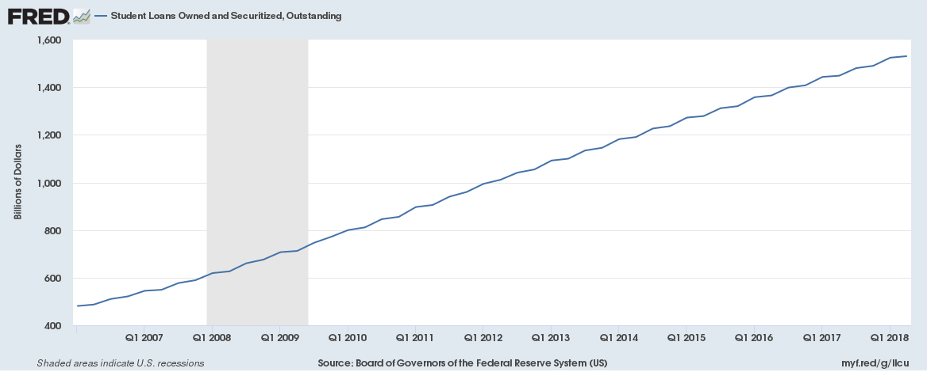

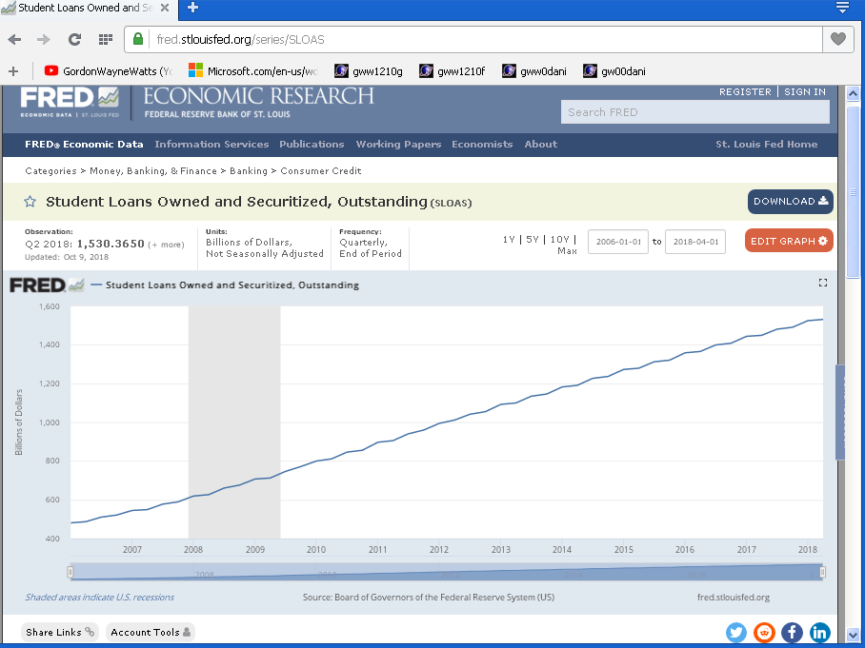

Income vs. Outlays – source: I.R.S.: https://apps.IRS.gov/app/understandingTaxes/whys/thm01/les01/ac3_thm01_les01.jsp
(NOTE that borrowing is about 30% of income, so we are spending too much! See also that we pay INTEREST on outstanding debt!)

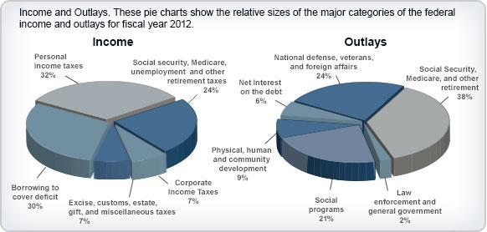

Total U.S. National Debt is now over 21 Trillion Dollars ($21,000,000,000,000.oo). Source:

- “$21,683,971,652,591.44” per https://www.UsGovernmentDebt.us as of Sat. 02 Nov. 2018.
- “Q2 2018: [$]21,195,070 (+ more) Updated: Aug 31, 2018” per https://Fred.StLouisFed.org/series/GFDEBTN
- About $21,692,655,641 (running clock with changing figure) per: http://www.UsDebtClock.org/index.html as of same date as above.

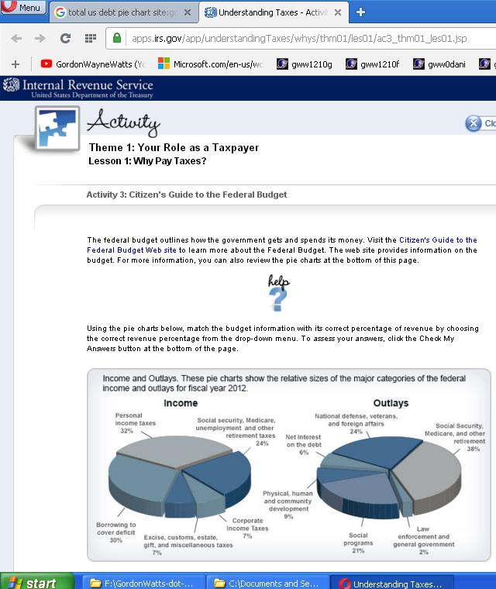

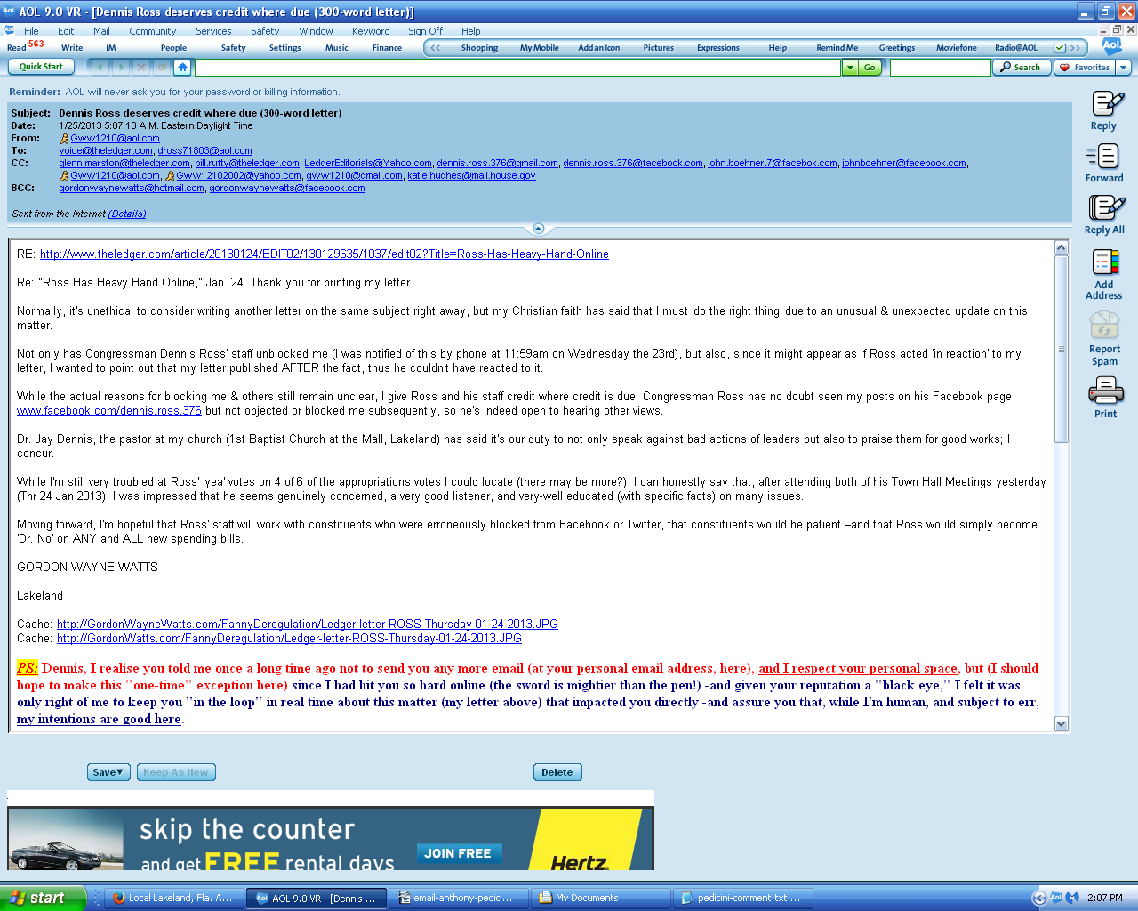

One LAST thing: In order to convince the nice staff at The Ledger to override the “word limits” restrictions, I will do one more thing: Drop of 'big' name—mine. I am “the”guy who almost won in court—all by myself—as Terri Schiavo's next friend. (Remember the Fla. 'feeding tube' girl?) For context, my 4-3 loss in the Fla. Supreme Court was far better than former Gov. Jeb Bush (who lost 7-0 before the same panel), or even Schiavo's parents (who only got a third of their panel in Federal Court).

In Re: GORDON WAYNE WATTS (as next friend of THERESA MARIE 'TERRI' SCHIAVO), No. SC03-2420 (Fla. Feb.23, 2005), denied 4-3 on rehearing. (Watts got 42.7% of his panel) http://www.FloridaSupremeCourt.org/clerk/dispositions/2005/2/03-2420reh.pdf
In Re: JEB BUSH, GOVERNOR OF FLORIDA, ET AL. v. MICHAEL SCHIAVO, GUARDIAN: THERESA SCHIAVO, No. SC04-925 (Fla. Oct.21, 2004), denied 7-0 on rehearing. (Bush got 0.0% of his panel before the same court) http://www.FloridaSupremeCourt.org/clerk/dispositions/2004/10/04-925reh.pdf
Schiavo ex rel. Schindler v. Schiavo ex rel. Schiavo, 403 F.3d 1223, 2005 WL 648897 (11th Cir. Mar.23, 2005), denied 2-1 on appeal. (Terri Schiavo's own blood family only got 33.3% of their panel on the Federal Appeals level) http://media.ca11.UsCourts.gov/opinions/pub/files/200511556.pdf

Submission to The Ledger – total word-length is 1,104 words. That which is in GREEN is 700 words – here goes nothing!...

On August 4, 2016, the column-heard-round-the-world was published in The Ledger, my embarrassing guest column on student debt, “Fix our bankrupt policy,” and not-coincidentally, Congressman Dennis Ross (R-FL-15) –the subject of my column –introduced H.R.6191, the “Student Loan Repayment Act of 2016,” on 9/27/2016, the following month. But, what have we learned since then? Apparently nothing!

Caveat: While I'll continue my unrelenting political attack on Ross' liberal tax-and-spend policies, I'm NOT attacking him as a person, and condemn not only actual attacks, which we've seen of late (shootings, threats, etc.), but even verbal insults. We can disagree without attacking the person. I must add: After my infamous “Heavy Hand” letter published in The Ledger on 1/16/2013, calling out Ross' office for blocking people on social media, it appeared that Ross acted in reaction, but, as it's not widely known, I'll credit him for unblocking us twelve hours BEFORE said letter published, and then firing the staffer responsible for this, meaning he unblocked us for the right reasons, not “in reaction” to my letter. He was never mad at me after my embarrassing column, and this letter –and continued calling on me in subsequent Town Halls, even knowing my questions were often difficult.

Now, H.R.6191 was a small step in the right direction, but it was basically just an employer tax credit to help match funds for college debt, and optional at that. Lastly, it never passed into law.

My prior column documented Ross' promise to not only support Bankruptcy Equality for collegiate loans, but also opposition for use of tax dollars to make or guarantee said loans. But, he never introduced legislation for either, and where has that gotten us? Collegiate debt, now almost 2 Trillion dollars, is almost 10% of total U.S. Debt, and, I go one record as predicting that we WILL crash the U.S. Dollar if we ignore “crazy Gordon” one more time. But it's worse than that: While 10% may not seem like a lot (National Defense & Social Security are about 60—70% of the Budget), use of tax dollars to make/back collegiate debt can be eliminated TOTALLY, unlike Defense, etc., which can only be cut a tiny bit (for both political and actual reasons). Indeed, back in the 50's we used little or no tax dollars for college loans. (They got credit cards, IF they needed credit, and most didn't, since college was affordable, in the first place.)

Since I've documented the eventual crash of the dollar if this is ignored, then this justifies my 12-part series on the matter. (Short of WW3 or a terrorist attack, the crash of the dollar is the worst disaster we face.)

Our Founding Fathers, victims of British banks & merchants' predatory lending, included bankruptcy rights in the Constitution, ahead of the power to raise an army and even to declare war in Art.1, Sec.8, Cl.4. Known as the “Uniformity Clause,” it's a special type of Equal Protection: “There are two ways to enslave and conquer a nation. One is by the sword. The other is by debt.” –John Adams

So, I call on Ross to introduce a bill to begin reversing the loan limit increases made by §422 of H.R.507 (109th CONGRESS), the “College Access and Opportunity Act of 2005,” a bill by R.I.N.O. John Boehner. This is why I call fellow-Republicans “spending” liberals, as we spend tax dollars for something that we not only didn't need in the past, but which, actually, induces colleges to increase tuition to match increased borrowing abilities. And the “tax” part? Well, tuition is technically a tax, as it's funding to an arm of government (state govt colleges), and students are sorely overtaxed! Lastly, before session ends, I call on Ross to cosponsor H.R.2366, which would afford student loans the same bankruptcy protection as, say, Credit Cards, also unsecured (or Mr. Trump, whose businesses repeatedly got BK discharge for MILLIONS). This would not only scare off lenders (resulting in decreases in loans, and, per above, lower tuition), but it would cure a constitutional flaw in U.S. Bankruptcy law:

Does the Constitution, or fiscal Conservatism, matter to Republicans anymore?

Now that I've hit my 700-word limit, I will push my luck, banking on the strength of my “crash the dollar” argument (which is quite true!), and add that Ross used to be a fiscal Conservative, while in the Fla. State House. But it's documented that then-Speaker Marco Rubio punished Ross and one other representative for voting against the costly, and risky, reinsurance bill, the property insurance bill that made Citizens the largest property insurer in Florida: Ross voted to get the tax dollar “off the hook” for this liberal tax-and-spend Boondoggle Pork, and was booted off a committee for it, and now that he's in U.S. Congress, he's afraid to do the right thing: He's under a curse of fear, but I break that curse, if only with the strength of my push-back here, and encourage him to do the right thing, in the use of our tax dollars. (By the way, if H.R.2366 passes, taxpayers will NOT have to “bail-out” students filing bankruptcy. In fact, Bankruptcy, the “Economic Second Amendment” would scare off lenders, and the sharp decline in collegiate loans would save taxpayers huge amounts, not even counting the millions in interest we pay on these toxic, predatory, and sub-prime collegiate loans.) One LAST thing: In order to convince the nice staff at The Ledger to override the “word limits” restrictions, I will do one more thing: Drop of 'big' name—mine. I am “the”guy who almost won in court—all by myself—as Terri Schiavo's next friend. (Remember the Fla. 'feeding tube' girl?) For context, my 4-3 loss in the Fla. Supreme Court was far better than former Gov. Jeb Bush (who lost 7-0 before the same panel), or even Schiavo's parents (who only got a third of their panel in Federal Court).

In Re: GORDON WAYNE WATTS (as next friend of THERESA MARIE 'TERRI' SCHIAVO), No. SC03-2420 (Fla. Feb.23, 2005), denied 4-3 on rehearing. (Watts got 42.7% of his panel) http://www.FloridaSupremeCourt.org/clerk/dispositions/2005/2/03-2420reh.pdf
In Re: JEB BUSH, GOVERNOR OF FLORIDA, ET AL. v. MICHAEL SCHIAVO, GUARDIAN: THERESA SCHIAVO, No. SC04-925 (Fla. Oct.21, 2004), denied 7-0 on rehearing. (Bush got 0.0% of his panel before the same court) http://www.FloridaSupremeCourt.org/clerk/dispositions/2004/10/04-925reh.pdf
Schiavo ex rel. Schindler v. Schiavo ex rel. Schiavo, 403 F.3d 1223, 2005 WL 648897 (11th Cir. Mar.23, 2005), denied 2-1 on appeal. (Terri Schiavo's own blood family only got 33.3% of their panel on the Federal Appeals level) http://media.ca11.UsCourts.gov/opinions/pub/files/200511556.pdf
“You wouldn't like me when I'm angry... Because I always back up my rage with facts and documented sources.” – The Credible Hulk

