From: Gordon Wayne Watts
To: Kyle Glenn
Subject: Looked like a 'flip-flop,' but it can't be...
Date: Thursday, 17 July 2014

Kyle, thank you for all the legislative help you've given me and other constituents of U.S. Rep. Dennis A. Ross (R-Fla.-15th). Here is that email with several questions I had...

First off, before I ask any question, or offer any constituent feedback, I wanted to remind you of a misunderstanding … see the famous “Heavy Hand” letter that published back on Thursday, January 24, 2013.

Link: http://www.theledger.com/article/20130124/EDIT02/130129635
Cache: http://webcache.googleusercontent.com/search?q=cache:xiDObaI1ltsJ:www.theledger.com/article/20130124/EDIT02/130129635+%22Although+I+agree+with+his+fiscal-cliff+no+vote,+this+time,+here+is+a+canard%22&cd=1&hl=en&ct=clnk&gl=us
Cache: http://gordonwaynewatts.com/RepRoss/Heavy-Hand-Letter.jpg
Cache: http://gordonwatts.com/RepRoss/Heavy-Hand-Letter.jpg

As you can see, I didn't pull any punches, and came out swinging hard! -and “ganged up” on him, by calling in “many people” reinforcement... LOL.

However, notice that, as soon as I found out what happened, I issued a retraction, because I wanted to clear his innocent name: http://gordonwatts.com/Twittergate.html
Cache (top of page) http://gordonwaynewatts.com/RepRoss/redaction-1.JPG
Cache (top of page) http://gordonwatts.com/RepRoss/redaction-1.JPG
Cache (middle of page) http://gordonwaynewatts.com/RepRoss/redaction-2.JPG
Cache (middle of page) http://gordonwatts.com/RepRoss/redaction-2.JPG

I also issued a retraction on Facebook: https://www.facebook.com/dennis.ross.376/posts/506781639372174
Cache: http://gordonwaynewatts.com/RepRoss/redaction-3.JPG
Cache: http://gordonwatts.com/RepRoss/redaction-3.JPG

And also, on the same page as the letter, itself:
Screenshot: http://gordonwaynewatts.com/RepRoss/redaction-4.JPG
Screenshot: http://gordonwatts.com/RepRoss/redaction-4.JPG
Link: http://www.theledger.com/article/20130124/EDIT02/130129635 (look at bottom of page)

Lastly, please jump to 1 minute 57 seconds of the 2nd to last THM here, where I thank Dennis for his attention to detail, when he was able to she me respect and courtesy in remembering me and addressing me by name:
http://www.youtube.com/watch?v=D7Z9wWWjTJo&list=UUfLIm8vdy6ESq1g6tgcGvmA
Cache: http://gordonwaynewatts.com/FannyDeregulation/DennisRoss-TeleTHM-Wed21May2014_WMV.wmv
Cache: http://gordonwatts.com/FannyDeregulation/DennisRoss-TeleTHM-Wed21May2014_WMV.wmv

(Or, scroll to the bottom of this letter, here, to see images pasted in, if you're looking at this off-line, and/or don't want to click the links.)

So, while this may seem off-topic (to my actual question), it is Sine Qua Non required to show that I made Redactions/Corrections to defend Dennis when I discovered that he was not guilty as we all initially thought – and this is proof that I know the Dennis and his staff have the highest integrity, and therefore, when I ask “why did he contradict” or “flip-flop,” we can safely eliminate any integrity issues. OK... page 2 is my question...

Page 1 of 3

My 'main' question... Referring, again, to the THM video http://www.youtube.com/watch?v=D7Z9wWWjTJo&list=UUfLIm8vdy6ESq1g6tgcGvmA

Cache: http://gordonwaynewatts.com/FannyDeregulation/DennisRoss-TeleTHM-Wed21May2014_WMV.wmv
Cache: http://gordonwatts.com/FannyDeregulation/DennisRoss-TeleTHM-Wed21May2014_WMV.wmv

Dennis is a brave Congressman who has integrity to defend both Loan Forgiveness as well as College loan Bankruptcy (which will certainly not put him in good stead with 'Old Guard' GOP leadership, and certainly not encourage bankers to continue to bankroll his upcoming campaign for reelection!).

However, in his email to me, June 02, and apparently in 2011 (based on the date on the screen shot), he said the he is against bankruptcy (one of the more commonly well-known Standard Consumer Protections). Here's a screen shot of that conversation: http://gordonwaynewatts.com/RepRoss/DennisRoss-reply.jpg
Mirror: http://gordonwatts.com/RepRoss/DennisRoss-reply.jpg

A copy/paste of the relevant sections of that conversation are as follows:

Gordon Wayne Watts June 2 at 10:16am
I posted a question about H.R. 5043 just now, and it's deleted - I guess you deleted it. Was my post offensive in some way? The issues surrounding that are explained on...For some reason, liberals support this too -and I suspect they view it as a free handout...What is your take on this issue? -- And, what about my post was offensive to motivate you to delete it?

Dennis Ross June 2 at 10:55am Report
I toko it down because I wanted my constituents to see the post about the balanced budget hearing going on right now. Nothing offenseive, just didn't want that post mvoed down the page so far.

As for HR 5043, I do not support it. Allowing discharge in bankruptcy for student loans would cause a sharp decline in availability of loans. I also do not supoprt the federal government being the only student loan lender, as it is now after last year.

My question to Dennis is this:
Why did he appear to flip-flop on this issue (first opposing BK protections in his email, and then supporting them, which seems fair, since other borrowers have this option)? – Only 4 possible explanations exist, and I can eliminate one of them:

- He could have “flip-flopped” to pander to the current opinion, but I eliminate this option, as Dennis and his current staff pass the Integrity test with 100% - going above and beyond what is required.
- Dennis could have had a genuine “flip-flop” based on a change of mind, new information, etc.
- Dennis is a very busy man, and it is possible that he was under pressure (he was new to office, and had not set up his staff completely), and thus maybe did not think things through.
- Lastly, it is also possible that a staff member was answering emails in his name, and somehow a mis-communication occurred and/or the staffer “guessed” wrongly.

My guess would be that #4 is the most likely possibility, and this is based on the fact that Katie Hughes and I collectively agreed that this is probably what happened in the 'Heavy Hand' Facebook/Twittergate blocking scandal: We think that, probably, an overzealous staffer (who is no longer with Ross' office) got carried away...but, I don't know for sure. – It looked like a 'flip-flop,' but it can't be: Dennis is a man of integrity... Only Dennis would know why he gave 2 apparently different answers... Thank you to both you, Katie, Dennis, and his staffers for all y'alls' collective assistance on this -and other matters... That was my only question, but, after hearing Sen. Rubio, I have some helpful feedback on Immigration. Please see the next page...

Page 2 of 3

I did get Dennis' postal letter to me, dated July 09, 2014, in which he informs me of his co-sponsorship of H.R. 4962, the Nat'l Border & Homeland Sec. Act, which would add Border Patrol agents and fund the Border Fence, while mandating/ordering that it be built.

Good job!... but after hearing Sen. Marco Rubio (R-Fla) on a recent Sean Hannity program, I have a few new ideas that should probably be implemented ASAP:

- Fund and mandate the building of the BORDER FENCE (Dennis' idea; Gordon's idea; Sen. Rubio's idea)
- Add PATROL AGENTS (Dennis' idea, which I must've overlooked, but I will agree with this good idea)
- TRACK people who have WORKER VISAS to kick out those who over-stay their visa (Sen. Rubio's idea)
- Fund and mandate E-VERIFY for employers (Sen. Rubio's idea to “turn off the magnet,” since there will no longer be any “magnet” for jobs if Immigrants know that they can not be illegal and still work in the USA)
- Allow State, County, and Local POLICE to enforce Immigration Policy (and help out their Federal counterparts who are overwhelmed at the present time) – this was Gordon's idea uniquely, but I'm sure that others have asked for this to be done, ARIZONA in particular, so I admit I “borrowed” their idea – all good and fine, but we need to make it Federal Law! – Teamwork: United We Stand – or Divided We Fall... ---which will it be??
- I will add one more thing: We need to continue to address the root causes of this by doing anything we can to help other countries lower crime, increase jobs, etc., so their citizens will want to stay in their own countries.
- We must also assure foreigners (and their friends/supporters) that we wish to help them all, but are limited on how many Immigrants we can accept.

Page 3 of 3

Inline images below in this PDF...
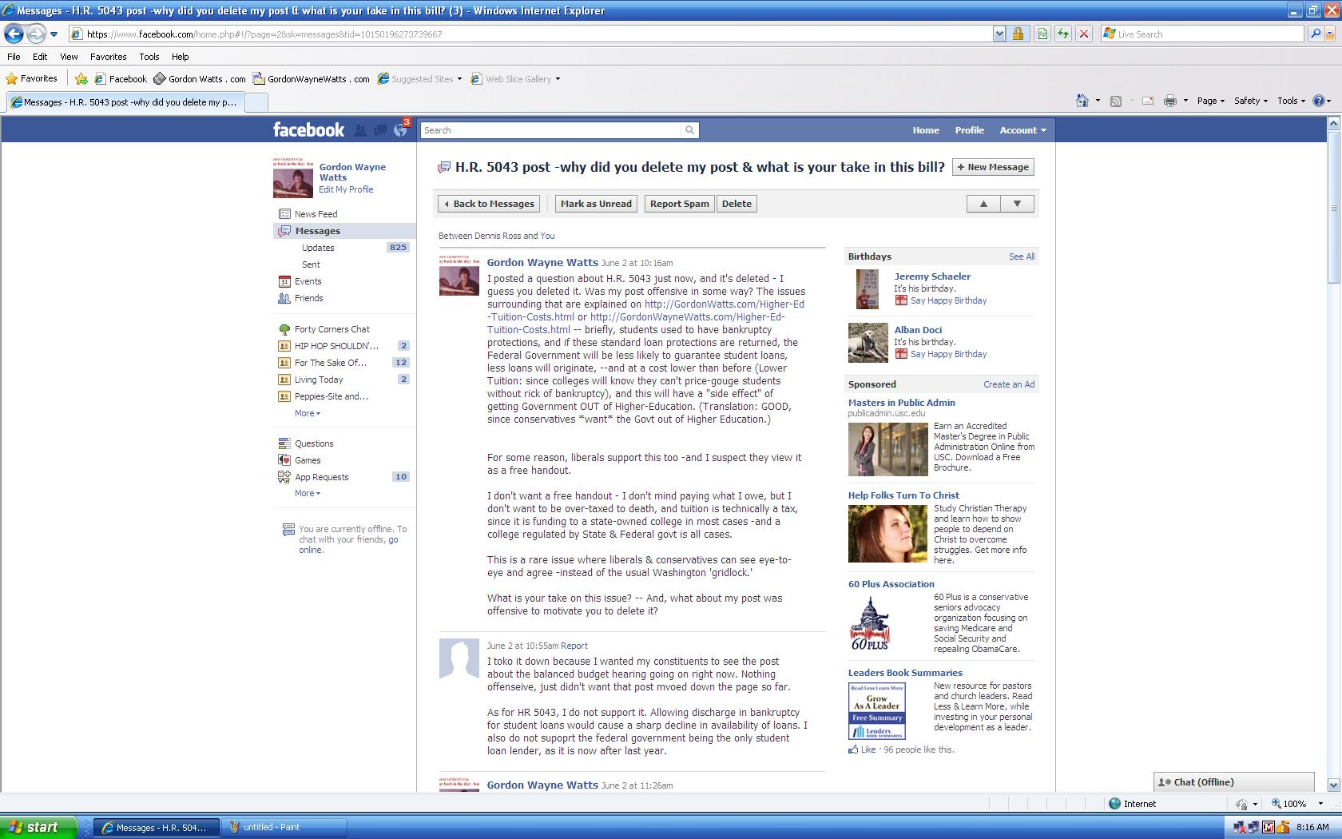
Closeups:
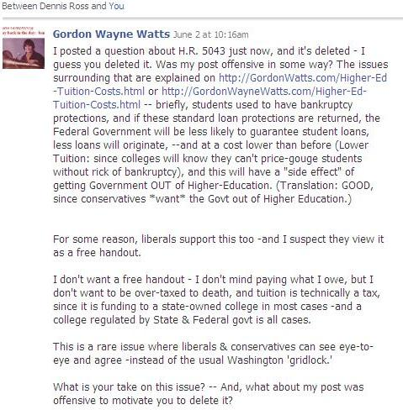
and...
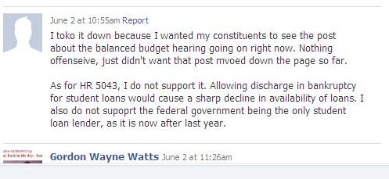

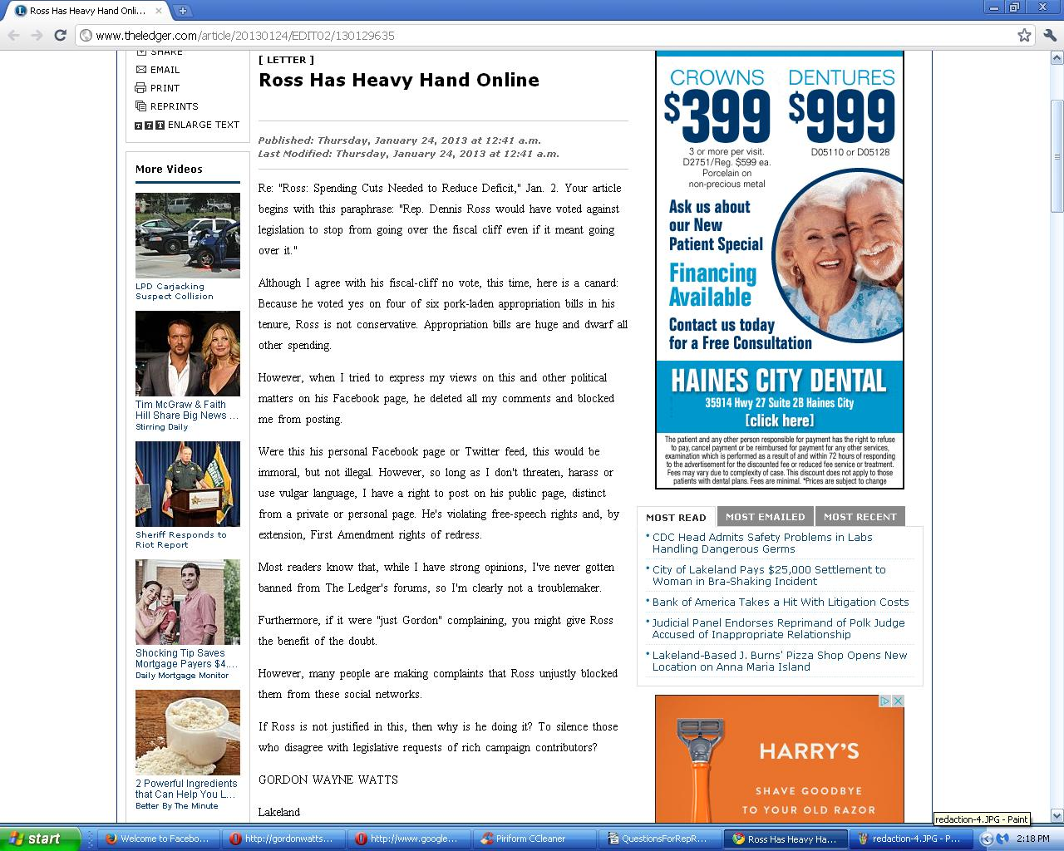

Redaction:

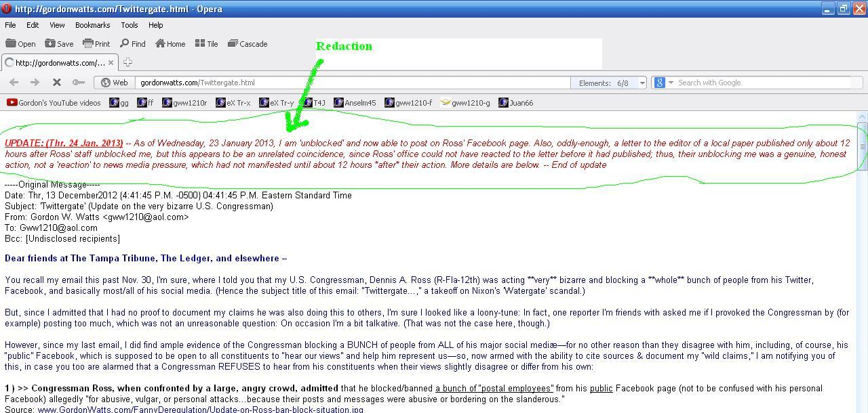

and...

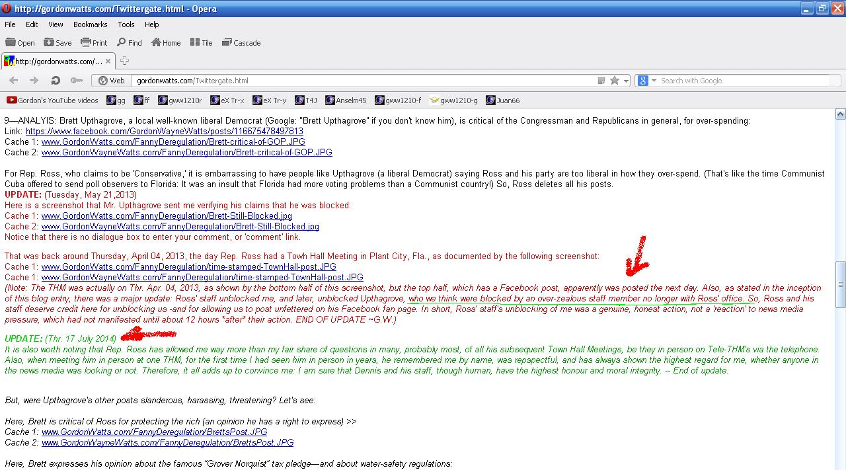

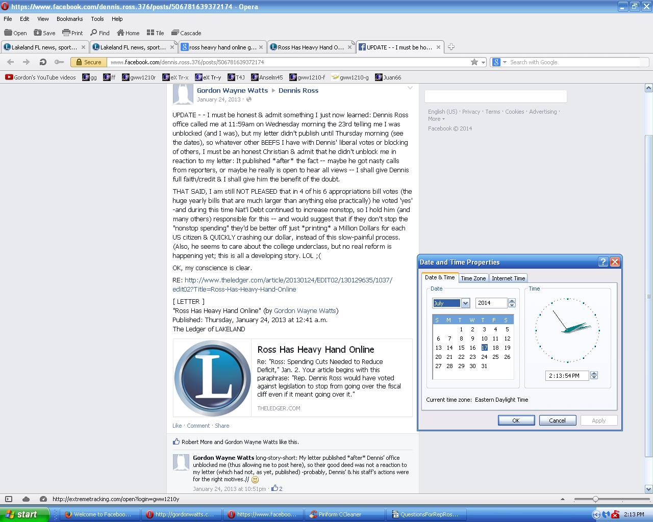

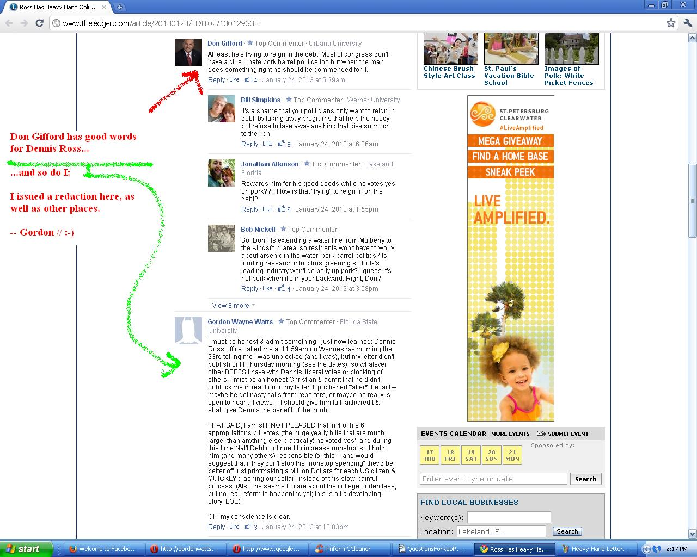

Summary:

So, page 1 is just an “I've got your back” page, showing I'm trying to follow Jesus' example (John 13:15; I Peter 2:21), and let you know that ,while I'm human, my intents and motives are pure.

Page 2 is my main question, and page 3 are policy and legislative suggestions.

Thank you, in advance, Kyle and Dennis, for whatever help you may afford in solving this mystery here on page 2 of the apparent contradiction.

Gordon Wayne Watts

