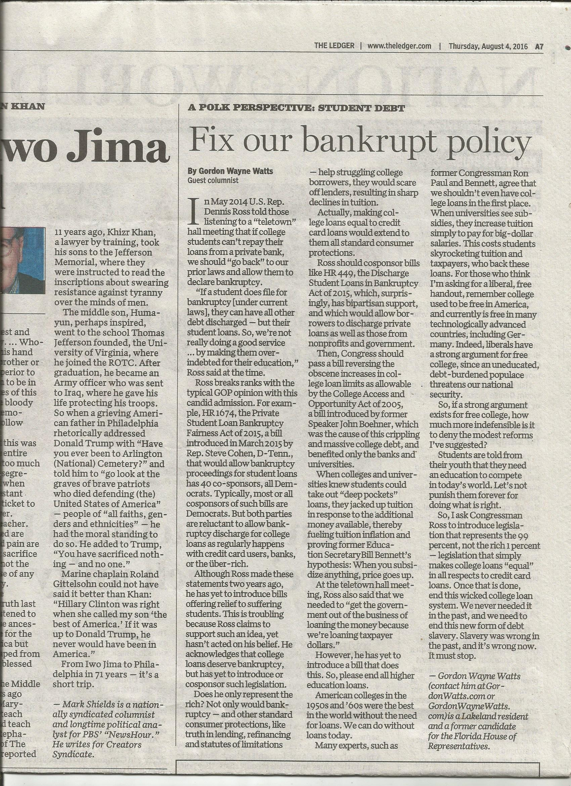
** TIPS to help Donald Trump WIN the Presidential Election **
(Translation: Here's stuff you overlooked, and if you continue to overlook it, then DISHONEST Hillary Clinton will continue to STEAL VOTES from Mr. Trump with her continued lies & false promises of 'Free College' & 'Loan Forgiveness')

* PROBLEM: Hillary Clinton is trying to nominate U.S. Supreme Court Justices who will overturn District of Columbia v. Heller, 554 U.S. 570 (2008), which just barely (5-4 split vote) upheld a FEDERAL SECURITY GUARD's right to own a gun in his OWN home. (For his job, Mr. Heller carried a gun in federal office buildings, but wasn't allowed to have one in his home! And, if he almost lost his 2nd Am. Rights, how much quicker could you lose your rights if Hillary gets elected!?) MOREOEVER, when she was a senator, Hillary made ONE attempt at passing S.3255, the "Student Borrower Bill of Rights Act" (109th Congress, 2005-2006), but quickly gave up when the banks "bought her off" with campaign contributions.
* PROOF this is a Problem: She might become president because she's making promises of 'Free College,' which seems reasonable since AMERICA did have free (or very low cost) college a few decades ago, & yet the best higher-ed in the world. BUT we know she's lying –for 2 reasons: FIRST, while we had free college in the past, we can't afford it now; 'low-cost' is the best we can do now. SECONDLY, she's been caught in so many lies, and was a "do-nothing" Senator, so we know she'd be a "do-nothing" liar if she became President. So... What can we do?...
*** SOLUTION: First, remember that tuition is Monie$ being paid to colleges owned (or regulated) by the state GOVERNMENT, and thus, legally, a type of TAX—and STUDENTS (read: middle class) are being over-taxed. Then, read my OpEd, on the other side of this flyer, to see my solutions: If liberals have a good 'historical' case for FREE college, an even better case can be made for return of (at the least) bankruptcy (& maybe other Standard Consumer Protections that even unsecured Credit Card loans have) – as well as getting tax$$ out of the business of making/backing college loans. - If Mr. Trump does not push for these, he will lose votes, as Millennials will vote for Hillary.
*** WARNING: After King Solomon died, and his son, Rehoboam became king of ISRAEL, the people complained about being "over-taxed," & they asked him if he'd lighten the load a little. (Sound familiar? I'm suggesting that Mr. Trump promise to push for "lighter 'tuition tax' for students," above: Peel out those old, dusty Bibles & look in 1st King 12 and 2nd Chronicles 10 to see what happened to Solomon's son: He told the people to shove off, & that he'd over-tax them even worse, and TEN of the TWELVE tribes of Israel REBELLED, & split the kingdom!! THIS WILL HAPPEN to Mr. Trump – voters will reject HIM TOO – if he ignores my advice.) Summary: If you don't carefully study my OpEd that The Ledger published (other side of this paper), then THREE (3) things will happen: First, college tuition will continue to rise, crushing college students (making them a new class of slaves!). Secondly, this will crash the U.S. Dollar (since college debt, at ~1.5 Trillion, is almost 10% of total U.S. Debt). Third, it greatly risks angering Millennials, & losing their vote: WE'RE not asking for 'Free College' or 'Debt Forgiveness' (even tho deceptive lending, illegal monopoly, free college in the past all make a good case for it), but at the least, please enact the 2 measures I outline in my guest column, published by The Ledger (of LAKELAND, Fla., between Tampa & Orlando) "A Polk Perspective: Fix our bankrupt policy on student debt," By Gordon Wayne Watts, Guest columnist, The Ledger, August 04, 2016 www.TheLedger.com/article/20160804/COLUMNISTS03/160809884/1382/edit?p=all&tc=pgall ** www.GordonWatts.com/TheLedger-print-version-WATTS-GuestColumn-Thr04Aug2016.html
www.GordonWayneWatts.com/TheLedger-print-version-WATTS-GuestColumn-Thr04Aug2016.html

See also... Accepted by all observant Christians as Canon Scripture: The Holy Bible – JESUS speaking:
“46 And He said, “Woe to you also, lawyers! For you load men with burdens hard to bear, and you yourselves do not touch the burdens with one of your fingers.” [Luke 11:46, NKJV] “3 Therefore whatever they tell you to observe, that observe and do, but do not do according to their works; for they say, and do not do. 4 For they bind heavy burdens, hard to bear, and lay them on men’s shoulders; but they themselves will not move them with one of their fingers.” [Matthew 23:3-4, NKJV] See also JAMES, the brother of our Lord, Jesus: “1 Now listen, you rich people, weep and wail because of the misery that is coming on you. 2 Your wealth has rotted, and moths have eaten your clothes. 3 Your gold and silver are corroded. Their corrosion will testify against you and eat your flesh like fire. You have hoarded wealth in the last days.” [James 5:1-3, NIV] – Commentary: 'Lawyers' & others, such as Federal Lawmakers, who “load men with burdens” (by passing laws stripping students' ability to obtain bankruptcy for most college loans -and stripping 'Truth In Lending' requirements to give borrowers fair 'Due Process' notice of this) certainly violate the Golden Rule. Lawmakers are hypocrites: They wouldn't accept this 'too hard to bear' 'burden' on their shoulders!
Accepted by both Jews & Christians as Canon Scripture: MOSES, prophet Nehemiah, & wise-man, King Solomon speaking:
* Exodus 22:25, (AMP) – “If you lend money to any one of My people with you who is poor, you shall not act as a creditor (professional moneylender) to him; you shall not charge him interest.
* Nehemiah 5:7; 5:10; 10:31b (AMP) – 7 I thought it over and then challenged the nobles and the rulers. I said to them, “You are exacting usury (excessive interest) from your own brother (relative).” So I held a great assembly to confront them. 10 And likewise I, my brothers, and my servants are lending them money and grain. Please, let us stop [charging] this interest. 31b ...we will not buy from them on the Sabbath or on a holy day; and we will give up raising crops during the seventh year [leaving the land uncultivated], and forgive every debt.
* Proverbs 28:8 (AMP) – He who increases his wealth by interest and usury (excessive interest) Gathers it for him who is gracious to the poor.

Gordon Wayne Watts (gww1210@aol.com ; contact him at GordonWatts.com or GordonWayneWatts.com) is a Lakeland, Fla. resident[[**]], one-time candidate for Florida state house, and part-time advocate. He almost won on behalf of Terri Schiavo[1], all by himself, in state court, and, more recently, was believed to be the only NonLawyer that a Federal Appeals court allowed to participate in the recent spate of 'Gay Marriage' cases.[2] Watts is currently asking the US Supreme Court to strike the law in question.[3] Watts has a double major with honours in Biological & Chemical Sciences from The Florida State University, and was Valedictorian of his graduating class at United Electronics Institute. DISCLAIMERS: Watts has a huge college debt, estimated to be almost 60 thousand dollars, according to the March 18, 2016 intervention motion he filed in Tetzlaff v. ECMC, #15-485, before the US Supreme Court[3], which suggests a bias for relief. But as Watts is currently on IBR (Income Based Repayment) with his loan, capping him at 10% of his discretionary income, which is 10% of zero, and does not expect this to change, this removes a conflict of interest (aka personal bias) of monetary gain from the proposed change in law he seeks. [[**]] Lakeland, Fla. is squarely between Tampa & Orlando, Florida.

[1] In Re: GORDON WAYNE WATTS (as next friend of THERESA MARIE 'TERRI' SCHIAVO), No. SC03-2420 (Fla. Feb.23, 2005), denied 4-3 on rehearing. (Watts got 42.7% of his panel) http://www.FloridaSupremeCourt.org/clerk/dispositions/2005/2/03-2420reh.pdf
In Re: JEB BUSH, GOVERNOR OF FLORIDA, ET AL. v. MICHAEL SCHIAVO, GUARDIAN: THERESA SCHIAVO, No. SC04-925 (Fla. Oct.21, 2004), denied 7-0 on rehearing. (Bush got 0.0% of his panel before the same court) http://www.FloridaSupremeCourt.org/clerk/dispositions/2004/10/04-925reh.pdf
Schiavo ex rel. Schindler v. Schiavo ex rel. Schiavo, 403 F.3d 1223, 2005 WL 648897 (11th Cir. Mar.23, 2005), denied 2-1 on appeal. (Terri Schiavo's own blood family only got 33.3% of their panel on the Federal Appeals level) http://media.ca11.uscourts.gov/opinions/pub/files/200511556.pdf

[2] Consolidated Appeals Docket: 11th U.S. Circuit Court of Appeals
Case #: 14-14061 (James Brenner, et al v. John Armstrong, et al),
Case #: 14-14066 (Sloan Grimsley, et al v. John Armstrong, et al)

[3] “Is the Mark Tetzlaff Case Over at the Supreme Court? Maybe Not.,” Posted by: Guest Post March 23, 2016: https://GetOutOfDebt.org/98813/mark-tetzlaff-case-supreme-court-maybe-not ** Case #: 15-485, Mark Warren Tetzlaff, Petitioner v. Educational Credit Management Corporation (U.S. Supreme Court, Docketed: October 16, 2015)
http://GordonWatts.com/FannyDeregulation/Tetzlaff-case/DOCKET-15-485_Tetzlaff-v-ECMC.html
http://GordonWayneWatts.com/FannyDeregulation/Tetzlaff-case/DOCKET-15-485_Tetzlaff-v-ECMC.html

