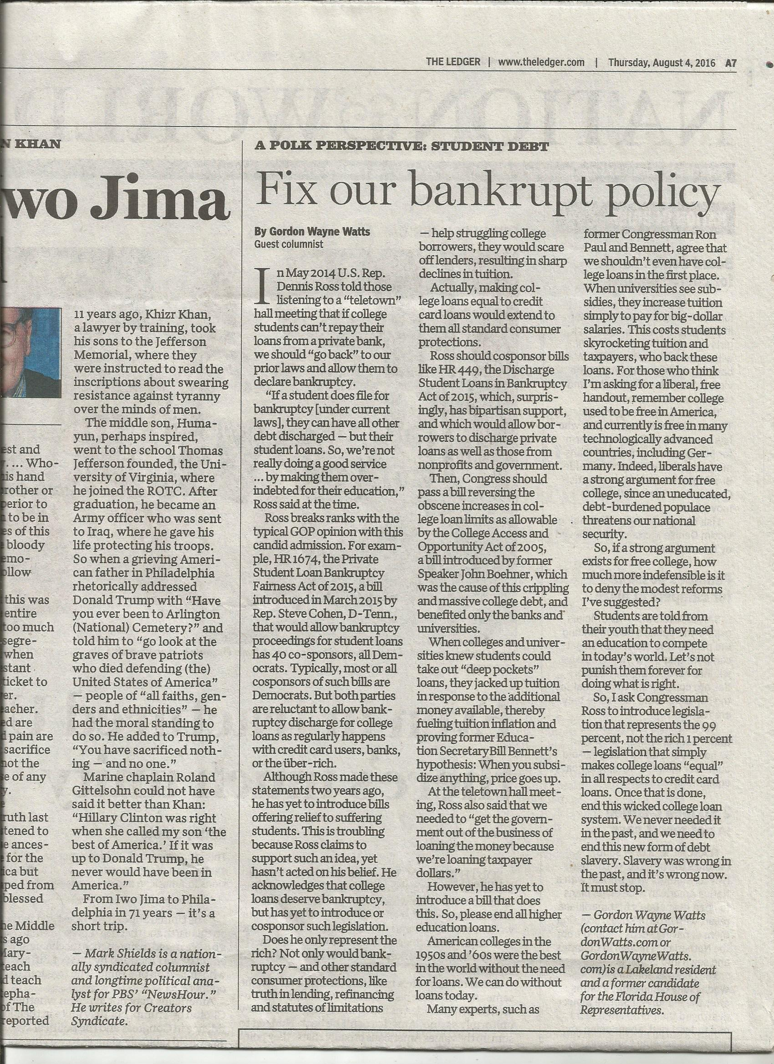
Accepted by all observant Christians as Canon Scripture: The Holy Bible – JESUS speaking:

“46 And He said, “Woe to you also, lawyers! For you load men with burdens hard to bear, and you yourselves do not touch the burdens with one of your fingers.” “3 Therefore whatever they tell you to observe, that observe and do, but do not do according to their works; for they say, and do not do. 4 For they bind heavy burdens, hard to bear, and lay them on men’s shoulders; but they themselves will not move them with one of their fingers.” [Luke 11:46; Matthew 23:3-4, NKJV] – Commentary: 'Lawyers' & others, such as Federal Lawmakers, who “load men with burdens” (by passing laws stripping students' ability to obtain bankruptcy for most college loans -and stripping 'Truth In Lending' requirements to give borrowers fair 'Due Process' notice of this) certainly violate the Golden Rule. Lawmakers are hypocrites: They wouldn't accept this 'too hard to bear' 'burden' on their shoulders!

* Exodus 22:25, (AMP) If you lend money to any of My people with you who is poor, you shall not be to him as a creditor, neither shall you require interest from him.
* Nehemiah 5:7; 5:10; 10:32b: 7 I thought it over and then rebuked the nobles and officials. I told them, You are exacting interest from your own kinsmen. And I held a great assembly against them. 10 I, my brethren, and my servants are lending them money and grain. Let us stop this forbidden interest! 32b ...we shall not buy it on the Sabbath or on a holy day; and we shall forego raising crops the seventh year [letting the land lie fallow] and the compulsory payment of every debt.
* Proverbs 28:8: He who by charging excessive interest and who by unjust efforts to get gain increases
his material possession gathers it for him [to spend] who is kind and generous to the poor.

Gordon Watts (gww1210@aol.com) is a Lakeland resident, one-time candidate for state house, and part-time advocate. He almost won on behalf of Terri Schiavo[1], all by himself, in state court, and, more recently, was believed to be the only NonLawyer that a Federal Appeals court allowed to participate in the recent spate of 'Gay Marriage' cases.[2] Watts is currently asking the US Supreme Court to strike the law in question.[3] Watts has a double major with honours in Biological & Chemical Sciences from The Florida State University, and was Valedictorian of his graduating class at United Electronics Institute. DISCLAIMERS: Watts has a huge college debt, estimated to be almost 60 thousand dollars, according to the March 18, 2016 intervention motion he filed in Tetzlaff v. ECMC, #15-485, before the US Supreme Court[3], which suggests a bias for relief. But as Watts is currently on IBR (Income Based Repayment) with his loan, capping him at 10% of his discretionary income, which is 10% of zero, and does not expect this to change, this removes a conflict of interest (aka personal bias) of monetary gain from the proposed change in law he seeks.

[1] In Re: GORDON WAYNE WATTS (as next friend of THERESA MARIE 'TERRI' SCHIAVO), No. SC03-2420 (Fla. Feb.23, 2005), denied 4-3 on rehearing. (Watts got 42.7% of his panel) http://www.FloridaSupremeCourt.org/clerk/dispositions/2005/2/03-2420reh.pdf
In Re: JEB BUSH, GOVERNOR OF FLORIDA, ET AL. v. MICHAEL SCHIAVO, GUARDIAN: THERESA SCHIAVO, No. SC04-925 (Fla. Oct.21, 2004), denied 7-0 on rehearing. (Bush got 0.0% of his panel before the same court) http://www.FloridaSupremeCourt.org/clerk/dispositions/2004/10/04-925reh.pdf
Schiavo ex rel. Schindler v. Schiavo ex rel. Schiavo, 403 F.3d 1223, 2005 WL 648897 (11th Cir. Mar.23, 2005), denied 2-1 on appeal. (Terri Schiavo's own blood family only got 33.3% of their panel on the Federal Appeals level) http://media.ca11.uscourts.gov/opinions/pub/files/200511556.pdf

[2] Consolidated Appeals Docket: 11th U.S. Circuit Court of Appeals
Case #: 14-14061 (James Brenner, et al v. John Armstrong, et al)
Case #: 14-14066 (Sloan Grimsley, et al v. John Armstrong, et al)

[3] “Is the Mark Tetzlaff Case Over at the Supreme Court? Maybe Not.,” Posted by: Guest Post March 23, 2016: https://GetOutOfDebt.org/98813/mark-tetzlaff-case-supreme-court-maybe-not
Case #: 15-485, Mark Warren Tetzlaff, Petitioner v. Educational Credit Management Corporation (U.S. Supreme Court, Docketed: October 16, 2015)
http://GordonWatts.com/FannyDeregulation/Tetzlaff-case/DOCKET-15-485_Tetzlaff-v-ECMC.html
http://GordonWayneWatts.com/FannyDeregulation/Tetzlaff-case/DOCKET-15-485_Tetzlaff-v-ECMC.html

