( UPDATED List of key supporters of both bills )
TEAMWORK !!

Introduction: It seems all my lawmakers (of both parties) are scared of their shadow with regard to “doing the right thing” in both “spending cuts” and “tax cuts.” So, I've found more “supporters” for both bills—and am updating my list accordingly.
American lawmakers need to stop the obscenely high hemorrhage/bleedout in the current excessive taxing and spending – lest we CRASH THE U.S. DOLLAR and collapse the economy!
– THEREFORE, oh ye lawmakers, ye who be afraid—have faith and fear not: See how many other supporters there are, and stop cowering in fear: ACT before we crash the dollar!!

By Gordon Wayne Watts, Editor-in-Chief, The Register (GordonWatts.com / GordonWayneWatts.com)
National Director, CONTRACT WITH AMERICA: PART II^{(TM)}
(ContractWithAmerica2.com) Date: Monday, 29 November 2021

My father (the late Bobby Watts, R.I.P., dad) once told me that if I was trying to fight a problem that was too big for me, to NOT “go it alone,” but rather, ask for help from others to add their voice to mine. To that end, here are lists (with references) of supporters of all bills for which I'm asking your advocacy & support, Federal LAWMAKERS—but this advice is also good for local city, county, and state lawmakers—and also citizens!

“ SPENDING CUTS ” supporters—especially harmful & unnecessary “Higher Education loan” pork subsidies—unneeded PORK using YOUR tax dollars :

GOAL: “Loan Limits” bill –to reduce or eliminate use of U.S. Tax Dollars to make/back Collegiate Loans

“LOAN LIMITS” = “SPENDING CUTS” – Before we get going, let me make it clear: The “loan limits” requests of numerous American leaders shown below =EQUALS= “spending cuts,” in spite of occasional objections. TEST-TIME: Before I tell you why, can YOU tell ME why? That's right: “Loan Limits” equal “spending cuts,” because our tax dollars are being used to make or “back” (guarantee) said student loans. Given that student debt is almost TWO ($2,000,000,000,000.oo) TRILLION Dollars as of this writing – and thus almost TEN (10%) PERCENT of total U.S. Debt, we need to pay attention... and cut unnecessary wasteful spending: Since collage was once FREE in the U.S., or close to it, we needed NO student loans, much less ones made/backed by YOUR tax dollars! –Carry on...

Table of Contents:

(1) President Donald J. Trump (R-U.S.A.) – “Trump Proposes Limits On Student Loan Borrowing,” By Zack Friedman, FORBES, Tue. March 19, 2019: https://www.Forbes.com/sites/zackfriedman/2019/03/19/trump-proposes-limits-on-student-loans <<< ( You're correct, Mr. President –but you need help – see below... )

(2) President Joe Biden (past views) Sen. Joe Biden was VERY hawkish, e.g., opposed excessive Liberal pork spending. QUOTE: “"Whatever happened to the old conservative discipline about paying for what you spend?" he said in a 1995 floor speech. [] "If we don't do that, all of the things I care most about are going to be gone. Gone," he added, suggesting that federal spending should amount to roughly 19 percent of gross domestic product.” – SOURCE: “Biden sheds hawkish past on deficit with debt-laden budget,” By Niv Elis, The Hill, 06/02/2021: https://TheHill.com/policy/finance/budget/556410-biden-sheds-hawkish-past-on-deficit-with-debt-laden-budget <<< ( You're correct, Mr. President –but you need help – see below... )

(3) (Retired) Rep. Ron Paul (R-TX-14th) (seeks and end to ALL U.S.-taxpayer-backed student loans –not merely a reduction on loan limits)

(4) (Former) U.S. Secretary of Education, Betsy DeVos (her comments imply support for my proposed bill)

(5) (Former) U.S. Secretary of Education, Dr. Bill Bennett (hint: The 'Bill Bennett Hypothesis')

(6) Superman actor, Dean Cain – QUOTE: “If you want to make college more accessible and affordable- stop guaranteeing student loans, and keep big government out. YOU’RE THE REASON it’s so expensive!” – Responding to Rep. Ted Lieu · Oct. 18, who said: “We must do everything in our power to make college more accessible and affordable.” – SOURCE: Dean Cain on Twitter, By @RealDeanCain, 11:34 AM · Oct 18, 2021

(7) The Heritage Foundation (calls for elimination of subsidized student loans—decries profligate federal spending through subsidized student loans, which has fueled tuition inflation,driving up college costs and burdening families, thereby exposing taxpayers to $1.6 trillion in outstanding student loan debt)

(8) OpenTheBooks.com, a public transparency website, founded by CEO, Adam Andrzejewski (pronounced: “Angie-eff-ski”), an Illinois entrepreneur, and with the late Senator, Dr. Tom Coburn, as the Honorary Chairman, is, currently, the world’s largest private repository of public spending, with 2.6 billion individually captured transactions from the federal government, in 48 of the 50 U.S. states and 36,000 local units of government across America. Mr. Andrzejewski’s work has been repeatedly featured on The Wall Street Journal editorial page, USA Today, and in a column at Forbes Magazine—and Adam is a contributor at Forbes:
OpenTheBooks.com calls out the top “25 colleges and universities with the largest endowments in the country [which] reaped $6.9 billion in Department of Education (ED) funding despite holding a quarter-trillion in existing assets, collectively. This money was distributed as grants, contracts, and direct payments (FY2017) as well as student loans (FY2017-FY2018),” – decries how college “tuition, room and board costs can now exceed $50,000 to $70,000 a year...a massive financial hardship of the families that actually pay out-of-pocket the $200,000 to $300,000 tab for a four-year degree,” and with this quote about spending cuts:

“Adam Andrzejewski, OpenTheBook’s founder, said the federal government’s expanding role has become counterproductive, creating incentives for schools to raise their costs, knowing taxpayers are helping pick up the tab. [] “Scaling back the amount of public funding flowing to cosmetology colleges should be a nonpartisan reform,” Mr. Andrzejewski said...The Education Department’s budget stands at about $115 billion a year, a gargantuan expansion from its early years after it was established by President Jimmy Carter in 1979.” (Emphasis added in “red” bold-face font, and underlined in some cases, for clarity – not in original. Sources for all quotes below.)

(9) Sen. Marco Rubio (R-FL) (supports balanced budget within 10 years; has long advocated freezing spending for everything but defense at 2008 levels—also joined with 10 fellow Republican Senators in sending a letter to former House Speaker John Boehner (R-Ohio) urging House Republican Leadership to make spending cuts of no less than $100 billion for Fiscal Year 2011, opposes Washington's reckless spending and resultant financial burdens on everyday Americans)

(10) Other Conservatives – on record as “Debt and deficit hawks” include (but are not limited to) President Donald J. Trump (R-U.S.A.); and, Sens. Rand Paul (R-KY), Ted Cruz (R-TX), Mike Lee (R-UT), and Marco Rubio (R-FL).

(11) Sen. Rick Scott (R-FL) (considers responsible fiscal oversight as one of the most important responsibilities of our federal government. Laments that this year’s federal budget deficit will likely be the largest in the history of our nation, in excess of the cumulative deficits for the first 200 years of our country’s existence, and end the year with more than $25 trillion in federal debt—opposes member projects & special-interest giveaways, complains how Congress is about to waste your money, supports fiscal conservatism, warns of looming fiscal crisis and financial system crashing down because of excess government spending and borrowing) Primary Sponsor of S.3708 - Agency Accountability Act, which, if passed, creates a temporary federal commission tasked with finding inefficiencies within the federal government, determining which federal agencies functions should be relegated to the private sector, and proposes recommendations for eliminating unnecessary agencies—in order to to help streamline operations and reduce waste at federal agencies. Companion bill to H.R.7226. KEY QUOTES: “Senator Rick Scott said, “Raising tuition on families is a tax increase. And, it’s a tax increase that harms Floridians’ ability to achieve the American dream of earning a highereducation diploma.” – SOURCE: PRESS RELEASE: “Sen. Rick Scott to Florida Board of Governors: Do Not Raise Tuition on Florida Students,” by Sen. Rick Scott (R-FL), Monday, November 30, 2020 – AND: “Here’s what I’m proposing: [] 3. Third, if a college or university raises tuition or fees, they will be automatically cut off from ALL federal funding, including federally-guaranteed loan programs. That’s right, ALL FEDERAL FUNDING WILL BE CUT OFF IF TUITION OR FEES ARE INCREASED.” – SOURCE: PRESS RELEASE: “Sen. Rick Scott Announces Proposals to Lower the Cost of Higher Education,” by Sen. Rick Scott (R-FL), Tuesday, September 10, 2019

(12) (Former) Rep. Ross Spano (R-FL-15) (Laments that the national debt crossed the $22 Trillion-dollar threshold. Decries the hypocritical double standard in which American people are responsible with their personal finances, while their Congress and government continues an out-of-control spending spree. Warns that this is a clear and present danger to our national security. Identifies this as American spending problem, not a revenue problem. Reports that his constituents – which include the undersigned GORDON WAYNE WATTS of FLORIDA, U.S.A. – routinely voice concern about our escalating national debt and why Congress doesn't make hard choices necessary to deal with it.) Primary Sponsor of H.R.7226 - To establish a Federal Agency Sunset Commission, and for other purposes, which, if passed, creates a temporary federal commission tasked with finding inefficiencies within the federal government, determining which federal agencies functions should be relegated to the private sector, and proposes recommendations for eliminating unnecessary agencies—in order to to help streamline operations and reduce waste at federal agencies. Companion bill to S.3708.

(13) (Current) Rep. C. Scott Franklin (R-FL-15) – Franklin quote 1-of-2: “As a businessman, I believe in lowering taxes, reducing wasteful spending and eliminating excessive regulations...” SOURCE: Official House website, Rep. Scott Franklin (R-FL-15), HOME → ISSUES → ECONOMY, undated position page, – AND: Franklin quote 2-of-2: “WASHINGTON—Representative Scott Franklin (R–FL) today opposed the Senate amendment to H.R. 1319, the “American Rescue Plan.” This massive spending package is disguised as a COVID relief bill, yet 91% of the spending fails to address the pandemic...“Unlike the three prior COVID relief bills that enjoyed wide support from both sides of the aisle, it’s disheartening to see my Democrat colleagues forego sincere bipartisan efforts to help America,” Rep. Franklin said. “Congress could have provided targeted relief where it is most needed, yet Democrats chose to load up a nearly $2,000,000,000,000 payoff to political allies, while handing our children and grandchildren a legacy of debt...” Franklin concluded.” SOURCE: PRESS RELEASE: “Franklin Statement on $1.9 Trillion "American Rescue Plan",” by Rep. Scott Franklin (R-FL-15), March 11, 2021

(14) Rep. Greg Steube (R-FL-17) (opposed voting for a budget that would add over $300 billion in new spending with zero offsets. Laments that we have kicked the can down the road when it comes to our ever-growing national debt)

(15) Rep. Darren Soto (D-FL-09) (Objected to seven (7) years of a Republican Congress, which added seven ($7,000,000,000,000.oo) Trillion Dollars in national debt, even after going against the GOP Caucus’ promise to eliminate deficit. Self-identifies as a “fiscal conservative.”)

*NEW: We hear from four (4) constituents of Congressman Franklin, residing in U.S. Congr. Dist. FL-15:
(16) Royal Brown III (local Republican and Heritage Sentinel), (17) Jim Sapp (local republican businessman), (18) Paul Hatfield, VP of local Republican Club & Financial expert, and (19) John R. Anderson (local Democrat constituent and regular visitor to Congressman Franlkin's Facebook) ALL support cutting harmful pork sending.

(16) Polk County resident, Royal Brown III (a member of a local Republican club) Is a Heritage Action Sentinel who, along with his wife, Glynnda, do their best to influence our elected officials to curb their excess spending. Has gone on record publicly with his advocacy in a public Facebook post. Laments public ignorance that don't know a “Trillion” dollars is a THOUSAND billions. Opposes and decries RINO republicans and spendthrift Democrats who have desensitized the American public to lawmakers' reckless spending habits. Is NOT alone in the general public—but space does not permit me to “squeeze in” ALL the “angry as a hornet” comments from disgusted American citizens (see #14 & #15, below) of both or all political parties—yes, including many Democrats (see #12, above) who oppose wasteful excesses in our obscenely reckless spending of precious and limited taxpayer dollars. – References below...

(17) Polk County resident, Jim Sapp: I asked Jim (one of the smartest and most honest people I know, a prominent businessman, and a constituent in FLORIDA'S 15TH U.S. Congressional District–my district too) to give me a supportive public statement so we can “join voices” and “collectively” ask our Federal lawmakers to STOP harmful, inflationary excessive pork spending. QUOTE: “Some one today asked my opinions [] on a couple of subjects. ? [] Our power grid is vulnerable to EMF [] attacts[sic].congress let's fix it. [] Let's close the border now. [] Student loan forgiveness under certain conditions yes. [] 3.5 trillion Bill [] Hell no. [] Give illegal border aliens ss benefits [] Hell no” – References below...

(18) Paul Hatfield, Vice President, Faith Based Republican Club of West Polk Cty., Fla., Club Chaplain, CFCA (Christian Financial Advisors Association) financial advisor, also supports cutting unneeded pork spending.

(19) John R. Anderson, yet another a constituent of Congressman Franklin, residing in U.S. Congr. Dist. FL-15, a Democrat, also supports cutting unneeded pork spending. – References below for 16—19...

(20) Many others: Ask petition-writer, Gordon Wayne Watts, for a list of friends who email and Facebook him—and others—about this. (Note to self: Crazy Robert William “Bob” Hartung's many emails; many Facebook friends of Mike Schmidt who “came out of the woodwork” in support of Mr. Schmidt when he was planning to run against Ross Spano in the GOP primary for Fla. Dist. 15, U.S. House of Representatives; “OpenTheBooks” private advocacy website regarding pork spending excesses; friends of both political parties who are opposed to endless wars, which [[a]] costs lives of American servicemen and servicewomen; [[b]] cost goodwill with other nations; and [[c]] cost Trillions, if not TENS of Trillions of precious and limited taxpayer dollars; Etc.) Many other friends and neighbours of Gordon W. Watts regularly report to him that they are disgusted with the irresponsibly reckless spendthrift spending habits of lawmakers (of both parties) who spend/waste our taxpayer dollars “like drunken sailors.” (Apologies to all drunken sailors for the comparison!) Too numerous to name, but ask them—if you are not afraid!

(21) Conservative writer, Gordon Wayne Watts (myself!) (UPDATE with links to columns, etc.) Regularly complains of obscenely excessive spending by American lawmakers, and laments that this pushes the U.S.A. toward an inevitable crash of the U.S. Dollar if this poison trend is not reversed. Mr. Watts does so by several means, including, but not limited to, published columns[[**]] and letters to the editor, social media, regular calls, visits, & e-mails to Federal lawmakers, occasional postal and electronic mail to The President, and his own web-ring. Mr. Watts is author of this compilation of spending cuts supporters and various petitions to that same end. Is the same “Gordon Wayne Watts,” heavyweight conservative, who—in losing a 4-3 case at the Florida Supreme Court, almost won the legendary pro-life Terri Schiavo case—all by himself—doing better even than former Fla. Gov. Jeb Bush, who lost 7-0 before the same panel and on the same subject matter: Case #'s SC04-925 vs SC03-2420, if you will.) [[**]] One of my columns was copied and plagiarized, as I document below—by Sec. DeVos—but not in an illegal way: Her use was a small quote/idea covered by Fair Use.

WATTS says: American Higher Education is an “EPIC FAILED LENDING SYSTEM” that—obviously—must be destroyed, abolished, and replaced by methods which worked in the past: Getting the government OUT of the lending business, and letting the Free Market work its magic—and for those who disagree, please recall that THIS method worked before, and it will work AGAIN—if employed.

(22) I assert that God Almighty is on my side on this: Hashtag: #Stewardship, anyone?
“Be sure you know the condition of your flocks, give careful attention to your herds;” Proverbs 27:23 (NIV)
>> Sovereign King JESUS speaking >> “For which of you, desiring to build a tower, does not first sit down and count the cost, whether he has enough to complete it?” Luke 14:28 (ESV)
“If then you have not been faithful in the unrighteous wealth, who will entrust to you the true riches?” Luke 16:11 (ESV) << Sovereign King JESUS speaking << WORDS of OUR LORD in RED.
“Moreover, it is required of stewards that they be found faithful.” 1 Corinthians 4:2 (ESV)
“So then each of us will give an account of himself to God.”Romans 14:12(ESV) Hashtag: #JudgmentDay

(23) Dave Ramsey, well-known right-wing, Christian Conservative aka “America's trusted voice on money,” is a National best-selling finance author (including The Total Money Makeover, The Dummy's Complete Guide to Money, & 3 other New York Times bestsellers), speaker, businessman, and American radio show host, whose 3-hour syndicated radio program & podcast, The Dave Ramsey Show (Mon.—Fri., 2-5 PM, ET) is heard on more than 500 radio stations throughout the United States and Canada, in podcast format, on iHeartRadio, the Dave Ramsey Show iOS application, live on YouTube, as well as live audio & video on his eponymous and namesake website, DaveRamsey.com – As of 2008, it is one of the top ten most-listened-to radio shows—clocking in at number 6 on Talkers.com.
Dave Ramsey – a world-renowned finance expert – has this to say about American Higher Education lending system: Both the PSLF (Public Service Loan Forgiveness) program –and the American Higher Education lending system, itself, are both EPIC FAILURES – here are exact quotes to verify:

QUOTE: “Less than 1% of applicants get their college debt forgiven, so the current student loan forgiveness program is an epic failure.” Source: “Borrowed Future, Episode 6: Don’t Bank on Student Loan Forgiveness,” (41 minutes) [Date: November 04, 2019]

EDITOR'S NOTE: This quote is included in the “spending cuts” paper, here, because it implies and suggests that Dave Ramsey is suggesting a 100% TOTAL “cut” in tax-dollar spending for Higher Education loans—by declaring it a “failure” – and thus implying (quite correctly, I might add) that the Lending System be ABOLISHED and DESTROYED. Though he doesn't say it, he clearly implies it, and **_I_** say it.

See also: “The Federal Student Loan Program Is an Epic Failure! (Hour 2)” [Date: July 24, 2019]

And: “DAVE RANT: The Student Loan Program Is an Epic Failure! (Hour 3)” [Date: December 05, 2019]

(24) Alan Collinge – Nationally-recognised Student Debt expert (Google him if you doubt his credentials) agrees with this writer (Gordon Wayne Watts) – and Dave Ramsey (see immediately above), in his claims that American Higher Education is a “FAILED LENDING SYSTEM”:
SOURCE: “A Failed Lending System,” by Alan Collinge, interviewee, FrankInterviews (FrankNews.us), Wednesday, 30 September 2020, LINK: http://www.FrankNews.us/interviews/455/a-failed-lending-system

(25) With 1—24, above, take this list & copies of all three (3) of my columns in The Ledger to House & Senate Lawmakers, & get this loan limits bill passed into law. If Pres. Obama could “lobby for” the sorry ACA & get it passed into law, you GOP lawmakers can lobby for this bill! Don't let Mr. Obama outdo you, all yo uso-called Conservative GOP lawmakers! Our nation depends on you: We must avert disaster and avoid crash of the dollar & collapse of the economy. Maybe ask GOP lawmakers to team up with Blue Dog Democrats and get back the “old” Joe Biden, who was a fiscal hawk in #2 above...or, maybe give up and see the dollar crash...LOL.

REFERENCES – for the above claims:

(1) President Donald J. Trump (R-U.S.A.) – “Trump Proposes Limits On Student Loan Borrowing,” By Zack Friedman, FORBES, Tue. March 19, 2019: https://www.Forbes.com/sites/zackfriedman/2019/03/19/trump-proposes-limits-on-student-loans << (You're correct, Mr. President –but you need help – see below...)
Archive-1: https://Web.Archive.org/web/20190320175742/https://www.forbes.com/sites/zackfriedman/2019/03/19/trump-proposes-limits-on-student-loans
Archive-2: http://Archive.vn/wip/Sa8n1
Archive-3: https://GordonWatts.com/TrumpProposesLoanLimits.pdf
Archive-4: https://GordonWayneWatts.com/TrumpProposesLoanLimits.pdf
Archive-5: https://ContractWithAmerica2.com/TrumpProposesLoanLimits.pdf

(2) President Joe (D-U.S.A.) – QUOTE: “President Biden regularly fell on the hawkish side of fiscal debates during his decades-long Senate career, often going a step further than other centrist Democrats in his push to rein in deficits and debt. [] About 10 years into his Senate career, Biden made a major push for across-the-board spending cuts in an effort to slash $100 billion from the deficit. The 1984 plan — dubbed the KGB plan after the names of its co-sponsors Sen. Nancy Landon Kassebaum (R-Kan.), Sen. Chuck Grassley (R-Iowa) and Biden — is more akin to the kinds of proposals most recently championed by Sen. Rand Paul (R-Ky.), among the most fiscally conservative members of Congress. [] And in the mid-1990s, Biden broke with his party twice to support a Balanced Budget Amendment to the Constitution. [] "Whatever happened to the old conservative discipline about paying for what you spend?" he said in a 1995 floor speech. [] "If we don't do that, all of the things I care most about are going to be gone. Gone," he added, suggesting that federal spending should amount to roughly 19 percent of gross domestic product. His budget proposal on Friday would bring it closer to 25 percent, a level never seen in peacetime. [] The gulf between Biden’s legislative proposals as a moderate, purple state senator during the Reagan and Clinton administrations and his current plans reflect a sea change in the role of debt and deficits in American politics.” – SOURCE: “Biden sheds hawkish past on deficit with debt-laden budget,” By Niv Elis, The Hill, 06/02/2021, 06:00 A.M. (EDT): https://TheHill.com/policy/finance/budget/556410-biden-sheds-hawkish-past-on-deficit-with-debt-laden-budget
Archive-1: https://Archive.vn/DR9Ro
Archive-2: https://Web.Archive.org/web/20210609125412/https://TheHill.com/policy/finance/budget/556410-biden-sheds-hawkish-past-on-deficit-with-debt-laden-budget
Archive-3: https://GordonWatts.com/BidenShedsHawkishPastOnDeficit_6-2-2021_TheHill-viaArchiveToday.pdf
Archive-4: https://GordonWayneWatts.com/BidenShedsHawkishPastOnDeficit_6-2-2021_TheHill-viaArchiveToday.pdf
Archive-5: https://ContractWithAmerica2.com/BidenShedsHawkishPastOnDeficit_6-2-2021_TheHill-viaArchiveToday.pdf

(3) (Retired) Rep. Ron Paul (R-TX-14th) – Dr. Paul seeks and end to ALL U.S.-taxpayer-backed student loans (and not merely a reduction on loan limits) – “Ron Paul: End U.S. student loans,” By Associated Press, 10/23/2011 12:35 PM EDT: https://www.Politico.com/story/2011/10/ron-paul-end-us-student-loans-066645
Archive-1: https://Web.Archive.org/web/20200531092733/https://www.politico.com/story/2011/10/ron-paul-end-us-student-loans-066645
Archive-2: http://Archive.vn/wip/I2npW
Archive-3: https://GordonWatts.com/RonPaul_End-US-StudentLoans_PDF.pdf
Archive-4: https://GordonWayneWatts.com/RonPaul_End-US-StudentLoans_PDF.pdf
Archive-5: https://ContractWithAmerica2.com/RonPaul_End-US-StudentLoans_PDF.pdf

(4) (Former) U.S. Secretary of Education, Betsy DeVos – “Prepared Remarks by U.S. Secretary of Education Betsy DeVos to Federal Student Aid’s Training Conference,” By Hon. Betsy DeVos, U.S. Sec. of Education, U.S. Department of Education, November 27, 2018,
LINK: https://www.ed.gov/news/speeches/prepared-remarks-us-secretary-education-betsy-devos-federal-student-aids-training-conference where she said in salient part:

“Tuition, fees, room and board have grown at twice the rate of inflation and almost two and a half times median income. [] It has something to do with what one of my predecessors [Dr. Bill Bennett—see below] famously pointed out decades ago. When the federal government loans more taxpayer money, schools raise their rates. FSA financing accounts for 80 percent of the actual tuition and fee revenue received by schools. [] Today, FSA's portfolio is nearly 10 percent of our nation's debt. [] Stop and absorb that for a moment. Ten percent of our total national debt. [] The student loan program is not only burying students in debt, it is also burying taxpayers and it's stealing from future generations.” ( Note: Sec. DeVos doesn't outright call for loan limits, but STRONGLY implies it, ok? – Oh, and one more thing: DeVos outright copied & plagiarized me – as documented in entry #15, below. However, her last comment strongly implies that we need to abolish this epic failed lending system—and her quote bears repeating: DeVos said: “The student loan program is not only burying students in debt, it is also burying taxpayers and it's stealing from future generations.” )
Archive-1: https://Web.Archive.org/web/20200609000217/https://www.ed.gov/news/speeches/prepared-remarks-us-secretary-education-betsy-devos-federal-student-aids-training-conference
Archive-2: http://Archive.vn/wip/aRKbd
Archive-3: https://GordonWatts.com/DeVos-speech_11-27-2018_PDF.pdf
Archive-4: https://GordonWayneWatts.com/DeVos-speech_11-27-2018_PDF.pdf
Archive-5: https://ContractWithAmerica2.com/DeVos-speech_11-27-2018_PDF.pdf

(5) (Former) U.S. Secretary of Education, Dr. Bill Bennett – famous for the “Bill Bennett Hypothesis” (Google it), which states that subsidies have enabled & induced colleges to RAISE tuition! – SOURCE: “Our Greedy Colleges,” By Dr. WILLIAM J. 'Bill' BENNETT, The New York Times, February 18, 1987,
LINK: https://www.NyTimes.com/1987/02/18/opinion/our-greedy-colleges.html
Archive-1: https://TimesMachine.NyTimes.com/timesmachine/1987/02/18/623887.html
Archive-2: https://Web.Archive.org/web/20200630162856/https://www.nytimes.com/1987/02/18/opinion/our-greedy-colleges.html
Archive-3: http://Archive.vn/wip/PF1pT
Archive-4: https://GordonWatts.com/OurGreedyColleges-BillBennett-NYTimes.pdf
Archive-5: https://GordonWayneWatts.com/OurGreedyColleges-BillBennett-NYTimes.pdf
Archive-6: https://ContractWithAmerica2.com/OurGreedyColleges-BillBennett-NYTimes.pdf

(6) Superman actor, Dean Cain – QUOTE: “If you want to make college more accessible and affordable- stop guaranteeing student loans, and keep big government out. YOU’RE THE REASON it’s so expensive!” – Responding to Rep. Ted Lieu · Oct. 18, who said: “We must do everything in our power to make college more accessible and affordable. Joined @RepMarkTakano and 21 Members in urging House leadership to retain @POTUS' #AmericasCollegePromise proposal in the budget reconciliation package. #FreeCommunityCollege” – SOURCE: Dean Cain on Twitter, By @RealDeanCain, Twitter for iPhone, 11:34 AM · Oct 18, 2021, LINK: https://Twitter.com/RealDeanCain/status/1450123045406851092
Archive-1: https://Archive.vn/GbvyE
Archive-2: https://Web.Archive.org/web/20211020185851/https://Twitter.com/RealDeanCain/status/1450123045406851092
Archive-3: https://GordonWatts.com/FannyDeregulation/Superman-on-HigherEdLoanSubsidies.pdf
Archive-4: https://GordonWayneWatts.com/FannyDeregulation/Superman-on-HigherEdLoanSubsidies.pdf
Archive-5: https://ContractWithAmerica2.com/FannyDeregulation/Superman-on-HigherEdLoanSubsidies.pdf

(7) The Heritage Foundation – QUOTE: “The budget wisely calls for elimination of subsidized student loans (saving $18 billion from 2021 to 2030), along with the elimination of Obama-era public service loan forgiveness (saving $52 billion from 2021 to 2030). It also would cap the Graduate PLUS loan program, saving $27.5 billion over 10 years, as well as the Parent PLUS loan program. [] The administration wisely would eliminate Public Service Loan Forgiveness—which passes the tab for public employees’ student loans onto taxpayers after 10 years. But is also would reduce from 20 years to 15 years the length of repayment for undergraduate students under the proposed Income Driven Repayment plan—a step in the wrong direction. [] Profligate federal spending through subsidized student loans has fueled tuition inflation, driving up college costs and burdening families. Student loan forgiveness policies have exposed taxpayers to $1.6 trillion in outstanding student loan debt.”
SOURCE: “Trump Budget Cuts Size of Federal Government, but Bolder Reforms Needed,” by Justin Bogie @JustinBogie, Part-Time Senior Policy Analyst in Fiscal Affairs, The Heritage Foundation, Feb 10th, 2020, “31 min read,” LINK: https://www.Heritage.org/budget-and-spending/commentary/trump-budget-cuts-size-federal-government-bolder-reforms-needed
Archive-1: https://Web.Archive.org/web/20200620181221/https://www.heritage.org/budget-and-spending/commentary/trump-budget-cuts-size-federal-government-bolder-reforms-needed
Archive-2: http://Archive.vn/wip/uLgfP
Archive-3: https://GordonWatts.com/HeritageFoundation-on-TrumpBudgetCuts_PDF.pdf
Archive-4: https://GordonWayneWatts.com/HeritageFoundation-on-TrumpBudgetCuts_PDF.pdf
Archive-5: https://ContractWithAmerica2.com/HeritageFoundation-on-TrumpBudgetCuts_PDF.pdf

(8) OpenTheBooks.com, a public transparency website, founded by CEO, Adam Andrzejewski (pronounced: “Angie-eff-ski”), an Illinois entrepreneur, and with the late Senator, Dr. Tom Coburn, as the Honorary Chairman, is, currently, the world’s largest private repository of public spending, with 2.6 billion individually captured transactions from the federal government, in 48 of the 50 U.S. states and 36,000 local units of government across America. Mr. Andrzejewski’s work has been repeatedly featured on The Wall Street Journal editorial page, USA Today, and in a column at Forbes Magazine—and Adam is a contributor at Forbes:

Landing page: https://www.OpenTheBooks.com
In Memoriam:
https://www.OpenTheBooks.com/in-loving-memory-of-open-the-books-honorary-chairman-dr-tom-coburn/
At FORBES: https://www.Forbes.com/sites/adamandrzejewski
Archive-1: https://Archive.vn/i3oxi
Archive-2: https://Web.Archive.org/web/20201004204213/https://www.Forbes.com/sites/adamandrzejewski
Archive-3: https://GordonWatts.com/AdamAndrzejewski-at-FORBES_PDF.pdf
Archive-4: https://GordonWayneWatts.com/AdamAndrzejewski-at-FORBES_PDF.pdf
Archive-5: https://ContractWithAmerica2.com/AdamAndrzejewski-at-FORBES_PDF.pdf
On C-SPAN: https://www.C-Span.org/video/?432472-1/qa-adam-andrzejewski
Wikipedia-1: https://en.Wikipedia.org/wiki/OpenTheBooks
Wikipedia-2: https://en.Wikipedia.org/wiki/Adam_Andrzejewski
Wall Street Journal: https://www.WSJ.com/articles/why-does-the-irs-need-guns-1466117176
Elsewhere: https://www.NationalReview.com/2015/01/let-andrzejewski-open-books-illinois-deroy-murdock/

OpenTheBooks.com calls out the top “25 colleges and universities with the largest endowments in the country [which] reaped $6.9 billion in Department of Education (ED) funding despite holding a quarter-trillion in existing assets, collectively. This money was distributed as grants, contracts, and direct payments (FY2017) as well as student loans (FY2017-FY2018),” – decries how college “tuition, room and board costs can now exceed $50,000 to $70,000 a year...a massive financial hardship of the families that actually pay out-of-pocket the $200,000 to $300,000 tab for a four-year degree,” and with this quote about spending cuts:

“Adam Andrzejewski, OpenTheBook’s founder, said the federal government’s expanding role has become counterproductive, creating incentives for schools to raise their costs, knowing taxpayers are helping pick up the tab. [] “Scaling back the amount of public funding flowing to cosmetology colleges should be a nonpartisan reform,” Mr. Andrzejewski said...The Education Department’s budget stands at about $115 billion a year, a gargantuan expansion from its early years after it was established by President Jimmy Carter in 1979.” (Emphasis added in “red” bold-face font, and underlined in some cases, for clarity – not in original. Sources for all quotes below.)

QUOTE: “The 25 colleges and universities with the largest endowments in the country reaped $6.9 billion in Department of Education (ED) funding despite holding a quarter-trillion in existing assets, collectively. This money was distributed as grants, contracts, and direct payments (FY2017) as well as student loans (FY2017-FY2018).”

QUOTE: “College tuition, room and board costs can now exceed $50,000 to $70,000 a year. This is a massive financial hardship of the families that actually pay out-of-pocket the $200,000 to $300,000 tab for a four-year degree and for those who get loans. The debt for a 22-year-old graduate can easily exceed $100,000. Meanwhile, the size of the student loan debt nationwide has reached some $1.7 trillion. [] As one solution, leading voices in the Democratic Party — ranging from Sens. Bernie Sanders to Kamala Harris to Rep. Alexandria Ocasio-Cortez — are touting “free college” or even more guaranteed student loans for families. The worst idea of all is student loan forgiveness of up to $1 trillion. This would only shift the costs of expensive colleges onto the back of taxpayers — many of whom never even went to college. [] There are two glaring problems with free college. [] First, instituting free college tuition does nothing to incentivize college administrators to lower costs. Instead, it simply transfers the burden of paying for higher education from kids whose families have relatively high incomes to general taxpayers, many of whom didn’t go to college at all. As education economist Richard Vedder of Ohio University has pointed out, “free college” would be one of the most regressive public policies of modern times. [] Second, we know from other industries, such as health care, the bigger the government role, the more costs escalate. [] There is a much more equitable and practical solution to lowering the high cost of universities — especially at the most expensive and elite schools. The federal government could incentive colleges with high tuitions to lower their costs by tapping into their tax deductible massive endowments...We are not fans of price controls. But if universities are going to rely on taxpayers to subsidize their exorbitant costs, it makes sense for the public to hold these schools to the high standards they say they hold their students to. If they don’t take federal money, they can do as they wish.

Lower college tuitions are easily achievable for every family in America, and unlike our failed multi-billion-dollar student loan programs, or populist slogans like “free college tuition,” this strategy won’t cost taxpayers a dime.

• Stephen Moore, a columnist for The Washington Times, is an economic consultant with FreedomWorks. He served as a senior economic advisor to the Trump presidential campaign. Adam Andrjewski is president of Openthebooks.com.”

SOURCE: “The US Department of Education | Open The Books Oversight Report,” by Adam Andrjewski, president of OpenTheBooks.com, Open The Books, April 3, 2019, 12:01 AM (EDT),
LINK: https://www.OpenTheBooks.com/the-us-department-of-education--open-the-books-oversight-report/
Archive-1: https://Archive.vn/6Lo2P
Archive-2: https://Web.Archive.org/web/20200731001656/https://www.OpenTheBooks.com/the-us-department-of-education--open-the-books-oversight-report/
Archive-3: https://GordonWatts.com/OpenTheBooks-4-3-2019-DeptOfEd_OversightReport_PDF.pdf
Archive-4: https://GordonWayneWatts.com/OpenTheBooks-4-3-2019-DeptOfEd_OversightReport_PDF.pdf

Editor's Note: Double brackets '[]' denote a line-break, and used for clarity, compactness, and to save space. But line breaks and italic for the last two paragraphs are in original, and not edited or altered. Also, the claims above that “forgiveness” would cost taxpayers is only partly correct. If Congress “forgives” student debt, they might—per Congressional rules—be required to pay for it with raised taxes. If, on the other hand, the President (whomever may win the election) uses EO (Executive Order) authority, conferred under the Higher Education Act of 1965, forgiveness of any/all federally-held Student Debt would cost NO tax dollars—adding NOTHING to U.S. Debt: It would simply be forgiven, no different than if Mary Jane Doe owed John Q. Citizen a million dollars, and John forgave the amount that Mary owed him—Documented proof of my claims that the Dept of Ed, per FEDERAL STATUTORY legal authority, CAN – under the 1965 Higher Education Act forgive/cancel any/all student debt. This is confirmed by the text of the act itself, in SEC.432(6), which gives the DOE the right to: “pay, compromise, waive or release” ANY student debt "however acquired, including any equity or any right or redemption."

- Source: The Higher Education Act of 1965 (HEA) (Pub.L. 89–329), SEC.432(6),
- LINK: https://www.GovTrack.us/congress/bills/89/hr9567 (Summary)
- LINK: https://www.govtrack.us/congress/bills/89/hr9567/text (Text)
- Archives-1-and-2: https://Archive.vn/d3GzP or https://Archive.vn/7DteW ( Summary )
- Note: Archive.Today (Archive.vn) captured summary only, but not text page, for reasons unknown.
- Archive-3: (Summary) https://Web.Archive.org/web/20201022051723/https://www.GovTrack.us/congress/bills/89/hr9567
- Archive-4: (Text) https://Web.Archive.org/web/20201023113500/https://www.govtrack.us/congress/bills/89/hr9567/text
- Summary and Text – as indicated in URL's of cache archive links below:
- Archive-5: https://GordonWatts.com/HEA-of-1965-via-GovTrack_SUMMARY_PDF.pdf.pdf
- Archive-6: https://GordonWayneWatts.com/HEA-of-1965-via-GovTrack_SUMMARY_PDF.pdf.pdf
- Archive-7: https://ContractWithAmerica2.com/HEA-of-1965-via-GovTrack_SUMMARY_PDF.pdf.pdf
- Archive-8: https://GordonWatts.com/HEA-of-1965-via-GovTrack_Text_PDF.pdf.pdf
- Archive-9: https://GordonWayneWatts.com/HEA-of-1965-via-GovTrack_Text_PDF.pdf.pdf
- Archive-10: https://ContractWithAmerica2.com/HEA-of-1965-via-GovTrack_Text_PDF.pdf.pdf

Editor's Note: (continued from above) – * Therefore, a willing president could, without new legislation, immediately enact the cancellation of at least all public student debt by directing his Sec of Ed to do so, by "prosecutorial discretion," using his/her Executive Order authority. If anyone doubts this, they need only remember that the President can fire the Sec of Ed, and, since that's true, The President could use ●that● threat to compel the Secretary of Education to forgive some or ALL student loans ■and■ decline to oppose any Bankruptcy filings. – Indeed, almost all student loans are owned – not guaranteed – by the taxpayer: Therefore, we already paid the colleges-- and forgiveness would require NO new funding like a guaranteed loan would. CONCEPT: If I owed you money, and was too poor to pay off my debt, and you weren't getting paid anyway, then forgiveness by you would require NO new taxes-- period: You'd simply forgive the loan, STOP loaning to poor credit risks, & save a bundle. (End of editor's note)

SOURCE: “The biggest college scandal of all,” by Stephen Moore and Adam Andrjewski, The Washington Times, Sunday, March 31, 2019,

LINK:
https://www.WashingtonTimes.com/news/2019/mar/31/elite-universities-sit-on-massive-endowments-that-/
Cross-post: https://www.OpenTheBooks.com/the-washington-times-the-biggest-college-scandal-of-all/
Archive-1: https://Archive.vn/8Yaeh
Archive-2: https://Web.Archive.org/web/20191210093904/https://www.WashingtonTimes.com/news/2019/mar/31/elite-universities-sit-on-massive-endowments-that-/
Archive-3: https://GordonWatts.com/BiggestScandal-of-all-WahsingtonTimes.pdf
Archive-4: https://GordonWayneWatts.com/BiggestScandal-of-all-WahsingtonTimes.pdf
Archive-5: https://ContractWithAmerica2.com/BiggestScandal-of-all-WahsingtonTimes.pdf

QUOTE: “Adam Andrzejewski, OpenTheBook’s founder, said the federal government’s expanding role has become counterproductive, creating incentives for schools to raise their costs, knowing taxpayers are helping pick up the tab. [] “Scaling back the amount of public funding flowing to cosmetology colleges should be a nonpartisan reform,” Mr. Andrzejewski said. “Public funding in the form of student loans and grants is so lucrative it has pushed up the cost of student tuition to above-market rates. Many of these beauty schools now charge student tuitions that exceeds Big 10 universities, and students graduate after one year with a license to cut hair, manicure nails, and do massage therapy and they have tens of thousands of dollars in student loans.” [] In addition, a spreadsheet from the Office of Management and Budget shows the Education Department pegging the level of improper spending on Pell Grants, the biggest share of college loans, at $12.2 billion between 2004 and 2017, with the figure soaring from less than $1 billion in 2015 to more than $2 billion in 2016. [] The department did not respond to inquiries from The Washington Times about improper Pell Grants and other parts of the report, after officials asked for questions in writing and wanted clarification on some questions...The Education Department’s budget stands at about $115 billion a year, a gargantuan expansion from its early years after it was established by President Jimmy Carter in 1979.”
SOURCE: “Tax dollars driving up costs of college education: Study finds government spending creates incentive for hikes,” by James Varney, The Washington Times, Tuesday, April 2, 2019,
LINK: https://www.WashingtonTimes.com/news/2019/apr/2/tax-dollars-driving-costs-college-education
Cross-post: https://www.OpenTheBooks.com/the_washington_times_tax_dollars_driving_up_cost_of_college_education/
Archive-1: https://Archive.vn/SDuvS
Archive-2: https://Web.Archive.org/web/20191025220532/https://www.washingtontimes.com/news/2019/apr/2/tax-dollars-driving-costs-college-education/
Archive-3: https://GordonWatts.com/TaxDollarsDrivingUpCostsOfCollegeEducation-WashingtonTimes_PDF.pdf
Archive-4: https://GordonWayneWatts.com/TaxDollarsDrivingUpCostsOfCollegeEducation-WashingtonTimes_PDF.pdf
Archive-5: https://ContractWithAmerica2.com/TaxDollarsDrivingUpCostsOfCollegeEducation-WashingtonTimes_PDF.pdf

(9) Sen. Marco Rubio (R-FL) [[ SIX quotes ]]

RUBIO QUOTE, 1-of-6: “Rubio supports balancing the federal budget within 10 years and has long advocated freezing spending for everything but defense at 2008 levels. This year, the Florida senator proposed raising defense spending. He voted for the Senate Republican plan, which balances the budget and cuts $4.3 trillion in spending, including funds from Medicare and other programs. [] Source: PBS News Hour "2016 Candidate Stands" series , Apr 13, 2015,” –cited here: SOURCE: “Marco Rubio on Budget & Economy,” OnTheIssues,
LINK: https://www.OnTheIssues.org/2016/Marco_Rubio_Budget_+_Economy.htm
Archive: https://Web.Archive.org/web/20190715235253/http://www.ontheissues.org/2016/Marco_Rubio_Budget_+_Economy.htm

RUBIO QUOTE, 2-of-6: “Presidents in both parties – from John F. Kennedy to Ronald Reagan – have known that our free enterprise economy is the source of our middle class prosperity. [] But President Obama? He believes it's the cause of our problems. That the economic downturn happened because our government didn't tax enough, spend enough and control enough. And, therefore, as you heard tonight, his solution to virtually every problem we face is for Washington to tax more, borrow more and spend more.”
SOURCE: “Transcript: Marco Rubio's Republican Response,” By ABC News, February 12, 2013, 10:39 PM, 14 min read,
LINK: https://ABCNews.go.com/Politics/transcript-marco-rubios-state-union-response/story?id=18484413
Archive: https://Web.Archive.org/web/20190930001606/https://abcnews.go.com/Politics/transcript-marco-rubios-state-union-response/story?id=18484413
See also: “Marco Rubio on Budget & Economy,” OnTheIssues,
LINK: https://www.OnTheIssues.org/2016/Marco_Rubio_Budget_+_Economy.htm
Archive: https://Web.Archive.org/web/20190715235253/http://www.ontheissues.org/2016/Marco_Rubio_Budget_+_Economy.htm

RUBIO QUOTE, 3-of-6: “Today, U.S. Senator Marco Rubio joined with 10 fellow Republican Senators in sending a letter to House Speaker John Boehner (R-Ohio) urging House Republican Leadership to make spending cuts of no less than $100 billion for Fiscal Year 2011.” SOURCE: PRESS RELEASE: “Senator Rubio Calls For Spending Cuts,” by Sen. Marco Rubio (R-FL), February 04, 2011,
LINK: https://www.Rubio.Senate.gov/public/index.cfm/press-releases?ID=61bea6b5-7ff5-4c0b-b45e-abd690584bb1-30k
Fair Use Archive-1: https://Archive.vn/50CYH
Fair Use Archive-2: https://Web.Archive.org/web/20211107102557/https://www.rubio.senate.gov/public/index.cfm/press-releases?ID=61bea6b5-7ff5-4c0b-b45e-abd690584bb1-30k
Fair Use Archive-3: https://GordonWatts.com/RUBIO-PressRelease-Feb-04-2011_PDF.pdf
Fair Use Archive-4: https://GordonWayneWatts.com/RUBIO-PressRelease-Feb-04-2011_PDF.pdf

RUBIO QUOTE, 4-of-6: “Without real spending cuts, future generations will be weighed down by high interest payments on our debt and won't be able to afford basic government functions, such as a strong national defense and social safety-net programs. [] That is why any future increase in the debt ceiling must be accompanied by real spending cuts and reforms to unsustainable entitlement programs...The president's goal should not be to find the path of least resistance to raise the debt ceiling. He should join the American people clamoring for a solution that creates jobs for the middle class, stops Washington's reckless spending, and preserves America's exceptionalism in the 21st century.” SOURCE: “Marco Rubio: Stop Washington's reckless spending,” OPINION, by Sen. Marco Rubio (R-FL), USA TODAY, Published 8:12 p.m. ET January 14, 2013 | Updated 8:22 p.m. ET January 14, 2013,
LINK: https://www.USAToday.com/story/opinion/2013/01/14/debt-limit-marco-rubio/1834709
See also: PRESS RELEASE: “ICYMI: Rubio: Stop Washington's Reckless Spending,” by Sen. Marco Rubio (R-FL), January 15, 2013, LINK: https://www.Rubio.Senate.gov/public/index.cfm/press-releases?ID=9FE1D732-1B03-4C04-A377-6A9ECD5664E4-25k
Fair Use Archive-1: https://GordonWatts.com/RUBIO-PressRelease-Jan-15-2013_PDF.pdf
Fair Use Archive-2: https://GordonWayneWatts.com/RUBIO-PressRelease-Jan-15-2013_PDF.pdf
Fair Use Use Archive-3: https://Web.Archive.org/web/20200124215530/https://www.usatoday.com/story/opinion/2013/01/14/debt-limit-marco-rubio/1834709

RUBIO QUOTE, 5-of-6: “This budget continues Washington’s irresponsible budgeting decisions by spending more money than the government takes in and placing additional financial burdens on everyday Americans.” SOURCE: “Exclusive-Rubio: Budget Deal Threatens American Dream” by Sen. Marco Rubio (R-FL), BREITBART, 11 December 2013, LINK: https://www.Breitbart.com/politics/2013/12/11/Budget-Deal-Fails-to-Stop-Washington-Spending-Problems
Archive: https://Web.Archive.org/web/20200124220700/https://www.breitbart.com/politics/2013/12/11/Budget-Deal-Fails-to-Stop-Washington-Spending-Problems
See also: PRESS RELEASE: “ICYMI: Rubio: Budget Deal Fails To Stop Washington Spending Problems,” by Sen. Marco Rubio (R-FL), December 12, 2013, LINK: https://www.Rubio.Senate.gov/public/index.cfm/2013/12/icymi-rubio-budget-deal-fails-to-stop-washington-spending-problems
Fair Use Archive-1: https://GordonWatts.com/RUBIO-PressRelease-Dec-12-2013_PDF.pdf
Fair Use Archive-2: https://GordonWayneWatts.com/RUBIO-PressRelease-Dec-12-2013_PDF.pdf
Fair Use Archive-3: https://Web.Archive.org/web/20200124220654/https://www.Rubio.Senate.gov/public/index.cfm/2013/12/icymi-rubio-budget-deal-fails-to-stop-washington-spending-problems

RUBIO QUOTE, 6-of-6: “Washington, DC – U.S. Senator Marco Rubio (R-FL) released the following statement today after the Senate failed to pass a $14.8 billion rescissions package of 2018 spending cuts: [] “At a time when our country faces serious fiscal challenges, we can’t even rescind money that will never be spent? Today’s vote was a disappointment, and it’s time we got serious about getting our federal spending under control.””
SOURCE: PRESS RELEASE: “Rubio Statement on Senate Failure to Cut Spending,” by Sen. Marco Rubio (R-FL), June 20, 2018, LINK: https://www.Rubio.Senate.gov/public/index.cfm/2018/6/rubio-statement-on-senate-failure-to-cut-spending
Editor's Note: This was very brave of Senator Rubio, that is, to confront fellow-Republicans, as we recall that the GOP held the Senate after the 2016 elections, and also when he made this June 2018 statement, before the subsequent elections—which meant that the GOP was still in control. Brave! https://En.Wikipedia.org/wiki/2016_United_States_Senate_elections
Fair Use Archive-1: https://GordonWatts.com/RUBIO-PressRelease-June-20-2018_PDF.pdf
Fair Use Archive-2: https://GordonWayneWatts.com/RUBIO-PressRelease-June-20-2018_PDF.pdf
Fair Use Archive-3: https://Web.Archive.org/web/20200124212658/https://www.rubio.senate.gov/public/index.cfm/2018/6/rubio-statement-on-senate-failure-to-cut-spending

(10) Other Conservatives – QUOTE: “Debt and deficit hawks on Wednesday blasted the Senate vote against starting work on a bill to cut $15 billion in unspent federal funds. [] The Senate called up a House bill to rescind that money and called for a vote to start debate on the bill. But the Senate voted against the idea 48-50, after two Republicans voted with Democrats: Sens. Susan Collins of Maine and Richard Burr of North Carolina. [] Sen. Rand Paul, R-Ky., said the vote shows how unwilling Congress is to cut any spending, even when it's unspent money appropriated in years past...Paul said Congress needs to "grow up" and recognize that the U.S. government will fail at some point in the future "when it goes broke." [] Sen. Ted Cruz, R-Texas, tweeted that he was "disappointed" in the Senate vote. Senator Ted Cruz ✔ @SenTedCruz I am disappointed the Senate failed today to pass the President’s $15 billion spending cut package. This is a small, but critical, first step to rein in wasteful government spending and provide relief from our nation's crippling debt. 3,338 3:31 PM - Jun 20, 2018 [] Sen. Mike Lee, R-Utah, took an indirect shot at Collins and Burr for voting with Democrats not to cut the unneeded funds. [] "I thought we all campaigned on cutting wasteful spending," Lee said. "I thought our party was about lowering federal deficits by lowering federal spending." [] "It saddens me to see people who campaigned on lower spending break their promise and vote with Democrats against President Trump," he said. [] Sen. Marco Rubio, R-Fla., agreed with his colleagues. [] "At a time when our country faces serious fiscal challenges, we can’t even rescind money that will never be spent?" Rubio asked. "Today's vote was a disappointment, and it's time we got serious about getting our federal spending under control."” SOURCE: “Conservatives rip Senate for rejecting cuts to $15 billion in unspent funds,” by Pete Kasperowicz, The Washington Examiner, June 20, 2018, 03:35 PM, LINK:
https://www.WashingtonExaminer.com/news/conservatives-rip-senate-for-killing-bill-to-cut-15-billion-in-unspent-funds
Archive: https://Web.Archive.org/web/20180621042248/https://www.washingtonexaminer.com/news/conservatives-rip-senate-for-killing-bill-to-cut-15-billion-in-unspent-funds
See also: https://Twitter.com/SenTedCruz/status/1009519174048210945
Archive: https://Web.Archive.org/web/20200217211204/https://twitter.com/SenTedCruz/status/1009519174048210945

(11) Sen. Rick Scott (R-FL) [[ SEVEN quotes ]]

Scott quote 1-of-7: “Here’s what I’m proposing: [] 3. Third, if a college or university raises tuition or fees, they will be automatically cut off from ALL federal funding, including federally-guaranteed loan programs. That’s right, ALL FEDERAL FUNDING WILL BE CUT OFF IF TUITION OR FEES ARE INCREASED.” – SOURCE: PRESS RELEASE: “Sen. Rick Scott Announces Proposals to Lower the Cost of Higher Education,” by Sen. Rick Scott (R-FL), Tuesday, September 10, 2019, LINK:
https://www.RickScott.senate.gov/2019/9/sen-rick-scott-announces-proposals-lower-cost-higher-education
Archive-1: https://GordonWatts.com/FannyDeregulation/SCOTT-PressRelease-Sept-10-2019_PDF.pdf
Archive-2: https://GordonWayneWatts.com/FannyDeregulation/SCOTT-PressRelease-Sept-10-2019_PDF.pdf
Archive-3: https://ContractWithAmerica2.com/FannyDeregulation/SCOTT-PressRelease-Sept-10-2019_PDF.pdf
Archive-4: https://Archive.vn/bOr5L
Archive-5: https://Web.Archive.org/web/20201026053431/https://www.RickScott.Senate.gov/sen-rick-scott-announces-proposals-lower-cost-higher-education

Scott quote 2-of-7: “Senator Rick Scott said, “Raising tuition on families is a tax increase. And, it’s a tax increase that harms Floridians’ ability to achieve the American dream of earning a highereducation diploma.” – SOURCE: PRESS RELEASE: “Sen. Rick Scott to Florida Board of Governors: Do Not Raise Tuition on Florida Students,” by Sen. Rick Scott (R-FL), Monday, November 30, 2020, LINK:
Archive-1: https://GordonWatts.com/FannyDeregulation/SCOTT-PressRelease-Nov-30-2020_PDF.pdf
Archive-2: https://GordonWayneWatts.com/FannyDeregulation/SCOTT-PressRelease-Nov-30-2020_PDF.pdf
Archive-3: https://ContractWithAmerica2.com/FannyDeregulation/SCOTT-PressRelease-Sept-10-2019_PDF.pdf
Archive-4: https://Archive.vn/uONHw
Archive-5: https://Web.Archive.org/web/20201209181658/https://www.rickscott.senate.gov/sen-rick-scott-florida-board-governors-do-not-raise-tuition-florida-students
See also: “Rick Scott: ‘Raising Tuition on Families is a Tax Increase’,” by Kevin Derby, Florida Daily, Tuesday, 01 December 2020,
LINK: https://www.FloridaDaily.com/rick-scott-raising-tuition-on-families-is-a-tax-increase
Archive-1: https://Archive.vn/CyDEm
Archive-2: https://Web.Archive.org/web/20201202031211/https://www.floridadaily.com/rick-scott-raising-tuition-on-families-is-a-tax-increase
Archive-3: https://GordonWatts.com/RickScott_RaisingTuitionOnFamiliesIsATaxIncrease_FloridaDaily-01Dec2020.pdf
Archive-4: https://GordonWayneWatts.com/RickScott_RaisingTuitionOnFamiliesIsATaxIncrease_FloridaDaily-01Dec2020.pdf
Archive-5: https://ContractWithAmeroica2.com/RickScott_RaisingTuitionOnFamiliesIsATaxIncrease_FloridaDaily-01Dec2020.pdf

Scott quote 3-of-7: “Responsible fiscal oversight is one of the most important responsibilities of our federal government. And let’s not forget, this year’s federal budget deficit will be the largest in the history of our nation, in excess of the cumulative deficits for the first 200 years of our country’s existence. We will end the year with more than $25 trillion in federal debt.” SOURCE: PRESS RELEASE: “Sen. Rick Scott Asks IRS to Address Improper Payments and Get Money to Americans in Need,” by Sen. Rick Scott (R-FL), Thursday, April 23, 2020, LINK: https://www.RickScott.senate.gov/sen-rick-scott-asks-irs-address-improper-payments-and-get-money-americans-need
Wayback Archive:
https://Web.Archive.org/web/20200506230914/https://www.RickScott.senate.gov/sen-rick-scott-asks-irs-address-improper-payments-and-get-money-americans-need
Archive Today: http://Archive.vn/wip/Q3aAb
Archive-3: https://GordonWatts.com/Rick-Scott-4-23-2020-PressRelease_PDF.pdf
Archive-4: https://GordonWayneWatts.com/Rick-Scott-4-23-2020-PressRelease_PDF.pdf

Scott quote 4-of-7: “Senator Rick Scott said, “I appreciate the work done by President Trump, Secretary Mnuchin, Leader McConnell and Senator Shelby. These are complicated deals to negotiate in divided government and I want to thank them for their hard work. This bill allows for significant investment in our military and doesn’t include the liberal poison bills that House Democrats usually try to insert into important legislation. That’s the good. [] “Unfortunately, this bill allows for trillions of dollars to be added to our national debt, includes huge increases in nondefense discretionary spending, and doesn’t even try to pay for it by cutting wasteful spending. I’m worried about the staggering debt we’re leaving for our children and grandchildren. Too often in Washington, compromise means both sides get everything they want so that no one has to make a tough choice. I can’t support that. As Governor of Florida, I turned a $4 billion deficit into $3 billion annual surpluses and was the first Governor in 20 years to pay down state debt. We paid down $10 billion in state debt – almost one-third of total debt. It can be done, but you have to be willing to make tough choices.”
SOURCE: PRESS RELEASE: “Sen. Rick Scott: I Can’t Support Budget Deal That Increases Our National Debt,” by Sen. Rick Scott (R-FL), Sunday, July 28, 2019, LINK:
https://www.RickScott.Senate.gov/sen-rick-scott-i-cant-support-budget-deal-increases-our-national-debt ** Editor's Note: Regardless of what you think of him, he was working hard—even on a Sunday; take a 2ND look at the day and date, above.
Fair Use Archive-1: https://GordonWatts.com/SCOTT-PressRelease-July-28-2019_PDF.pdf
Fair Use Archive-2: https://GordonWayneWatts.com/SCOTT-PressRelease-July-28-2019_PDF.pdf
Fair Use Archive-3: https://Archive.vn/DHWku
Fair Use Archive-4: https://Web.Archive.org/web/20200130041723/https://www.rickscott.senate.gov/sen-rick-scott-i-cant-support-budget-deal-increases-our-national-debt

Scott quote 5-of-7: “This week, Congress is set to vote on a giant spending package — 2,313 pages long — that was just released, was negotiated in secret, spends $1.4 trillion, and is chock full of member projects and special-interest giveaways. [] To put that number in context: Without any opportunity to read the bill, Congress will vote to spend more than $4,200 for every man, woman, and child in America. That’s on top of the $23 trillion in debt we’ve already accumulated, not to mention that the federal government is already running a trillion-dollar deficit, every year. [] For years, Republicans fought against wasteful spending under the Obama administration. My party (rightly) argued that our debt and deficits were unsustainable, that we were leaving a burden that future generations simply couldn’t afford. At some point, the bill will come due. [] Unfortunately, after regaining control of Congress, my party has shown an almost equal disregard for the dangers of our growing national debt and annual deficits as have the Democrats. Sure, you can argue that, in order to prevent a government shutdown, we have to work with Nancy Pelosi and House and Senate Democrats to get an agreement. But I look at these spending bills and wonder, How would they be different if Nancy Pelosi sat in her office and wrote them by herself? She’s driving this train, making sure Democratic priorities are funded, and we’re letting her...This is not how Washington is supposed to work. [] The average American holds Congress in low regard, and after one year in the Senate, I’ve learned just how well-earned that disdain is...It’s time to stop the madness. How many more trillions of dollars do we need to spend before we wake up to the danger of our national debt? [] We need to reform the way Washington works, and we need to do it now.” SOURCE: PRESS RELEASE: “Merry Christmas, Here’s How Congress Is about to Waste Your Money,” by Sen. Rick Scott (R-FL), Thursday, December 19, 2019,
LINK: https://www.RickScott.Senate.gov/merry-christmas-heres-how-congress-about-waste-your-money
Fair Use Archive-1: https://Archive.vn/4NIHh
Fair Use Archive-2:
Fair Use Archive-1: https://GordonWatts.com/SCOTT-PressRelease-Dec-19-2019_PDF.pdf
Fair Use Archive-2: https://GordonWayneWatts.com/SCOTT-PressRelease-Dec-19-2019_PDF.pdf
Fair Use Archive-3: https://Web.Archive.org/web/20200113085723/https://www.rickscott.senate.gov/merry-christmas-heres-how-congress-about-waste-your-money
See also: “Merry Christmas, Here’s How Congress Is about to Waste Your Money,” by Sen. Rick Scott (R-FL), National Review, December 18, 2019, 6:01 PM, LINK: https://www.NationalReview.com/2019/12/federal-budget-spending-debt-grow-both-parties-to-blame
Archive-1: https://Archive.vn/NcXi7
Archive-2: https://Web.Archive.org/web/20210927114801/https://www.nationalreview.com/2019/12/federal-budget-spending-debt-grow-both-parties-to-blame

Scott quote 6-of-7: “Today, Senator Rick Scott released the fourth episode of his “Let’s Get Back to Work” video series...highlighting everything Congress is not getting done for the American people, like lowering the cost of prescription drugs, passing No Budget, No Pay and securing the border.” SOURCE: PRESS RELEASE: “Sen. Rick Scott: Let’s Get Back To Work and Pass No Budget, No Pay,” by Sen. Rick Scott (R-FL), Saturday, January 25, 2020,
LINK: https://www.RickScott.Senate.gov/sen-rick-scott-lets-get-back-work-and-pass-no-budget-no-pay ** Editor's Note: Regardless of what you think of him, he was working hard—even on a Saturday; take a 2ND look at the day and date, above.
Fair Use Archive-1: https://Archive.vn/yUqdL
Fair Use Archive-2: https://GordonWatts.com/SCOTT-PressRelease-Jan-25-2020_PDF.pdf
Fair Use Archive-3: https://GordonWayneWatts.com/SCOTT-PressRelease-Jan-25-2020_PDF.pdf
Fair Use Archive-4: https://Web.Archive.org/web/20200202081824/https://www.RickScott.Senate.gov/sen-rick-scott-lets-get-back-work-and-pass-no-budget-no-pay

Scott quote 7-of-7: “In Washington, fiscal conservatism goes out the window during a crisis. As we work to solve the coronavirus crisis, make no mistake – Congress has significantly exacerbated and sped up our looming fiscal crisis. Even during the economic boom we were experiencing, our federal government was set to spend approximately $4.6 trillion dollars while collecting only $3.6 trillion in taxes and fees. [] Now, with the downturn in the economy and the new stimulus bill, the federal government this year will spend more than $7 trillion and collect much less than anticipated. [] If our financial system comes crashing down because of excess government spending and borrowing, history suggests we will either have runaway inflation, where the price of goods skyrockets, or deflation, where goods get cheaper by the day. Both of these scenarios hurt the poorest families and those living on a fixed income...That is exactly what happened to my mother’s generation that grew up during the Clutch Plague. She had to work multiple odd jobs to feed five children...Congress will soon be faced with tough choices about what programs are "must haves" and what programs are "nice to haves." If it wasn’t clear before, it must be now: we can no longer afford many government programs that are simply nice to have...It’s time to take action. Politicians in Washington no longer have time to hide behind the cowardice of political expediency. As I stated after Congress passed the CARES Act, once this crisis is over, we must make a plan to cut federal spending by at least the amount we spend during the crisis. There is no other option.”
[ Emphasis by bold/italics in original. ~~Editor ]
SOURCE: PRESS RELEASE: “After coronavirus, for US to survive, we must tackle looming debt crisis: Sen. Rick Scott,” by Sen. Rick Scott (R-FL), Monday, May 4, 2020, LINK: https://www.RickScott.Senate.gov/after-coronavirus-us-survive-we-must-tackle-looming-debt-crisis-sen-rick-scott
Archive-1: https://GordonWatts.com/SCOTT-PressRelease-May-4-2020_PDF.pdf
Archive-2: https://GordonWayneWatts.com/SCOTT-PressRelease-May-4-2020_PDF.pdf
Archive-3: https://Archive.vn/xHvWl
Archive-4: https://Web.Archive.org/save/https://www.rickscott.senate.gov/after-coronavirus-us-survive-we-must-tackle-looming-debt-crisis-sen-rick-scott
See also: “After coronavirus, for US to survive, we must tackle looming debt crisis: Sen. Rick Scott: Congress has significantly exacerbated and sped up our looming fiscal crisis,” by Sen. Rick Scott (R-FL), FOXBusiness, May 4, 2020, LINK: https://www.FoxBusiness.com/economy/coronavirus-us-debt-crisis-sen-rick-scott
Archive: https://Web.Archive.org/web/20200506005725/https://www.foxbusiness.com/economy/coronavirus-us-debt-crisis-sen-rick-scott

(12) (Former) Rep. Ross Spano (R-FL-15) [[ TWO quotes ]]

Spano quote 1-of-2: “According to Department of the Treasury numbers earlier this month, the national debt which refers to debt to direct liabilities of the United States Government, crossed the $22 Trillion-dollar threshold. [] “We cannot in good conscience ask the American people to be responsible with their personal finances, while their Congress and government continues an out-of-control spending spree,” said Representative Spano. “With our national debt now topping over $22 trillion dollars, and growing, this weight on our national finances is a clear and present danger to our national security.”...“America has a spending problem, not a revenue problem...” Said Representative Biggs.” SOURCE: PRESS RELEASE: “Spano Joins Colleagues in Recognizing National Debt as a Threat to National Security: Public Debt Now Tops: $22,067,095,964,458.39,” by Rep. Ross Spano (R-FL-15), Washington, DC, February 27, 2019,
LINK: https://Spano.House.gov/news/documentsingle.aspx?DocumentID=38
Archive-1: https://GordonWatts.com/SPANO-PressRelease-Feb-27-2019_PDF.pdf
Archive-2: https://GordonWayneWatts.com/SPANO-PressRelease-Feb-27-2019_PDF.pdf
Archive-3: https://Web.Archive.org/web/20200210154244/https://spano.house.gov/news/documentsingle.aspx?DocumentID=38

Spano quote 2-of-2: “As I have crossed the district, my constituents routinely voice concern about our escalating national debt and why Congress does not make the hard choices necessary to deal with the problem. Hardworking American families are forced to balance their checkbook every month, and they wonder why Washington doesn’t have to do the same.” SOURCE: PRESS RELEASE: “Spano Insists on Fiscal Responsibility,” by Rep. Ross Spano (R-FL-15), Washington, DC, July 25, 2019,
LINK: https://Spano.House.gov/news/documentsingle.aspx?DocumentID=2173
Archive-1: https://Web.Archive.org/web/20200124193925/https://Spano.House.gov/news/documentsingle.aspx?DocumentID=2173
Archive-2: https://GordonWatts.com/SPANO-PressRelease-July-25-2019_PDF.pdf
Archive-3: https://GordonWayneWatts.com/SPANO-PressRelease-July-25-2019_PDF.pdf

(13) (Current) Rep. C. Scott Franklin (R-FL-15) [[ TWO quotes ]]

Franklin quote 1-of-2: “As a businessman, I believe in lowering taxes, reducing wasteful spending and eliminating excessive regulations in order to create jobs and stimulate economic growth. As Florida and our nation continue to address the challenges of COVID-19, we must work to strengthen our economy and the businesses that have been devastated by this pandemic. As a former commissioner for the City of Lakeland, I opposed tax hikes and fought to cut wasteful government spending. As we continue to work on economic recovery, I will work to find areas to cut wasteful spending and excessive regulations that burden the small businesses that drive our economy.” SOURCE: Official House of Representatives website, by Rep. C. Scott Franklin (R-FL-15), HOME → ISSUES → ECONOMY, undated position page,
LINK: https://Franklin.House.gov/issues/economy Archive-1: https://Archive.vn/YP79C
Archive-2: https://Web.Archive.org/web/20210421132034/https://franklin.house.gov/issues/economy
Archive-3: https://GordonWatts.com/FannyDeregulation/RepFranklin-TaxingSpendingEtc.pdf
Archive-4: https://GordonWayneWatts.com/FannyDeregulation/RepFranklin-TaxingSpendingEtc.pdf
Archive-5: https://ContractWithAmerica2.com/FannyDeregulation/RepFranklin-TaxingSpendingEtc.pdf

Franklin quote 2-of-2: “WASHINGTON—Representative Scott Franklin (R–FL) today opposed the Senate amendment to H.R. 1319, the “American Rescue Plan.” This massive spending package is disguised as a COVID relief bill, yet 91% of the spending fails to address the pandemic. It is thin on measures to get Americans back to work, back to school, or back to health, but instead uses COVID as cover to fund a highly partisan wish list of far-left priorities.

“Unlike the three prior COVID relief bills that enjoyed wide support from both sides of the aisle, it’s disheartening to see my Democrat colleagues forego sincere bipartisan efforts to help America,” Rep. Franklin said. “Congress could have provided targeted relief where it is most needed, yet Democrats chose to load up a nearly $2,000,000,000,000 payoff to political allies, while handing our children and grandchildren a legacy of debt. The Congressional Budget Office reports that without any new stimulus funding, our economy is projected to reach pre-pandemic levels of real GDP growth by the middle of this year.

“Sadly, this bill remains a progressive wish list of provisions unrelated to COVID that will keep schools closed, bailout blue states and pay people not to work. Republicans tried to target spending and increase transparency and accountability. Our efforts were summarily rejected simply because there was an R next to the name of the sponsor. This is not unity, and this will not help America,” Franklin concluded.” SOURCE: PRESS RELEASE: “Franklin Statement on $1.9 Trillion "American Rescue Plan",” by Rep. C. Scott Franklin (R-FL-15), Washington, DC, March 11, 2021, Archive-1: https://Archive.vn/W0Adm
LINK: https://Franklin.House.gov/media/press-releases/franklin-statement-19-trillion-american-rescue-plan
Archive-2: https://Web.Archive.org/web/20210914022824/https://franklin.house.gov/media/press-releases/franklin-statement-19-trillion-american-rescue-plan
Archive-3: https://GordonWatts.com/FannyDeregulation/RepFranklin-PORK-spending-STIMULUS.pdf
Archive-4: https://GordonWayneWatts.com/FannyDeregulation/RepFranklin-PORK-spending-STIMULUS.pdf
Archive-5: https://ContractWithAmerica2.com/RepFranklin-PORK-spending-STIMULUS.pdf
See also: “Franklin: Democrats' $1.9 trillion stimulus bill wasteful, fails to target needs,” by Scott Franklin, Guest columnist, The Ledger, Published 12:00 a.m. ET, March 12, 2021,
LINK: https://www.TheLedger.com/story/opinion/columns/2021/03/12/franklin-1-9-trillion-stimulus-bill-wasteful-fails-target-needs/4644889001/
Archive-1: https://Archive.vn/sWPF6
Archive-2: https://Web.Archive.org/web/20210427225006/https://www.theledger.com/story/opinion/columns/2021/03/12/franklin-1-9-trillion-stimulus-bill-wasteful-fails-target-needs/4644889001/
Archive-3: https://Franklin.House.gov/media/in-the-news/franklin-democrats-19-trillion-stimulus-bill-wasteful-fails-target-needs
Archive-4: https://GordonWatts.com/FannyDeregulation/RepFranklin-PORK-spending.pdf
Archive-5: https://GordonWayneWatts.com/FannyDeregulation/RepFranklin-PORK-spending.pdf
Archive-6: https://ContractWithAmerica2.com/FannyDeregulation/RepFranklin-PORK-spending.pdf

(14) Rep. Greg Steube (R-FL-17)

Quote: “WASHINGTON, D.C.—Today, Congressman Greg Steube (FL-17) offered the following statement on his opposition to the proposed budget agreement: [] "I cannot in good conscience vote for a budget proposal that would add over $300 billion in new spending with zero offsets. For too long we have kicked the can down the road when it comes to our ever-growing national debt, and though I am pleased by the reversal of the sequester that would try to balance the budget on the backs of our military, this bill simply spends too much money."” SOURCE: PRESS RELEASE: “Steube Announces Opposition to the Proposed Budget Agreement,” by Rep. Greg Steube (R-FL-17), Washington, DC, July 24, 2019, LINK: https://Steube.House.gov/media/press-releases/steube-announces-opposition-proposed-budget-agreement
Archive-1: https://GordonWatts.com/STEUBE-PressRelease-July-24-2019_PDF.pdf
Archive-2: https://GordonWayneWatts.com/STEUBE-PressRelease-July-24-2019_PDF.pdf
Archive-3: https://Web.Archive.org/web/20200118230208/https://steube.house.gov/media/press-releases/steube-announces-opposition-proposed-budget-agreement

(15) Rep. Darren Soto (D-FL-09)

[Editor's Note: Yes, a Democrat calling for fiscal restraint; however, The Register, who is reporting on this, is NOT prejudiced, DOES have honour, and IS fair and honest. Thus, we will report on ALL good deeds, be they Republican, Democrat, or otherwise—to gather support needed to avert the looming crash of the U.S. Dollar. → Carry on...]

Quote: “On the House Floor, Rep. Soto reiterated that 7 years of a Republican Congress has added $7 Trillion in national debt, going against the Caucus’ promise to eliminate deficit. [] “I ask the Freedom Caucus, I ask all those other so-called fiscal conservatives in this Chamber. Where is all your big talk about the debt now? Is your desire to claim a victory worth betraying your deepest principals forever? Because if you all vote for this, the tea party movement is dead, broken beyond any stretch of credibility, and relegated to a laughingstock of history,” said Rep. Darren Soto on the House Floor...In 2010 “Tea Party” Republicans were swept into office on a passionate plea to eliminate the deficit, to reduce the national debt, to not pass this great fiscal burden onto our children. Upon election they formed the boldly named “Freedom Caucus”, the fiscal watchdogs of the House. [] At that time in 2010, the national debt was $13 Trillion dollars and they were “deeply concerned about our nation’s fiscal situation and recognized the danger it posed to our economic well-being and national security” [] And they made a promise: “to do everything in their power to reign in wasteful spending, fraud and abuse and push for tough reforms to ensure we get governments fiscal house in order.” [] Now here we are in 2017 after nearly 7 years of a Republican controlled Congress, the Chamber under our Constitution charged with originating all spending bills. And now the debt is over $20 Trillion. That’s 7 years of a Republican Congress and $7 Trillion in additional debt.” [Emphasis by boldface & italics in original. ~~Editor] SOURCE: PRESS RELEASE: “IN FLOOR SPEECH, SOTO REJECTS REPUBLICAN DEFICIT-EXPLODING BUDGET, CALLS ON FREEDOM CAUCUS DEBT BETRAYAL,” by Rep. Darren Soto (D-FL-09), Washington, DC, October 26, 2017, LINK: https://Soto.House.gov/media/press-releases/floor-speech-soto-rejects-republican-deficit-exploding-tax-cuts-wealthy-calls
Archive-1: https://GordonWatts.com/SOTO-PressRelease-Oct-26-2017_PDF.pdf
Archive-2: https://GordonWayneWatts.com/SOTO-PressRelease-Oct-26-2017_PDF.pdf
Archive-3: https://ContractWithAmerica2.com/SOTO-PressRelease-Oct-26-2017_PDF.pdf
Archive-4: https://Web.Archive.org/web/20200124190519/https://soto.house.gov/media/press-releases/floor-speech-soto-rejects-republican-deficit-exploding-tax-cuts-wealthy-calls

*NEW: We hear from four (4) constituents of Congressman Franklin, residing in U.S. Congr. Dist. FL-15:
(16) Royal Brown III (local Republican and Heritage Sentinel), (17) Jim Sapp (local republican businessman), (18) Paul Hatfield, VP of local Republican Club & Financial expert, and (19) John R. Anderson (local Democrat constituent and regular visitor to Congressman Franlkin's Facebook) ALL support cutting harmful pork sending.

(16) Polk County resident, Royal Brown III (a member of a local Republican club) (Is a Heritage Action Sentinel who, along with his wife, Glynnda, do their best to influence our elected officials to curb their excess spending. Has gone on record publicly with his advocacy in a public Facebook post. Laments public ignorance that don't know a “Trillion” dollars is a THOUSAND billions. Opposes and decries RINO republicans and spendthrift Democrats who have desensitized the American public to lawmakers' reckless spending habits. Is NOT alone in the general public—but space does not permit me to “squeeze in” ALL the “angry as a hornet” comments from disgusted American citizens (see #13, below) of both or all political parties—yes, including many Democrats who oppose wasteful excesses in our obscenely reckless spending of precious and limited taxpayer dollars.)

LINK: https://Facebook.com/story.php?story_fbid=10217181978923640&id=1295390968
Wayback Archive attempt-1: https://Web.Archive.org/web/20200705032219/https://www.facebook.com/story.php?story_fbid=10217181978923640&id=1295390968 oops – did NOT save “comments” LOL !?.. trying again...
Wayback Archive attempt-2: https://Web.Archive.org/web/20200705032829/https://gordonwatts.com/WATTS-archive_RoyalBrownIII-s-good-comments_PDF.pdf
Archive-3: http://Archive.vn/wip/ZoRo6
Archive-4: https://GordonWatts.com/WATTS-archive_RoyalBrownIII-s-good-comments_PDF.pdf
Archive-5: https://GordonWayneWatts.com/WATTS-archive_RoyalBrownIII-s-good-comments_PDF.pdf
Archive-6: https://ContractWithAmerica2.com/WATTS-archive_RoyalBrownIII-s-good-comments_PDF.pdf

[Editor's Note: You know things are desperate when I “dip into” quoting private citizens—but Mr. Brown was kind enough to post his views publicly—and given that we're about to Crash the U.S. Dollar, it's time to “pull out all the stops”: Indeed, I'm not treating Mr. Brown any differently than I would treat myself—note, please, that I'm putting MY name out there, and quoting MYSELF—see the following entries, ( #20 and #21 ), right below, for proof.]

In case the page is down, here's a screenshot (pan view first, and then a zoom view)

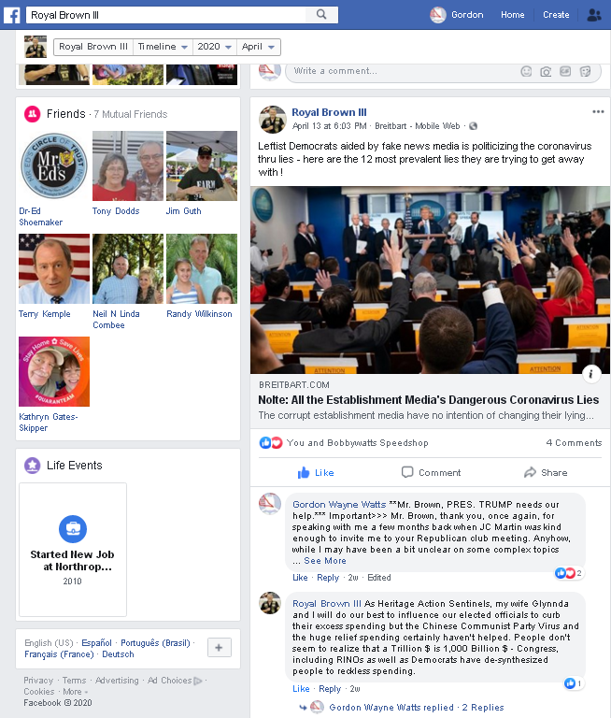

Zoom view, following page...

Zoom view of screenshot:

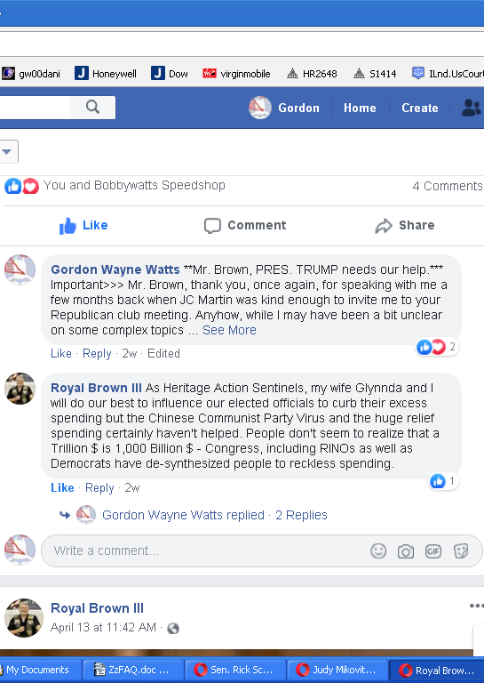

More facts & documented sources follow...

(17) Polk County resident, Jim Sapp, Expert Radio Communications Technician – Telecommunications engineering – OWNER: Lakeland Specialty Communications – Amateur (Ham) Radio operator, call sign: WB4ONX – QUOTE: “Some one today asked my opinions [] on a couple of subjects. ? [] Our power grid is vulnerable to EMF [] attacts[sic].congress let's fix it. [] Let's close the border now. [] Student loan forgiveness under certain conditions yes. [] 3.5 trillion Bill [] Hell no. [] Give illegal border aliens ss benefits [] Hell no”
LINK: https://www.Facebook.com/WB4ONX/posts/10220152630549544?comment_id=10220152812674097
Archive-1: https://GordonWatts.com/FannyDeregulation/JimSapp-brief-quote_FACEBOOK.pdf
Archive-2: https://GordonWayneWatts.com/FannyDeregulation/JimSapp-brief-quote_FACEBOOK.pdf
Archive-3: https://ContractWithAmerica2.com/FannyDeregulation/JimSapp-brief-quote_FACEBOOK.pdf
Archive-4: https://Archive.vn/HFS7Z
Archive-5: http://Web.Archive.org/web/20211026221931/https://gordonwatts.com/FannyDeregulation/JimSapp-brief-quote_FACEBOOK.pdf
Archive-6: https://Web.Archive.org/web/20211026221727/https://contractwithamerica2.com/FannyDeregulation/JimSapp-brief-quote_FACEBOOK.pdf

COMMENTARY: While the quote above may look “unprofessional,” let me assure readers 2 things: First, on just short notice, I asked Jim (a constituent in FLORIDA'S 15TH U.S. Congressional District – my district too) to give me a supportive public statement so we can “join voices” and “collectively” ask our Federal (and State) lawmakers to STOP harmful, inflationary excessive pork spending – thus, Jimmy's brief Facebook note isn't as professional as, say, Jim McGuire's quote in the parallel “grid” list of supporters, because Jimmy's a very busy business owner. SECONDLY, however, please take note of ONE THING: As smart as I am (see my creds elsewhere: United Electronic Institute, Valedictorian), Jim is my mentor and thus far smarter all things electronic. As BUZZFILE says, Jimmy's been in business for approximately thirty-three (33) years – as I recall, and is probably as smart as I estimate – or smarter:
LINK: https://wireless2.FCC.gov/UlsApp/UlsSearch/license.jsp?licKey=886682
LINK: https://www.BuzzFile.com/business/Lakeland-Specialty-Communications-863-683-7622
Archive-1: https://Archive.vn/tgYb7
Archive-2: https://Web.Archive.org/web/20211025032613/https://www.buzzfile.com/business/Lakeland-Specialty-Communications-863-683-7622
OFFICIAL FACEBOOK: https://Business.Facebook.com/LakelandSCommunications
OFFICIAL WEBSITE: http://www.RadioDiscounters.com

In case the page is down, here's are the 3 key panes in screenshot form of Jim's quote:

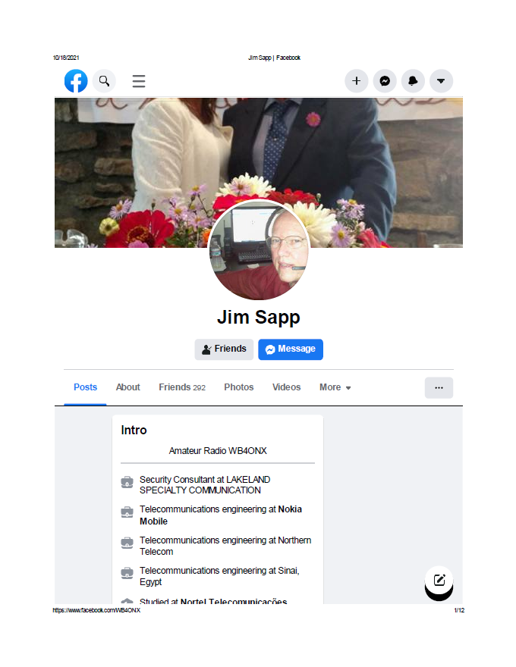
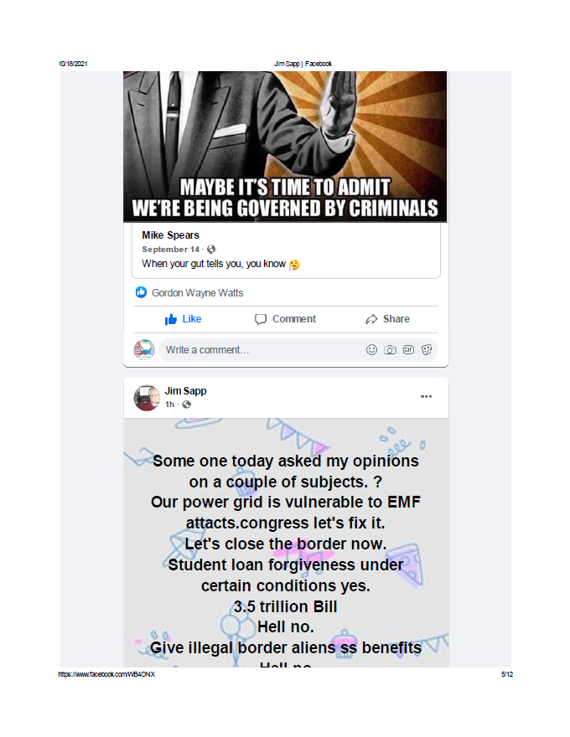
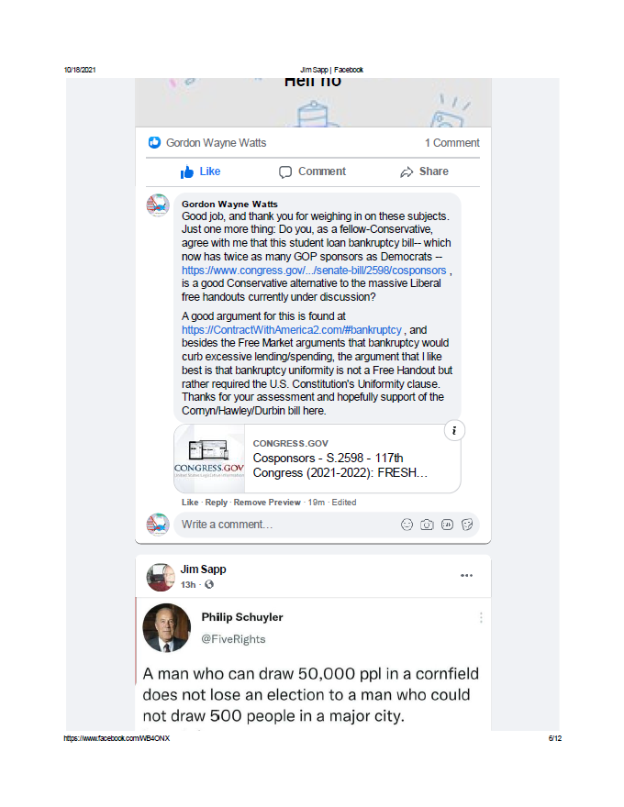
(18) Paul Hatfield, Vice President, Faith Based Republican Club of West Polk Cty., Fla., Club Chaplain, and CFCA (Christian Financial Advisors Association) financial advisor, also supports cutting excessive pork spending.

Comments: Paul is a financial expert by profession, thus his support for cutting pork is based on more than his mere “political leanings,” and should be trusted.

Paul, VP, Faith Based Republican Club of West Polk (Fla), who offered his support of S.2598 (see other “supporter” lists) also, in a “reply to all” in a very lengthy thread to numerous lawmakers—offers detailed & explicit support of my Press Inquiry to the U.S. Department of Education—in which I stated my explicit support for both student loan bankruptcy as well as cuts to pork higher ed subsidies for collegiate loans. Thus, we can infer not only Paul's support for spending cuts (supported by most GOP leaders & citizens), but also for the student loan bankruptcy bill discussed herein—which many view as a Conservative alternative to liberal policies.
Normally, private emails aren't public, but as many of you, lawmakers, already received a copy of Paul's “reply to all,” here, and implying public statement, this isn't a breach of privacy sharing his several public statements. PROOF:
Mirror-1: https://GordonWatts.com/FannyDeregulation/PaulHatfields-ReplyToAll_LAWMAKERS.pdf
Mirror-2: https://GordonWayneWatts.com/FannyDeregulation/PaulHatfields-ReplyToAll_LAWMAKERS.pdf
Mirror-3: https://ContractWithAmerica2.com/PaulHatfields-ReplyToAll_LAWMAKERS.pdf
Archive-4: https://Archive.vn/GLbxk (Clips after first page, but included as confirmatory proof)
Archive-5: https://Web.Archive.org/web/20211126032744/https://contractwithamerica2.com/FannyDeregulation/PaulHatfields-ReplyToAll_LAWMAKERS.pdf

((19)) John R. Anderson, a constituent of Congressman Franklin, residing in U.S. Congr. Dist. FL-15
Do Congressman Franklin's constituents matter? Besides all the right-leaning Conservative Republicans who support cutting excess pork spending, my good friend, John R. Anderson, a Democrat who lives in my U.S. Congressional District, FL-15, represented by U.S. Rep. C. Scott Franklin (R-15), also agrees with the rest of us. (See quote below: “Cut pork and the NDA. Congressman Franklin cares more about Afghanistan than district 15. What ever happened to make America Great?”) After I informed my congressman, on his Facebook, that earth's protective magnetic field is collapsing, and that he would need to “support grid upgrade legislation, cuts to pork spending to fund it, and vocally support S.2598, the bankruptcy defense bill which would make key higher ed pork subsidy cuts politically viable,” John responded in kind:

John Anderson said: “Nailed it Gordon Wayne Watts - Like my sales managers have always said - know the difference between activity and productivity. I saw the solar flare notes from NASA and read this is only the beginning of an 11 year cycle of solar flares that can cause MAJOR problems to navigation and communications. [] Cut pork and the NDA. Congressman Franklin cares more about Afghanistan than district 15. What ever happened to make America Great?” [Boldface and Highlight for clarify – not in original.]

Gordon Wayne Watts responded: “John Anderson -- as my grid research confirms, the solar cycle is projected to increase and peak in a few years while the protective geomagnetic field is slowly but surely collapsing... aa [sic] we head into a pole flip-- a phenomenon which earth encounters every 100 thousand years or so. Will you call his office as I ask folks on my recent wall post, tagging you...and ask others to do likewise?”

John Anderson replied: “Gordon Wayne Watts Yes. This world is about to go back to 1513 if navigation and communications are disrupted. Instead this congressman is playing on the fears of people and supporting violence against our democracy and the democratic process (which he swore to uphold as a military officer and as a congressman). He has failed on both.”

LINK: https://Facebook.com/story.php?story_fbid=270958745037132&id=100063690264265
Caveat: Congressman Franklin has “limited viewership” of comments, so that you might have to be on my friend's list to see it. See below for unredacted PDF prints:
Archive-1: https://GordonWatts.com/JohnAnderson-conversation_RepFranklinFACEBOOK.pdf
Archive-2: https://GordonWayneWatts.com/JohnAnderson-conversation_RepFranklinFACEBOOK.pdf
Archive-3: https://ContractWithAmerica2.com/JohnAnderson-conversation_RepFranklinFACEBOOK.pdf
Archive-4: https://Web.Archive.org/web/20211116215826/https://contractwithamerica2.com/JohnAnderson-conversation_RepFranklinFACEBOOK.pdf
Archive-5: See below for screenshots...

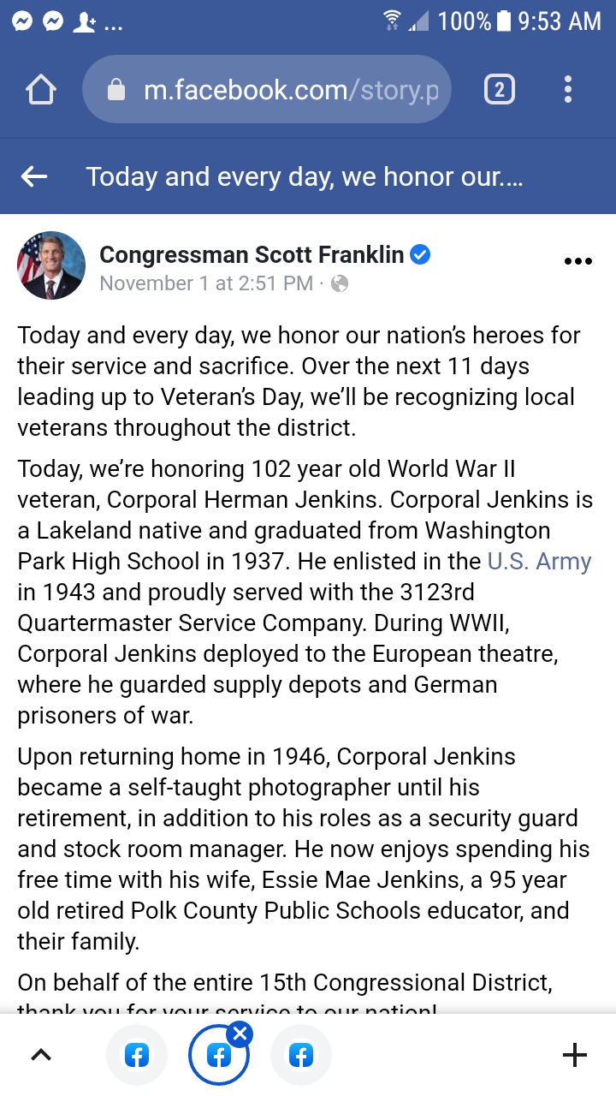
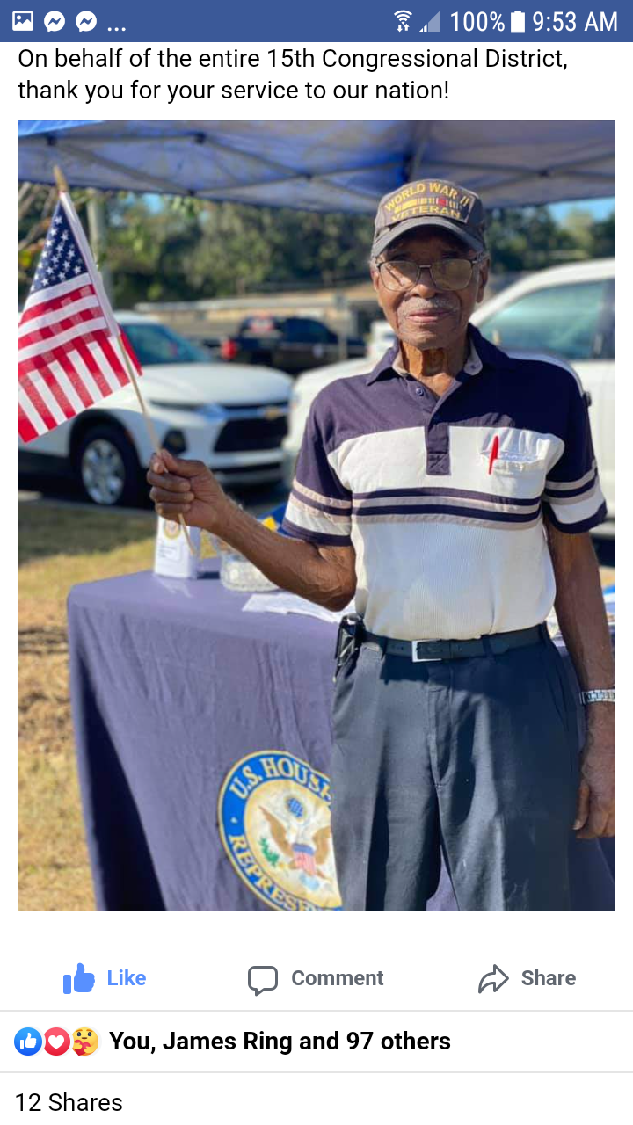
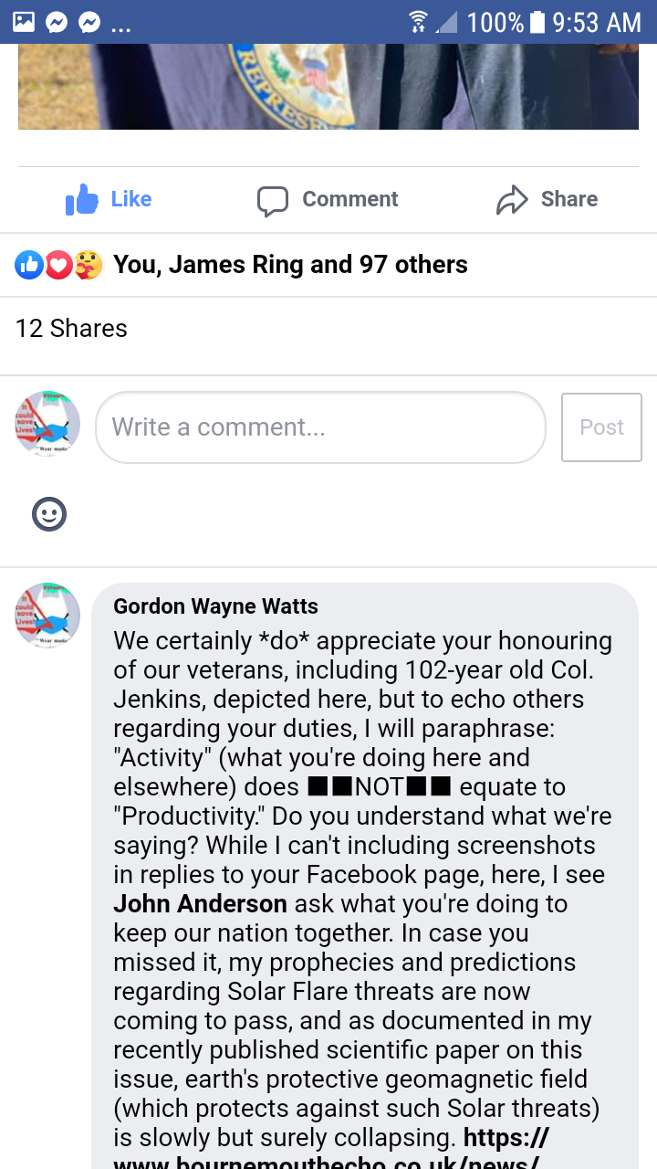
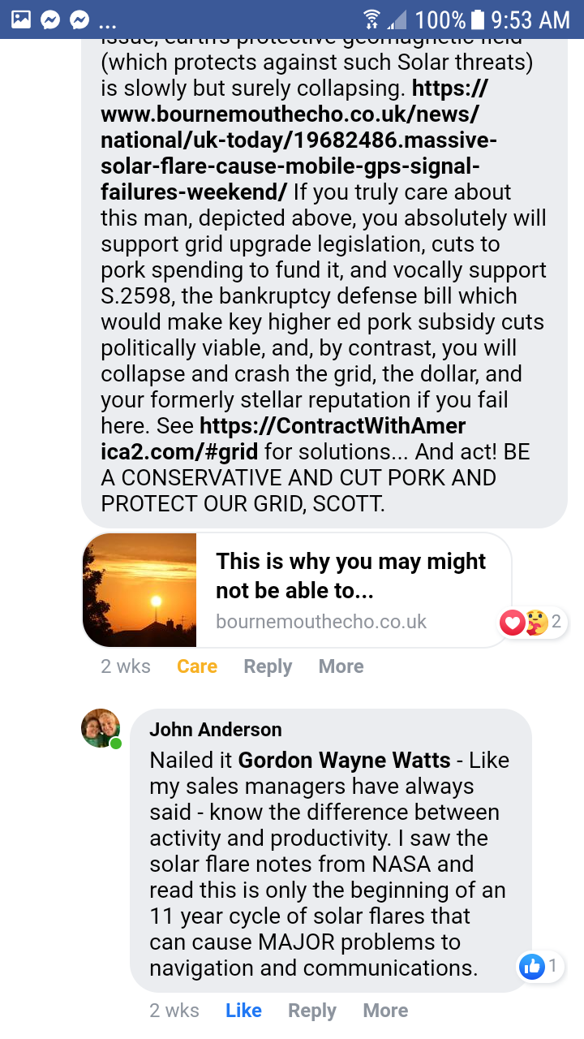
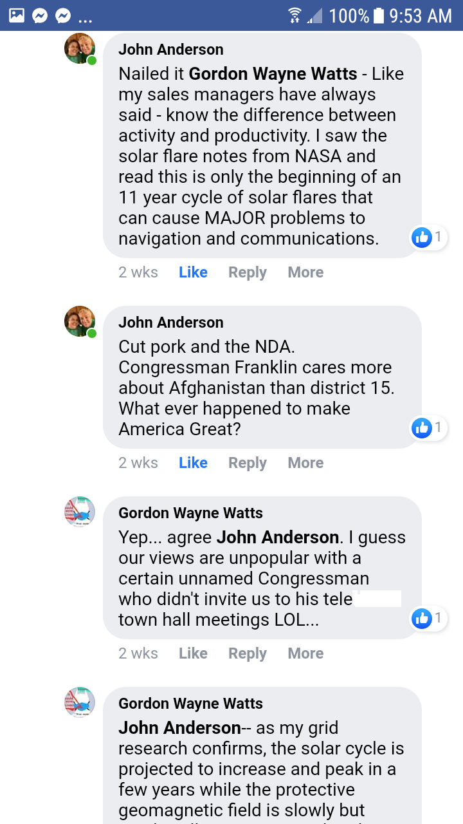
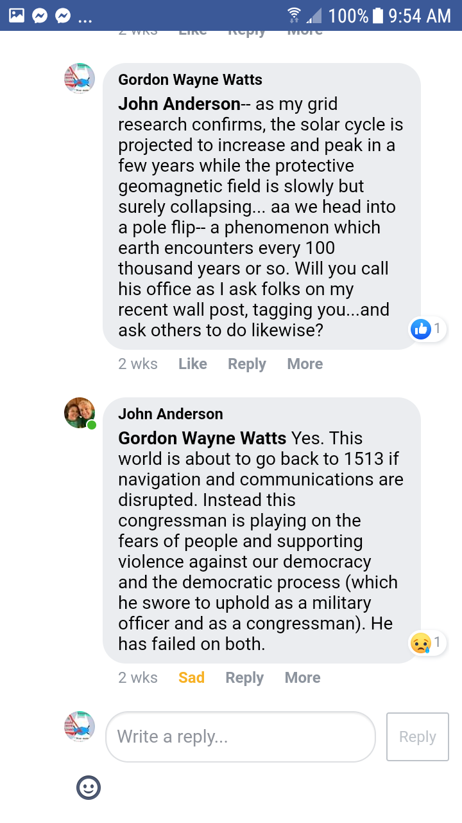
(20) Many others: Ask petition-writer, Gordon Wayne Watts, for a list of friends who email and Facebook him—and others—about this. (Note to self: Crazy Robert William “Bob” Hartung's many emails; many Facebook friends of Mike Schmidt who “came out of the woodwork” in support of him when he was planning to run against Ross Spano in the GOP primary for Fla. Dist. 15, U.S. House of Representatives; “OpenTheBooks” private advocacy website regarding pork spending excesses; friends of both political parties who are opposed to endless wars, which [[a]] costs lives of American servicemen and servicewomen; [[b]] cost goodwill with other nations; and [[c]] cost Trillions, if not TENS of Trillions of precious and limited taxpayer dollars; Etc.) Many other friends and neighbours of Gordon W. Watts regularly report to him that they are disgusted with the irresponsibly reckless spendthrift spending habits of lawmakers (of both parties) who spend/waste our taxpayer dollars “like drunken sailors.” (Apologies to all drunken sailors for the comparison!) Too numerous to name, but ask them—if you are not afraid!

(21) Conservative writer, Gordon Wayne Watts (~-_myself!_-~) (UPDATE with links to columns, etc.)(Regularly complains of obscenely excessive spending by American lawmakers, and laments that this pushes the U.S.A. toward an inevitable crash of the U.S. Dollar if this poison trend is not reversed. Does so by several means, including, but not limited to, published columns[[*-*]] and letters to the editor, social media, regular calls, visits, & e-mails to Federal lawmakers, occasional postal and electronic mail to The President, and his own web-wring. Author of this compilation of spending cuts supporters and various petitions to that same end. Is the same “Gordon Wayne Watts,” heavyweight conservative, who—in losing a 4-3 case at the Florida Supreme Court, almost won the legendary pro-life Terri Schiavo case—all by himself—doing better even than former Fla. Gov. Jeb Bush, who lost 7-0 before the same panel and on the same subject matter.) SOURCES for Gordon Wayne Watts – the text of TWO (2) VERSIONS of your 'Loan Limits' bill (reversing Boehner's bad bill!) is HERE, Mr. President –and included in the attachments with this data-sheet:
Download Mirror-1: https://GordonWatts.com/BILLS-116hr-GWW-proposed-ih.pdf and here:
Download Mirror-2: https://GordonWayneWatts.com/BILLS-116hr-GWW-proposed-ih.pdf and
Download Mirror-3: https://ContractWithAmerica2.com/BILLS-116hr-GWW-proposed-ih.pdf and
ARCHIVED:
https://Web.Archive.org/web/20200701044851/https://GordonWatts.com/BILLS-116hr-GWW-proposed-ih.pdf
...here, too: http://Archive.vn/wip/Sm730 – Oops, seems to have only gotten 1st page via PDF. Trying again:
Apparently an HTML archive: http://archive.vn/wip/hbd7J
Switching back to Wayback machine: https://Web.Archive.org/web/20200701051512/https://GordonWayneWatts.com/BILLS-116hr-GWW-proposed-ih.pdf

[[*-*]] My published columns:

** "A Polk Perspective: Fix our bankrupt policy on student debt," By Gordon Wayne Watts, Guest columnist, The Ledger , August 04, 2016; FAIR USE *.pdf cache-1 **and** FAIR USE *.pdf cache-2
** "Polk Perspective: Rescue taxpayers from mounting student debt," By Gordon Wayne Watts, Guest columnist, The Ledger , November 16, 2018; FAIR USE *.pdf cache-1 **and** FAIR USE *.pdf cache-2
** "Polk Perspective: Offer relief for taxes dressed up as ’loans’," By Gordon Wayne Watts, Guest columnist, The Ledger , November 19, 2019; FAIR USE *.pdf cache-1 **and** FAIR USE *.pdf cache-2

** PLAGIARISM, Lol... – Key quote from my 11-16-2018 column, above, says: “Collegiate debt, now almost $2 trillion, is almost 10 percent of total U.S. debt. I predict we will crash the U.S. dollar if we ignore “crazy Gordon” one more time.” ODDLY-ENOUGH, as mentioned above, Sec. Betsy DeVos, in her 11-27-2018 speech, said – and I quote her – that: “Today, FSA's portfolio is nearly 10 percent of our nation's debt. [] Stop and absorb that for a moment. Ten percent of our total national debt. [] The student loan program is not only burying students in debt, it is also burying taxpayers and it's stealing from future generations.” – It seems quite obvious that DeVos copied me here – “borrowed” this phrase & idea from my own column – which it appears she saw eleven (11) days earlier – and did not credit me for the “plagiarism,” here, LOL. However, in all fairness, her quote – while “borrowing” from my column, just days earlier – is not illegal (it's covered by Fair Use), and – I'm flattered that my ideas would be used. – In my 11-19-2019 column, above, I called her out on this: “Apparently, in response to my column, U.S. Secretary of Education Betsy DeVos, in her speech 11 days later, repeated my complaints that “collegiate debt, now almost $2 trillion, is almost 10 percent of total U.S. debt,” so I got the last laugh, here. – But, in all seriousness, as slow and unreliable as she is to work with me for a solution, we're on the same side, and need to work harder—to fix the soaring tuition inflation, oppressive college debt, and the threat this burden places on taxpayers, students, and the economy—as it threatens to crash the dollar and further alienate Americans—who already district their (our) government. [[It is possible—also—that her “plagiarism,” above was a mere coincidence, as in “brilliant minds think alike.” Given the stark similarities & timing, that seems statistically unlikely / improbable, but it is not impossible.]]

WATTS says: American Higher Education is an “EPIC FAILED LENDING SYSTEM” that—obviously—must be destroyed, abolished, and (possibly) replaced by methods which worked in the past: Getting the government OUT of the lending business, and letting the Free Market work its magic—and for those who disagree, please recall that THIS method worked before, and it will work AGAIN—if employed. – EXPANDED resources:

* “A Polk Perspective: Fix our bankrupt policy on student debt,” By Gordon Wayne Watts, Guest columnist, The Ledger, August 04, 2016,
LINK: https://www.TheLedger.com/opinion/20160804/a-polk-perspective-fix-our-bankrupt-policy-on-student-debt
Archive-1: https://Archive.vn/geCIO
Archive-2: https://Web.Archive.org/web/20201024160909/https://www.theledger.com/opinion/20160804/a-polk-perspective-fix-our-bankrupt-policy-on-student-debt (text-searchable HTML cache archive)
Archive-3: https://Web.Archive.org/web/20201024160638/https://www.theledger.com/opinion/20160804/a-polk-perspective-fix-our-bankrupt-policy-on-student-debt (image-based screenshot cache archive)
Archive-4: https://GordonWatts.com/TheLedger-Online-PDF-FairUse-cache-WATTS-GuestColumn-Thr04Aug2016.pdf
Archive-5: https://GordonWAYNEwatts.com/TheLedger-Online-PDF-FairUse-cache-WATTS-GuestColumn-Thr04Aug2016.pdf
Archive-6: https://ContractWithAmerica2.com/TheLedger-Online-PDF-FairUse-cache-WATTS-GuestColumn-Thr04Aug2016.pdf
Archive-7: https://Web.Archive.org/web/20201017125702/https://GordonWatts.com/TheLedger-Online-PDF-FairUse-cache-WATTS-GuestColumn-Thr04Aug2016.pdf (text-searchable PDF cache archive with images)

Note: To document the following quotes: “In May 2014 U.S. Rep. Dennis Ross told those listening to a “teletown” hall meeting that if college students can’t repay their loans from a private bank, we should “go back” to our prior laws and allow them to declare bankruptcy...At the teletown hall meeting, Ross also said that we needed to “get the government out of the business of loaning the money because we’re loaning taxpayer dollars.”,” in my Aug. 04, 2016 column, above, I had to provide The Ledger with an audio of the Public town hall meeting (not illegal to record: It was public), and said audio can be found at the links below:

DOWNLOAD MIRRORS:
- YouTube: https://www.YouTube.com/watch?v=D7Z9wWWjTJo
- Twitter: https://Twitter.com/Gordon_W_Watts/status/720318286949273600
- Facebook-NOTES: https://www.Facebook.com/notes/gordon-wayne-watts/brave-republican-congressman-breaks-with-party-admits-college-loans-deserve-bank/10153392004810248
- Facebook-VIDEO: https://www.Facebook.com/GordonWayneWatts/videos/10207696141426468/
- WMV – DOWNLOAD Mirror-1: https://GordonWatts.com/FannyDeregulation/DennisRoss-TeleTHM-Wed21May2014_WMV.wmv (28.8 MB)
- WMV – DOWNLOAD Mirror-2: https://GordonWayneWatts.com/FannyDeregulation/DennisRoss-TeleTHM-Wed21May2014_WMV.wmv (28.8 MB)
- MP4 – DOWNLOAD Mirror-1: https://GordonWatts.com/FannyDeregulation/DennisRoss-TeleTHM-Wed21May2014_WMV_mobile-phone-mpeg4.mp4 (17.6 MB)
- MP4 – DOWNLOAD Mirror-2: https://GordonWayneWatts.com/FannyDeregulation/DennisRoss-TeleTHM-Wed21May2014_WMV_mobile-phone-mpeg4.mp4 (17.6 MB)
- Archive-1 – NOTES: https://Archive.vn/wip/Yct1J
- Archive-2 – NOTES: https://Web.Archive.org/web/20201016134859/https://www.facebook.com/notes/gordon-wayne-watts/brave-republican-congressman-breaks-with-party-admits-college-loans-deserve-bank/10153392004810248
- Archive of YouTube: https://Web.Archive.org/web/20160917203439/https://www.YouTube.com/watch?v=D7Z9wWWjTJo
- Archive of Facebook: https://Web.Archive.org/web/20201016135104/https://www.facebook.com/GordonWayneWatts/videos/10207696141426468/
- Archive of WMV video file download: https://Web.Archive.org/web/20201016135336/https://gordonwatts.com/FannyDeregulation/DennisRoss-TeleTHM-Wed21May2014_WMV.wmv
- Archive of MP4 video file download: https://Web.Archive.org/web/20201016135512/https://gordonwatts.com/FannyDeregulation/DennisRoss-TeleTHM-Wed21May2014_WMV_mobile-phone-mpeg4.mp4

* “Polk Perspective: Rescue taxpayers from mounting student debt,” By Gordon Wayne Watts, Guest columnist, The Ledger, November 16, 2018,
LINK: https://www.TheLedger.com/opinion/20181116/polk-perspective-rescue-taxpayers-from-mounting-student-debt
Archive-1: https://Archive.is/YrNST
Archive-2: https://Web.Archive.org/web/20190215234600/https://www.TheLedger.com/opinion/20181116/polk-perspective-rescue-taxpayers-from-mounting-student-debt
Archive-3: https://GordonWatts.com/TheLedger-Online-PDF-FairUse-cache-WATTS-GuestColumn-Fri16Nov2018.pdf
Archive-4: https://GordonWAYNEwatts.com/TheLedger-Online-PDF-FairUse-cache-WATTS-GuestColumn-Fri16Nov2018.pdf
Archive-5: https://ContractWithAmerica2.com/TheLedger-Online-PDF-FairUse-cache-WATTS-GuestColumn-Fri16Nov2018.pdf
Archive-6: https://Web.Archive.org/web/20201024165023/https://gordonwaynewatts.com/TheLedger-Online-PDF-FairUse-cache-WATTS-GuestColumn-Fri16Nov2018.pdf (text-searchable PDF cache archive with images)

* “Polk Perspective: Offer relief for taxes dressed up as ’loans’,” By Gordon Wayne Watts, Guest columnist, The Ledger, November 19, 2019,
LINK: https://TheLedger.com/opinion/20191119/polk-perspective-offer-relief-for-taxes-dressed-up-as-loans
Archive-1: https://Archive.vn/2gdEW
Archive-2: https://Web.Archive.org/web/20200618074433/https://TheLedger.com/opinion/20191119/polk-perspective-offer-relief-for-taxes-dressed-up-as-loans
Archive-3: https://GordonWatts.com/TheLedger-Online-PDF-FairUse-cache-WATTS-GuestColumn-Tue19Nov2019.pdf
Archive-4: https://GordonWAYNEwatts.com/TheLedger-Online-PDF-FairUse-cache-WATTS-GuestColumn-Tue19Nov2019.pdf
Archive-5: https://ContractWithAmerica2.com/TheLedger-Online-PDF-FairUse-cache-WATTS-GuestColumn-Tue19Nov2019.pdf
Archive-6: https://Web.Archive.org/web/20201017225631/https://GordonWatts.com/TheLedger-Online-PDF-FairUse-cache-WATTS-GuestColumn-Tue19Nov2019.pdf (text-searchable PDF cache archive with images)

– with the arguments for passage of bill into law in these columns, and other resources here:
https://GordonWatts.com and https://GordonWayneWatts.com and https://ContractWithAmerica2.com

“Inside” links:
* https://Facebook.com/GordonWayneWatts
* https://YouTube.com/GordonWayneWatts
* https://Twitter.com/Gordon_W_Watts

“Outside” links:
* https://StudentLoanJustice.org (Official page)
* https://Twitter.com/AlanSLJ (Regularly-updated Twitter feed)
* https://m.Facebook.com/groups/SLJGroup (Facebook group for Mobile devices/iPhones)
* https://Facebook.com/groups/SLJGroup (Facebook group)
* https://Change.org/CancelStudentLoans (The legendary “million signature” petition—nearing 1M now.)

Gordon Wayne Watts
https://GordonWatts.com / https://GordonWayneWatts.com / https://ContractWithAmerica2.com
Editor-in-Chief, The Register (A Conservative publication)
National Director, CONTRACT WITH AMERICA: PART II^{(TM)}

(22) I assert that God Almighty is on my side on this: Hashtag: #Stewardship, anyone?
“Be sure you know the condition of your flocks, give careful attention to your herds;” Proverbs 27:23 (NIV)
>> Sovereign King JESUS speaking >> “For which of you, desiring to build a tower, does not first sit down and count the cost, whether he has enough to complete it?” Luke 14:28 (ESV) “If then you have not been faithful in the unrighteous wealth, who will entrust to you the true riches?” Luke 16:11 (ESV) << Sovereign King JESUS speaking << WORDS of OUR LORD in RED. “Moreover, it is required of stewards that they be found faithful.” 1 Corinthians 4:2 (ESV) “So then each of us will give an account of himself to God.”Romans 14:12(ESV) Hashtag: #JudgmentDay BEARS REPEATING: Hashtag: #Stewardship!..

(23) Dave Ramsey, well-known right-wing, Christian Conservative aka “America's trusted voice on money,” is a National best-selling finance author (including The Total Money Makeover, The Dummy's Complete Guide to Money, & 3 other New York Times bestsellers), speaker, businessman, and American radio show host, whose 3-hour syndicated radio program & podcast, The Dave Ramsey Show (Mon.—Fri., 2-5 PM, ET) is heard on more than 500 radio stations throughout the United States and Canada, in podcast format, on iHeartRadio, the Dave Ramsey Show iOS application, live on YouTube, as well as live audio & video on his eponymous and namesake website, DaveRamsey.com – As of 2008, it is one of the top ten most-listened-to radio shows—clocking in at number 6 on this Talkers.com ranking:
https://Web.Archive.org/web/20080324045418/http://www.talkers.com/main/index.php?option=com_content&task=view&id=17&Itemid=34

Dave Ramsey – a world-renowned finance expert – has this to say about American Higher Education lending system: Both the PSLF (Public Service Loan Forgiveness) program –and the American Higher Education lending system, itself, are both EPIC FAILURES – here are exact quotes to verify:

QUOTE: “Less than 1% of applicants get their college debt forgiven, so the current student loan forgiveness program is an epic failure.”
SOURCE: Borrowed Future, Episode 6: Don’t Bank on Student Loan Forgiveness (41 minutes)
[Date: November 04, 2019]
LINK: https://www.DaveRamsey.com/blog/borrowed-future
Archive-1: https://Archive.vn/zyvHb
Archive-2: https://Web.Archive.org/web/20200804111757/https://www.DaveRamsey.com/blog/borrowed-future
Archive-3: https://GordonWatts.com/BorrowedFuturePodcast_DaveRamseyOFFICIAL_PDF.pdf
Archive-4: https://GordonWayneWatts.com/BorrowedFuturePodcast_DaveRamseyOFFICIAL_PDF.pdf

Cross-post: https://www.Stitcher.com/podcast/dave-ramsey/borrowed-future/e/65034455?autoplay=true
– From: https://www.Stitcher.com/podcast/borrowed-future
Archive-1: https://Archive.vn/ue0XX
Archive-2: https://Web.Archive.org/web/20201026032413/https://www.stitcher.com/podcast/dave-ramsey/borrowed-future/e/65034455
Archive-3: https://GordonWatts.com/DaveRamsey-PSLF-quote_PDF.pdf
Archive-4: https://GordonWayneWatts.com/DaveRamsey-PSLF-quote_PDF.pdf
EDITOR'S NOTE: This quote is included in the “spending cuts” paper, here, because it implies and suggests that Dave Ramsey is suggesting a 100% TOTAL “cut” in tax-dollar spending for Higher Education loans—by declaring it a “failure” – and thus implying (quite correctly, I might add) that the Lending System be ABOLISHED and DESTROYED. Though he doesn't say it, he clearly implies it, and **_I_** say it.

SOURCE: “The Federal Student Loan Program Is an Epic Failure! (Hour 2)” [Date: July 24, 2019]
LINK: http://DaveRamsey.Ramsey.LibSynPro.com/07242019-h2
Cross-post LINK: https://www.MixCloud.com/thedaveramseyshow/the-federal-student-loan-program-is-an-epic-failure-hour-2/
Archive-1: https://Archive.vn/Qdkpb
Archive-2: https://Web.Archive.org/web/20190802151541/http://DaveRamsey.Ramsey.LibSynPro.com/07242019-h2
Archive-3: https://GordonWatts.com/DaveRamsey-EpicFail-Hour2_PDF.pdf
Archive-4: https://GordonWayneWatts.com/DaveRamsey-EpicFail-Hour2_PDF.pdf

SOURCE: “DAVE RANT: The Student Loan Program Is an Epic Failure! (Hour 3)”
[Date: December 05, 2019]
LINK: https://www.DaveRamsey.com/show/archives/2019-12-05?mode=watch
Cross-post LINK: https://www.ListenNotes.com/podcasts/the-dave-ramsey-show/dave-rant-the-student-loan-uGnybdX5f0E/amp/
Cross-post LINK: https://www.Podgist.com/dave-ramsey-show/dave-rant-the-student-loan-program-is-an-epic-failure-hour-3/index.html
Archive-1: https://Archive.vn/E6uo1
Archive-2: https://Web.Archive.org/web/20201026042709/https://www.daveramsey.com/show/archives/2019-12-05
Archive-3: https://GordonWatts.com/DaveRamsey-EpicFail-Hour3_PDF.pdf
Archive-4: https://GordonWayneWatts.com/DaveRamsey-EpicFail-Hour3_PDF.pdf

(24) Alan Collinge – Nationally-recognised Student Debt expert (Google him if you doubt his credentials) agrees with this writer (Gordon Wayne Watts) – and Dave Ramsey (see immediately above), in his claims that American Higher Education is a “FAILED LENDING SYSTEM”:

QUOTE: “We are left with a predatory, hyper-inflationary lending product. At this point, I consider it a wholly failed lending system...The Republicans have failed us, and the Democrats have been not much better. It has been a real sham, politically, and as a result student loans have continued to grow...I can only hope that both parties will converge on this solution. There is no better opportunity than this pandemic to reset this failed lending system, massively stimulate the economy, free the 44 million Americans from the jaws of this nationally threatening lending system, and replace it with a more rational and just funding model for higher education in this country.”
SOURCE: “A Failed Lending System,” by Alan Collinge, interviewee, FrankInterviews (FrankNews.us), Wednesday, 30 September 2020,
LINK: http://www.FrankNews.us/interviews/455/a-failed-lending-system
Archive-1: https://Archive.vn/MKvhN
Archive-2: https://Web.Archive.org/web/20201027030633/http://www.franknews.us/interviews/455/a-failed-lending-system
Archive-3: https://GordonWatts.com/FrankNews-AlanCollinge-interview_PDF.pdf
Archive-4: https://GordonWayneWatts.com/FrankNews-AlanCollinge-interview_PDF.pdf

QUOTE: “There are 44 million federal student loan borrowers in the country carrying about $1.5 Trillion in federal student loan debt. According to Education Secretary Betsy DeVos last year, 75% of these people were either unable to make payments on their loans, or were paying, but their balances were going up. Trump appointee Wayne Johnson, who ran the federal lending system under DeVos, said that this was closer to 80% just before covid-19 hit. Also, we now know that the class of 2004 are defaulting on their loans 40% of the time. This class, however, was only borrowing a third of what students are borrowing today. It is no stretch to say that the default rate for more recent borrowers will surely be 70% if not higher…and even higher still considering the pandemic and the uneven economic recovery that we are seeing. By comparison, The default rate for sub-prime home mortgages was less than 20%. [] To be blunt: it is a catastrophically failed lending system, and this was true before the pandemic.” [Editor's Note: Emphasis added above, in boldface and underline, for clarity. Not in original.]
SOURCE: https://StudentLoanJustice.org/president-trump-cancel-student-loans-by-executive-order/

QUOTE: “His message, one he has dedicated his life to, calls for the federal government to end student loan repayments for all Americans. [] “It’s a failed lending system,” he says.” [Editor's Note: Emphasis added above, in boldface and underline, for clarity. Not in original.]
SOURCE: “A Protester Fighting for Student Loan Forgiveness Stands Alone in the Streets, but is Backed by Thousands Online,” by Megan Carpenter (Wisconsin), SpectrumNews1.com, PUBLISHED 5:18 PM ET Aug. 21, 2020,
LINK: https://SpectrumNews1.com/wi/madison/news/2020/08/21/student-loan-justice-debt-forgiveness-protest

QUOTE: “JACKSON, Miss. (WJTV) – Leaders of an organization want student loans to be canceled. [] Student Loan Justice founder, Alan Collinge, said the student loan debt has grown to nearly $2 trillion in the United States. He called it a failed lending system by the federal government. [] Collinge claims students in the State of Mississippi owe $18 billion in student loan debt, while students in the City of Jackson alone owe $1 billion. [] “One in seven Americans owe in student loans. The population of Mississippi is three million people, so that’s about 430,000 people owing an average about $40,000 a piece.” [] Collinge wants President Donald Trump to cancel student loans by executive order.” [Editor's Note: Emphasis added above, in boldface and underline, for clarity. Not in original.]
SOURCE: “Organization calls for cancellation of student loans,” by: Jade Bulecza, WJTV.com (WJTV-12-News), Posted: September 09, 2020 / 04:53 PM (CDT) / Updated: September 09, 2020 / 04:53 PM (CDT), LINK: https://www.WJTV.com/news/organization-calls-for-cancellation-of-student-loans/

QUOTE: “Before the pandemic, this was a CATASTROPHICALLY FAILED lending system. The default rate for 2004 borrowers is 40%, and these people were borrowing less than a third of what today's students are borrowing. According to the recently resigned Chief Operating Officer of the lending program, 80% of all borrowers were never going be able to repay their loans...before the pandemic!...Some experts even believe that debt cancellation is the only way to avoid a depression! [] THE PRESIDENT MUST RESET THIS FAILED LENDING SYSTEM. [] President Trump has decried the fact that the government was making so much profit on the loans. The President should create a far more efficient higher education financing system that doesn’t wreck the citizens, hyper-inflate the price of college, and enable a national threat such as what the Department of Education and its financial partners have become.” [Editor's Note: Emphasis added above, in boldface and underline, for clarity. Not in original.]
SOURCE: https://www.Change.org/p/cancel-student-loans-now-to-save-the-economy
SOURCE: https://Change.org/CancelStudentLoans
Archive-1: https://Archive.vn/70lpR
Archive-2: https://Web.Archive.org/web/20201020222234/https://www.change.org/p/covid-19-economic-response-cancel-student-loans-by-executive-order?utm_source=share_petition&utm_medium=custom_url&recruited_by_id=1a06fd20-3beb-0130-63cd-38ac6f16d25f

QUOTE: “COLUMBUS, Ohio (WSYX/WTTE) — A petition wanting President Trump to cancel federal student loan debt via executive order has gained more than a half-million signatures since its inception, earlier this year. [] Student loan debt now sits at about $1.6 trillion nationwide, with about 44 million Americans owing some amount of money. [] "This is a failed lending system and, at this point, it’s a national threat economically," Alan Collinge, creator of the petition and founder of the grassroots group Student Loan Justice. "The fact of the matter is the President holds all the executive authority he needs."” [Editor's Note: Emphasis added above, in boldface and underline, for clarity. Not in original.]
SOURCE: “Petition calling for student loan cancellation gains more than 500k signatures,” by Jesse Pagan, ABC6OnYourSide.com (ABC-6, WSYX and WTTE), Tuesday, 08 September 2020,
LINK: https://ABC6OnYourSide.com/news/local/petition-calling-for-student-loan-cancellation-gains-more-than-500k-signatures

* * Alan Collinge's CREDENTIALS :
– Nationally-recognised Student Debt expert (Google him if you doubt his credentials)

QUOTE: “About Us [] WELCOME! We’re glad you found us. [] We are the oldest, largest, and only grassroots group in the nation fighting for student loan justice. We’ve been around for 15 years. We’ve been featured on 60 Minutes, in the New York Times, Wall Street Journal, CNN, CNBC, PBS, NPR, Fox News, MSNBC, Rolling Stone, VICE news, Fast Company, and many, many other places. We are non-partisan. Spread the word about this group. We are it. Unlike EVERY other loan in the country, student loans have been UNIQUELY stripped of bankruptcy protections, statutes of limitations, and other protections. The result is an unconstitutionally vicious, predatory, and hyper-inflationary lending system. [] THIS IS NOT RIGHT. WE DON’T HAVE TO TAKE THIS. [] We are fighting for the return of bankruptcy protections to student loans. The Founders called for bankruptcy rights in the Constitution. They are on our side. Having the THREAT of bankruptcy back on our side is absolutely KEY to this fight. Getting this right back (as it exists for all other loans in the country) will help you tremendously, whether you file for it or not. Thankfully, we now have two great bills to fight for: S.1414 (Senate), and HR 2648 (House). [] RIGHT NOW, WE ARE PUSHING THE PRESIDENT TO CANCEL STUDENT LOANS BY EXECUTIVE ORDER. WE CURRENTLY HAVE 236,000 SIGNATURES AND GROWING.”
[ Editor's Note: This is a bit 'dated' – aka 'outdated': The petition has far more than 236,000 signatures, and, at press time, is closing in on a Million signatures. – Also: Font size was changed a little to make it fit into this format, and the “pushing” link was added—as it appears to have been intended—not in original, but added for clarity. The font colours, boldface, and italics, however, were in original, and left 'as is'.” – Also: The 'double brackets' '[]', indicate a line-break in the original quote –and are added here & elsewhere to make paragraph line-breaks a little more compact & efficient. ]
LINK: https://StudentLoanJustice.org/about-us/
Archive-1: https://Archive.vn/wip/qNifU
Archive-2: https://Web.Archive.org/web/20200916101605/https://StudentLoanJustice.org/about-us/
Archive-3: https://GordonWatts.com/SLJ_AboutUs_PDF.pdf
Archive-4: https://GordonWayneWatts.com/SLJ_AboutUs_PDF.pdf

** Personal website: https://StudentLoanJustice.org
** Facebook group: https://Facebook.com/SLJgroup
** His “Million Signature” petition: https://Change.org/CancelStudentLoans
** His book: https://www.Amazon.com/Student-Loan-Scam-Oppressive-History/dp/0807042315
** His Wikipedia entry: https://en.Wikipedia.org/wiki/StudentLoanJustice.org

Proof of Alan M. Collinge's nationally-recognised status as a student debt expert:

Featured in CNN / Money's Gallery of HEROES alongside Warren Buffet

Link: https://Money.CNN.com/galleries/2008/news/0812/gallery.heroes_zeros_2008/5.html
Archive-1: https://Archive.vn/mbiz
Archive-2: https://Web.Archive.org/web/20200116202945/https://Money.CNN.com/galleries/2008/news/0812/gallery.heroes_zeros_2008/5.html
Archive-3: https://GordonWatts.com/AlanCollinge-CNN-Money-Hero-FEATURED_PDF.pdf
Archive-4: https://GordonWayneWatts.com/AlanCollinge-CNN-Money-Hero-FEATURED_PDF.pdf

Featured on CBS – QUOTE: “Graduation is a day of achievement and promise. But for two-thirds of every graduating class, the future includes serious debt. That can spiral out of control, as it did for Alan Collinge. [] "I graduated with degrees in aerospace engineering in 1999. I borrowed about $45,000 for school. Since that time, my student loan debt has exploded to where currently I owe about $103,000," Collinge explains...For some borrowers, the system is unforgiving. But it has worked well for lenders like Sallie Mae, which has 10,000 employees in 19 states and manages $123 billion in student loans. Sallie Mae declined to give 60 Minutes an on-camera interview, saying they didn't think they'd get a fair shake.”
SOURCE: “Sallie Mae's Success Too Costly?: Does The Lender's Success Come At Too Steep A Cost To Students And Taxpayers?,” by Daniel Schorn, CBS Correspondent (writer) and Lesley Stahl, CBS Correspondent (interviewer), CBS: 60 Minutes, May 05, 2006,
LINK: https://www.CbsNews.com/news/sallie-maes-success-too-costly
Archive-1: https://Archive.vn/wip/wcZkS
Archive-2: https://Web.Archive.org/web/20191112070639/https://www.CbsNews.com/news/sallie-maes-success-too-costly
Archive-3: https://GordonWatts.com/CBS-60-Minutes-Alan-Collinge-May-05-2006_PDF.pdf
Archive-4: https://GordonWayneWatts.com/CBS-60-Minutes-Alan-Collinge-May-05-2006_PDF.pdf

(25) DEAR LAWMAKERS: With 1—24, above, take this list & copies of all three (3) of my columns in The Ledger to House & Senate Lawmakers, & get this loan limits bill passed into law. If Pres. Obama could “lobby for” the sorry ACA & get it passed into law, you GOP lawmakers can lobby for this bill! Don't let Mr. Obama outdo you, all yo uso-called Conservative GOP lawmakers! Our nation depends on you: We must avert disaster and avoid crash of the dollar & collapse of the economy. Maybe ask GOP lawmakers to team up with Blue Dog Democrats and get back the “old” Joe Biden, who was a fiscal hawk in #2 above...or, maybe give up and see the dollar crash...LOL.
Gordon Wayne Watts, American citizen – and one of your constituents ///

P.S.: Here's another copy of the legislation that numerous American leaders have requested (see very top) – two (2) versions, if fact. (See below.)

116TH CONGRESS  1ST SESSION | H. R. 1 ( “Low Energy” version – flip over for the “FULL POWER” version. )

To amend the Higher Education Act of 1965 to begin weaning students, and taxpayer dollars, off of obscenely and dangerously high college loan limits ; aka, the: “Pres. TRUMP 'Limit on Student Loan Borrowing' Bill”
______________________

IN THE HOUSE OF REPRESENTATIVES

MAY 17, 2019
Mr. SPANO (for himself, Mr. DELANEY, Mr. KATKO, Ms. CASTOR and Ms. WILSON of Florida, Ms. BASS, Mr. COHEN, Mr. KILDEE, and Mr. GOHMERT) introduced the following bill; which was referred to the Committee on the Judiciary; and, then, to the Committee on Education & the Workforce
______________________

A BILL
To amend and extend the Higher Education Act of 1965.
Be it enacted by the Senate and House of Representatives of the United States of America in Congress assembled,

Section 1. SHORT TITLE.
This Act may be cited as the “Freedom from dangerous, risky, & very obscenely high Loan Limits Act of 2019.”

Section 2. PURPOSE.
This bill's purpose is to begin to reverse the adverse effects of §422 of H.R.507 (109th CONGRESS), the “College Access and Opportunity Act of 2005,” a chief cause of this crippling & massive college debt, which American college students are currently experiencing—and which costs taxpayers, who make and/or back such loans. Obscenely large higher education loans benefited only the banks & universities, and otherwise distorted the Free Market with increased subsidies, in the form of increases in taxpayer-backed college loans, and defeated the prior Conservative Free Market checks/balances against predatory lending, tuition inflation, etc.
[ Note: This is a fictitious bill, merely suggesting what should be done.
~Gordon Wayne Watts / GordonWatts.com / gordonWAYNEwatts.com ]

Section 3. LOAN LIMITS ; LOAN TERMS AND CONDITIONS.

(a) FEDERAL INSURANCE LIMITS.—Section 425(a)(1)(A) [20 U.S.C. 1075(a)(1)(A)] is amended—
(1) in clause (i)(I), by striking ‘‘$3,500’’ and inserting ‘‘$2,625’’; and
(2) in clause (ii)(I), by striking ‘‘$4,500’’ and inserting ‘‘$3,500’’.

(b) GUARANTEE LIMITS.—Section 428(b)(1)(A) [20 U.S.C. 1078(b)(1)(A)] is amended—
(1) in clause (i)(I), by striking ‘‘$3,500’’ and inserting ‘‘$2,625’’; and
(2) in clause (ii)(I), by striking ‘‘$4,500’’ and inserting ‘‘$3,500’’.

(c) LOAN LIMITS.—Section 464(a) [20 U.S.C. 1087dd(a)] is amended—
(1) in paragraph (2)(A)—
(A) by striking ‘‘$5,500’’ in clause (i) and inserting ‘‘$4,000’’; and
(B) by striking ‘‘$8,000’’ in clause (ii) and inserting ‘‘$6,000’’; and
(2) in paragraph (2)(B)—
(A) by striking ‘‘$60,000’’ in clause (i) and inserting ‘‘$40,000’’;
(B) by striking ‘‘$27,500’’ in clause (ii) and inserting ‘‘$20,000’’; and
(C) by striking ‘‘$11,000’’ in clause (iii) and inserting ‘‘$8,000’’.

Section 4. EFFECTIVE DATE; APPLICATION OF AMENDMENTS.
(a) Effective date.—The amendments made by this Act shall take effect immediately, e.g., on the date of the enactment of this Act.
(b) Application of amendments.—The amendments made by this Act shall apply to all public higher education loans (those made and/or guaranteed directly by the government) and all private loans, except in such cases where the private loans are tantamount and equal in terms to 'Credit Card' loans (e.g., lack all guarantees by the federal government for reimbursement in the event of default, have all standard consumer protections, such as statutes of limitations and bankruptcy on 'standard' terms, not to be confused with the 'Undue Hardship' standard). [[ “Low Energy” version – because this does NOT eliminate use of tax dollars, just reduce them. ]] ∅
- HR 1 IH
116TH CONGRESS  1ST SESSION | H. R. 1 ( “FULL POWER” version – flip over for the “Low Energy” version. )

To amend the Higher Education Act of 1965 to begin weaning students, and taxpayer dollars, off of obscenely and dangerously high college loan limits ; aka, the: “Pres. TRUMP 'Limit on Student Loan Borrowing' Bill”
______________________

IN THE HOUSE OF REPRESENTATIVES

MAY 17, 2019
Mr. SPANO (for himself, Mr. DELANEY, Mr. KATKO, Ms. CASTOR and Ms. WILSON of Florida, Ms. BASS, Mr. COHEN, Mr. KILDEE, and Mr. GOHMERT) introduced the following bill; which was referred to the Committee on the Judiciary; and, then, to the Committee on Education & the Workforce
______________________

A BILL
To amend and extend the Higher Education Act of 1965.
Be it enacted by the Senate and House of Representatives of the United States of America in Congress assembled,

Section 1. SHORT TITLE.
This Act may be cited as the “Freedom from dangerous, risky, & very obscenely high Loan Limits Act of 2019.”

Section 2. PURPOSE.
This bill's purpose is to begin to reverse the adverse effects of §422 of H.R.507 (109th CONGRESS), the “College Access and Opportunity Act of 2005,” a chief cause of this crippling & massive college debt, which American college students are currently experiencing—and which costs taxpayers, who make and/or back such loans. Obscenely large higher education loans benefited only the banks & universities, and otherwise distorted the Free Market with increased subsidies, in the form of increases in taxpayer-backed college loans, and defeated the prior Conservative Free Market checks/balances against predatory lending, tuition inflation, etc.
[ Note: This is a fictitious bill, merely suggesting what should be done.
~Gordon Wayne Watts / GordonWatts.com / gordonWAYNEwatts.com ]

Section 3. LOAN LIMITS ; LOAN TERMS AND CONDITIONS.

(a) FEDERAL INSURANCE LIMITS.—Section 425(a)(1)(A) [20 U.S.C. 1075(a)(1)(A)] is amended—
(1) in clause (i)(I), by striking ‘‘$3,500’’ and inserting ‘‘$ 0.oo’’; and
(2) in clause (ii)(I), by striking ‘‘$4,500’’ and inserting “$ 0.oo’’.

(b) GUARANTEE LIMITS.—Section 428(b)(1)(A) [20 U.S.C. 1078(b)(1)(A)] is amended—
(1) in clause (i)(I), by striking ‘‘$3,500’’ and inserting ‘‘$ 0.oo’’; and
(2) in clause (ii)(I), by striking ‘‘$4,500’’ and inserting ‘‘$ 0.oo’’.

(c) LOAN LIMITS.—Section 464(a) [20 U.S.C. 1087dd(a)] is amended—
(1) in paragraph (2)(A)—
(A) by striking ‘‘$5,500’’ in clause (i) and inserting ‘‘$ 0.oo’’; and
(B) by striking ‘‘$8,000’’ in clause (ii) and inserting ‘‘$ 0.oo’’; and
(2) in paragraph (2)(B)—
(A) by striking ‘‘$60,000’’ in clause (i) and inserting ‘‘$ 0.oo’’;
(B) by striking ‘‘$27,500’’ in clause (ii) and inserting ‘‘$ 0.oo’’; and
(C) by striking ‘‘$11,000’’ in clause (iii) and inserting ‘‘$ 0.oo’’.

Section 4. EFFECTIVE DATE; APPLICATION OF AMENDMENTS.
(a) Effective date.—The amendments made by this Act shall take effect immediately, e.g., on the date of the enactment of this Act.
(b) Application of amendments.—The amendments made by this Act shall apply to all public higher education loans (those made and/or guaranteed directly by the government) and all private loans, except in such cases where the private loans are tantamount and equal in terms to 'Credit Card' loans (e.g., lack all guarantees by the federal government for reimbursement in the event of default, have all standard consumer protections, such as statutes of limitations and bankruptcy on 'standard' terms, not to be confused with the 'Undue Hardship' standard). [[ “FULL POWER” version –because this DOES eliminate use of Tax$$, not just reduce them–you know? –Like it's ILLEGAL to use tax$$ to do abortions? ]] ∅
- HR 1 IH

