Scott David Barrish via Dennis Ross
Wednesday at 3:26pm ·

See you there, Congressman Dennis Ross !!!
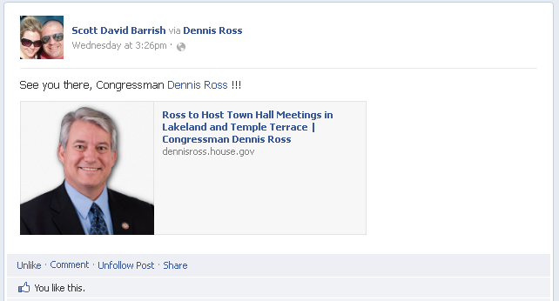
Mike Farris Scott, don't make the suits come again. I only know you on facebook and thats my alibi lol...
Wednesday at 3:27pm · Unlike · 1

Scott David Barrish Mike, Dennis and I are good.
Wednesday at 3:28pm · Unlike · 1

Mike Farris Ok, but I am sticking to my side of the story... I learned from others over the years lmao...
Wednesday at 3:29pm · Unlike · 1

Gordon Wayne Watts Scott, the congressman was having trouble with his email system, and I would like to know if it would be alright for me to post a link to the question(s) I hope to submit to him for his Town Hall Meeting - so Dennis will have a heads up. http://gordonwatts.com/FannyDeregulation/TownHallQuestion.pdf
http://gordonwatts.com/FannyDeregulation/TownHallQuestion.doc
http://gordonwaynewatts.com/FannyDeregulation/TownHallQuestion.pdf
http://gordonwaynewatts.com/FannyDeregulation/TownHallQuestion.doc

As you know, he blocked me (and a bunch of others) for reasons I'm not quite clear on; I disagree with him strongly sometimes, but I never mean to offend anyone --so, being blocked, I can't post this to his wall, and, rather, am hoping that it would be alright you allow me to 'piggy back' what I was going to post, here, so it will be visible in the public timeline.

Thanks,

Gordon //
Thursday at 4:39pm · Unlike · 1

Gordon Wayne Watts UPDATE: I was informed (not by Ross, tho) that my question (linked above) was "too long," so, I revised & resubmitted it -- the current version (with documentation to verify my scary claims!) is posted at the same link, above, e.g., http://gordonwatts.com/FannyDeregulation/TownHallQuestion.pdf
http://gordonwatts.com/FannyDeregulation/TownHallQuestion.doc
http://gordonwaynewatts.com/FannyDeregulation/TownHallQuestion.pdf
http://gordonwaynewatts.com/FannyDeregulation/TownHallQuestion.doc

I admit that I copied the format from that guy that asked Joe Biden about the same subject in Bidens recent visit to FSU; the change makes my question go from 60-seconds to 30-seconds, in other words, I am now normal once again!
Yesterday at 5:04pm · Unlike · 1

Scott David Barrish I DON'T work for the Congressman.
Yesterday at 5:56pm via mobile · Edited · Unlike · 1

Gordon Wayne Watts Well, I hope to be diplomatic, and not offend either my friends or those with whom I disagree: As Dennis says: We can disagree, but still be polite in our exchange of ideas -- if I did offend him (and I infer as much due to the block/ban), I'd like to know what it was, so maybe i can correct it -- was I too talkative? Did I use an offensive tone? What?

I surly would try to make "corrections" if i was out of line. Addendum (edit) Tho I make mistakes, I remember God Almighty helps me all the time, and would reasonably want me to help others, if I'm able.//
Yesterday at 5:47pm · Edited · Unlike · 1

Scott David Barrish CORRECTION...my auto correct on my phone messed that you....it should have read, "I ***don't*** work for the Congressman.
Yesterday at 5:56pm via mobile · Unlike · 1

Gordon Wayne Watts Thx 4 clarifying -- but all the same, it's good to have respect -right now, I'm listening to Lynne Miller Breidenbach on WLKF, on Pastor Wayne Friedt's "Ask the Preacher" show, and she said that tho Congressman Alan Grayson (D-FL-9th) (e.g., south-Orlando area) disagrees with many of her ideas, she can have a respectful conversation / exchange of ideas -- with which I agree, and hope I'm practicing, not just preaching.
21 hours ago · Edited · Unlike · 1

Gordon Wayne Watts (Addendum: My original post called upon you for assistance in your role as 'poster' to Dennis' board, asking for blessing to piggyback my post -- not based on you working for anyone. Sorry I was unclear, Scott)
Yesterday at 5:59pm · Unlike · 1

