Scientists have long known that the magnetic pole moves. James Ross located the pole for the first time in 1831 after an exhausting arctic journey during which his ship got stuck in the ice for four years. No one returned until the next century. In 1904, Roald Amundsen found the pole again and discovered that it had moved--at least 50 km since the days of Ross. https://science.nasa.gov/science-news/science-at-nasa/2003/29dec_magneticfield/ – Velocity: 50km/ 73 years = 0.685 KM/year or so... [[Points A1 and A2 on the annotated graph, almost 0.00 km / year, not this one, but the 2nd one, below, with my comments. ~~ Gordon Wayne Watts]]
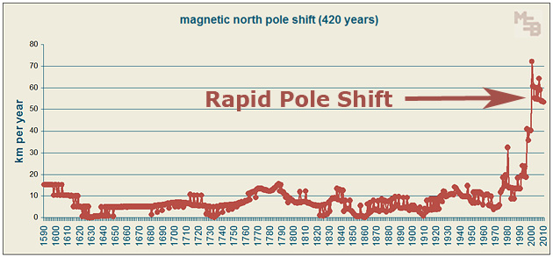
source for graph, above: http://www.collective-evolution.com/2013/01/20/earths-poles-are-shifting/420-year-graph-of-annual-magnetic-pole-shift/

Perspective: “The circumference of Earth at the equator is about 24,874 miles (40,030 km), but from pole-to-pole — the meridional circumference — Earth is only 24,860 miles (40,008 km) around. This shape, caused by the flattening at the poles, is called an oblate spheroid.” How Big is Earth?, By Tim Sharp, Reference Editor | September 17, 2012 04:14pm ET, http://www.space.com/17638-how-big-is-earth.html – See also: “The circumference of the Earth in kilometers is 40,075 km, and the circumference of the Earth in miles is 24,901.” CIRCUMFERENCE OF THE EARTH, Article Updated: 24 Dec , 2015, by Fraser Cain http://www.universetoday.com/26461/circumference-of-the-earth/
See also: Earth's Circumference | - 40,075.017 km (24,901.461 mi) (equatorial) [8] 40,007.86 km (24,859.73 mi) (meridional) [11][12] Source: https://en.wikipedia.org/wiki/Earth
Result: Take circumference to be 40,000km (rounded to nearest 100), thus distance from North Pole to South Pole is about 20,000km.

“The Earth's magnetic north pole is drifting from northern Canada towards Siberia with a presently accelerating rate—10 kilometres (6.2 mi) per year at the beginning of the 20th century, up to 40 kilometres (25 mi) per year in 2003,[19]” https://en.wikipedia.org/wiki/Earth's_magnetic_field
VERIFIED: “The pole kept going during the 20th century, north at an average speed of 10 km per year, lately accelerating "to 40 km per year," says Newitt. At this rate it will exit North America and reach Siberia in a few decades.” https://science.nasa.gov/science-news/science-at-nasa/2003/29dec_magneticfield/ [[This would be point 'B' on my graph, below, 10km/year, and take the year to be at 1900.~~ Gordon Wayne Watts]]

“The most recent survey, completed in May, 2001, determined an updated position for the Pole and established that it is moving approximately northwest at 40 km per year. ” Aug 08, 2010 capture from archive.org [[This would be point “C” on my graph. – Take the year to be 2001. ~~GWW//]] http://web.archive.org/web/20100808172818/http://www.ngdc.noaa.gov/geomag/faqgeom.shtml

“Earth's north magnetic pole is racing toward Russia at almost 40 miles (64 kilometers) a year due to magnetic changes in the planet's core, new research says.“ North Magnetic Pole Moving Due to Core Flux, Richard A. Lovett in San Francisco for National Geographic News
December 24, 2009 http://news.nationalgeographic.com/news/2009/12/091224-north-pole-magnetic-russia-earth-core.html [[This is point 'D' on my graph, and take the year to be 2009, as indicated in article's date.~~GWW//]]

“The most recent survey determined that the Pole is moving approximately north-northwest at 55 km per year. For more details visit our page on polar wandering. ” Sept. 14, 2010 capture from archive.org [[This would be point “E” on my graph. Take the year to be 2010. ~~GWW//]] http://web.archive.org/web/20100914204013/http://www.ngdc.noaa.gov/geomag/faqgeom.shtml
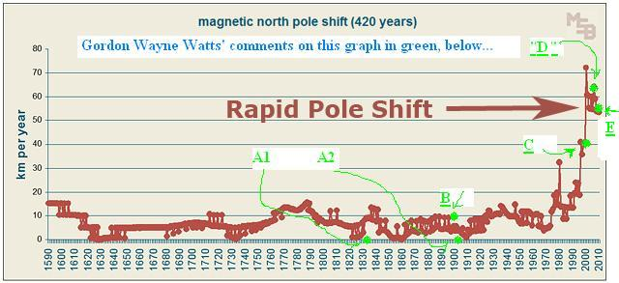
Conclusion: Let's say the velocity of the pole shift accelerates to, say, 100km/year (which seems VERY reasonable, given the recent trends), what might that mean? ANSWER: Since we know distance from North Pole to South Pole to be about 20,000km, you can do the math: In about 200 years (or sooner), expect the poles to flip, and the earth's magnetic field to collapse when the flip occurs, thus leaving us pretty much defenseless against cosmic X-Rays and solar flare radiation, and fulfilling some (but not all) of the many scary end-days, end-times, last-days, & last-times prophecies & predictions from the Holy Bible (cf: Matt 24, Revelation, etc.) ~GWW//

