A 'Conservative' solution to the
student loan debt crisis | Opinion
Gordon Wayne Watts Your Turn
Published 11:59 p.m. ET May 31, 2022

The Tallahassee Democrat recently published opposing columns on student debt: “Wiping Out Student Loan Debt is Inherently Unfair,” by Bill Cotterell and Alan Collinge's response, “Another view of the student loan debt crisis.” Both overlook key facts.

First, Collinge says Cotterell should “fight for S.2598, a bipartisan Senate bill that will return constitutional bankruptcy rights to the loans,” but didn't cite sources for his “constitutional” claim. I will: Bankruptcy isn't a “Liberal Free Handout,” but rather required by the Constitution's “Uniformity Clause” (Art.I, Sec.8, cl.4). Collinge's call for debt cancellation sounds “Liberal,” but I've known him for years and know he's almost as Conservative as me. For his “Student Loan Justice” group's first 15 years, he never sought cancellation until his recent petition: https://CHANGE.org/CancelStudentLoans instead only modestly calling for bankruptcy “uniformity.” Yes, I'm Conservative: ask Google “What role did Gordon Wayne Watts play in the Terri Schiavo case?,” the largest pro-life case since Roe, which I almost won. Besides being “morally” conservative, I'm also “fiscally” Conservative, opposing Liberal free handouts.

Secondly, Collinge claims most borrowers are “older” and the “federal government has been profiting around $50 billion per year on these loans,” but fails to document this. I will: see the “Clear Understanding” section of CONTRACT WITH AMERICA: PART II(TM) (https://ContractWithAmerica2.com/#clear)

Third, Collinge says “the taxpayers will have very little- perhaps no, net loss if the loans are cancelled,” but cites no sources. I will: https://ContractWithAmerica2.com/#PaidInFull verifies students have “paid in full” when looking at just gov't recovery of $1.22 from every $1.00 on “defaulted” loans (probably more considering loans in good standing have no repayment problems). On the “repayment” basis alone, cancellation is morally justified, but wouldn't be a permanent fix, making long-term solutions harder to pass in an already-gridlocked Congress.

Fourth, Cotterell claims it would cost taxpayers to cancel student debt, but he's incorrect: He, himself, admits, “the Obama Administration nationalized the loan market,” meaning taxpayers don't guarantee debt, but rather OWN it. As students have fully repaid, cancellation would cost nothing. Some say it's OK for students to pay more than borrowed, since interest was “part of the deal”: students “knew that they were getting into.” No, they didn't. Many student loans had bankruptcy removed by changes to federal law, illegally altering loan contracts. Altering existing contracts (without consent of both parties) is illegal. Also, price-gouging is illegal. This legal standard applies to tuition. Cotterell, if he's conservative, should complain about both violations of law!

Student Debt, at nearly 10% of U.S. Debt, will crash the dollar if we don't stop making student loans. Only a “threat” of bankruptcy from borrowers will tamp down irresponsible Education Department lending. Thus, restoration of student loan bankruptcy, a “Conservative” free market check on excessive lending, is necessary. Directly funding higher education seems “Liberal,” but would cost taxpayers (and students) less: It works for Public Education.
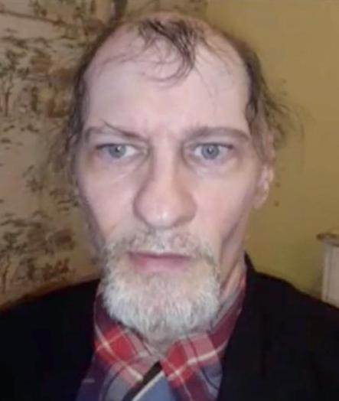
Gordon Wayne Watts Special To The Democrat

Gordon Wayne Watts (contact him at GordonWatts.com or GordonWayneWatts.com or ContractWithAmerica2.com) is a Plant City, Fla. resident, a graduate from The Florida State University, and national director of CONTRACT WITH AMERICA: PART II^{(TM)}. Mr. Watts also came closer to winning the Terri Schiavo case than all other pro-life litigants combined, including former Fla. Gov. Jeb Bush. Mr. Watts is very close to getting his trademark phrase, “CONTRACT WITH AMERICA: PART II,” granted copyright, according to the U.S. Trademark and Patent Office.

