IN THE UNITED STATES COURT OF APPEALS
FOR THE ELEVENTH CIRCUIT

______________________________________
Consolidated Appeal Nos. 15-10295, 15-10313

CARI SEARCY, et al.,  Plaintiffs-Appellees,  v.  LUTHER STRANGE, ATTORNEY GENERAL,  STATE OF ALABAMA, Defendant-Appellant. | JAMES STRAWSER, et al.,  Plaintiffs-Appellees,  v.  LUTHER STRANGE, ATTORNEY GENERAL,  STATE OF ALABAMA, Defendant-Appellant.
Appeals from the U.S. District Court, Southern District of Alabama

Time-Sensitive Applications for Reconsideration, Clarification,
11th Cir. R. 35-9 En Banc Amicus Briefs, etc. pursuant to
response from Acting Clerk of Court, dated February 06, 2015

( RULING REQUESTED BEFORE end of day FEB. 9, 2015 )

The name, office address, and telephone number of counsel[*]
representing the party for whom the brief is filed:

Gordon Wayne Watts, Amicus Curiae
821 Alicia Road, Lakeland, Florida 33801-2113
Official URL's: http://GordonWatts.com / http://GordonWayneWatts.com
Home Phone: (863) 688-9880 ; E-mail: gww1210@aol.com ; gww1210@gmail.com ; Work Phones: 863-686-3411 and 863-687-6141
BS, The Florida State University, Biological & Chemical Sciences;
Class of 2000, double major with honours
AS, United Electronics Institute, Class of 1988, Valedictorian

LAYMAN OF THE LAW:
Gordon W. Watts, PRO SE / PRO PER
[*] Mr. Watts, acting as his own counsel, is not a lawyer.

U.S. COURT OF APPEALS FOR THE ELEVENTH CIRCUIT

CERTIFICATE OF INTERESTED PERSONS
AND CORPORATE DISCLOSURE STATEMENT

Searcy, et al v. Strange, Consolidated Appeal Nos: 15-10295, 15-10313

Amicus, Gordon Wayne Watts, pursuant to 11th Cir. R. 26.1-1, hereby certifies that
the following is a list of trial judge(s), and all attorneys, persons, associations of persons, firms, partnerships, or corporations that have an interest in the outcome of
this case or appeal, including subsidiaries, conglomerates, affiliates and parent corporations, including any publicly held corporation that owns 10% or more of the party’s stock, and other identifiable legal entities related to a party those who have an interest in the outcome of this case and/or appeal:

1. Agricola, Jr., Algert Swanson, Attorney for Alabama Probate Judges Association (“APJA”) & Gov. Bentley
2. Alabama Probate Judges Association
3. Allen, Wes, Probate Judge, Pike County, Alabama, APJA Treasurer
4. Bentley, Robert J., Governor of Alabama
5. Boyd, Fernambucq, Dunn & Fann, P.C., attorneys for plaintiffs
6. Brasher, Andrew Lynn, Solicitor General
7. Byrne, Jr., David B., Attorney for Governor Robert J. Bentley
8. Davis, James W., Assistant Attorney General
9. English, Bill, Probate Judge, Lee County, Alabama, APJA Vice President
10. Fann, Heather, counsel for Plaintiffs-Appellees
11. Granade, Hon. Callie V. S., United States District Judge
12. Hernandez, Christine Cassie, attorney for plaintiffs
C-1 of 3

U.S. COURT OF APPEALS FOR THE 11th CIR., CERTIFICATE OF INTERESTED PERSONS AND CORPORATE DISCLOSURE STATEMENT
Searcy, et al v. Strange, Consolidated Appeal Nos: 15-10295, 15-10313

13. Howell, Laura Elizabeth, Assistant Attorney General
14. Humphrey, John E., Plaintiff-Appellee
15. Kennedy, David Graham, attorney for plaintiffs
16. McKeand, Kimberly, plaintiff
17. Minter, Shannon P., counsel for Plaintiffs-Appellees
18. Mitchell, Terry, Probate Judge, Coosa County, Alabama, APJA President Emeritus
19. National Center for Lesbian Rights, attorneys for Plaintiffs-Appellees
20. Norris, Greg, Probate Judge, Monroe County, Alabama, APJA President
21. Paluzzi, John Earl, Probate Judge, Pickens County, Alabama, APJA Secretary
22. Reinert, Jeff, Clerk of the Court, U.S. Dist. Court, S.D. of Alabama
23. Ryals, Joseph Lenn, Attorney for Alabama Probate Judges Association
24. Searcy, Cari D., plaintiff
25. Stoll, Christopher F., counsel for Plaintiffs-Appellees
26. Strawser, James N., Plaintiff-Appellee.
27. Strange, Luther, Attorney General
28. Watts, Gordon Wayne, Amicus Curiae
No counsel for any party authored this brief in whole or part, nor did anyone make any monetary contribution intended to subsidise/fund

C-2 of 3

U.S. COURT OF APPEALS FOR THE 11th CIR., CERTIFICATE OF INTERESTED PERSONS AND CORPORATE DISCLOSURE STATEMENT
Searcy, et al v. Strange, Consolidated Appeal Nos: 15-10295, 15-10313

preparation/submission of this brief. I, Gordon Wayne Watts, alone, both wrote & funded it. Amicus, Gordon Wayne Watts, is an individual, not a corporation, and accordingly does not does not issue any stock and does not have any parent corporations or any publicly held corporations that own 10 percent or more of stock of that nonexistent parent corporation.

/s/ _Gordon Wayne Watts_ Date: _Sat. 07 Feb. 2015_
Gordon Wayne Watts
821 ALICIA RD
LAKELAND, FL 33801-2113

C-3 of 3

Table of Contents / Citations
Cover page (not numbered).......................................................................................1

CERTIFICATE OF INTERESTED PERSONS
AND CORPORATE DISCLOSURE STATEMENT........................................C1-C3

Table of Contents / Citations.....................................................................................a

Motions / Applications:

Statement of the Case/Facts.................................................................................1—2
I. Motion for Clarification on Amicus status........................................................2—3
II. Motion for Clarification of 04 Feb 2015 Order -possibly Reconsideration....3—4
III. En Banc matters: Motion for leave to file.....................................................4—6
IV. CONCLUSION..............................................................................................6—7
Certificates of Service / Compliance...................................................................7—9

Citations in Alphabetical Order:
Amicus Curiae brief by Gordon Wayne Watts in Brenner/Grimsley...............passim
Amicus Curiae brief by Gordon Wayne Watts in Searcy/Strawser..................passim
Baker v. Nelson, 409 U.S. 810, 93 S. Ct. 37 (1972)..................................................5
Brenner v. Armstrong, 14-14061, 11th Cir. 2014.............................................passim
DeBoer, et al., v. Snyder, et al., 14-571, cert. Accepted............................................2
Grimsley v. Armstrong, 14-14066, 11th Cir. 2014...........................................passim
In Re: Gordon Wayne Watts (as next friend of Theresa Marie 'Terri '
Schiavo), No. SC03-2420 (Fla. Feb.23, 2003)..........................................................1
In Re: Jeb Bush, Governor of Florida, et al. v. Michael Schiavo,
Guardian: Theresa Schiavo, No. SC04-925 (Fla. Oct.21, 2004)..............................1
Lofton v. Secretary of Department of Children & Family
Services, 358 F.3d 804 (11th Cir. 2004),...................................................................5
Schiavo ex rel. Schindler v. Schiavo ex rel. Schiavo,
403 F.3d 1223, 2005 WL 648897 (11th Cir. Mar.23, 2005)......................................1
11th Cir.R.35-8..........................................................................................................4
11th Cir.R.35-9..........................................................................................................4
Rule 24(a), Fed.R.Civ.P.............................................................................................6
Rule 29(a), Fed.R.App.P............................................................................................4
Rule 35(b), Fed.R.App.P............................................................................................5

(a)

Statement of the Case/Facts

Pursuant to the letter of Acting Clerk of Court, Amy C. Nerenberg, dated Feb. 06, 2015, I am replying as requested or otherwise permitted. Although I'm not a lawyer, several years ago, I nearly won in court as Next Friend of Theresa “Terri” Schiavo –single-handedly, doing even better than a sitting governor –or Terri's own blood family—combined:
· In Re: Gordon Wayne Watts (as next friend of Theresa Marie 'Terri ' Schiavo), No. SC03-2420 (Fla. Feb.23, 2003), denied 4-3 on rehearing. (Watts got 42.7% of his panel) http://www.floridasupremecourt.org/clerk/dispositions/2005/2/03-2420reh.pdf
· In Re: Jeb Bush, Governor of Florida, et al. v. Michael Schiavo, Guardian: Theresa Schiavo, No. SC04-925 (Fla. Oct.21, 2004), denied 7-0 on rehearing. (Bush got 0.0% of his panel before the same court) http://www.floridasupremecourt.org/clerk/dispositions/2004/10/04-925reh.pdf
· Schiavo ex rel. Schindler v. Schiavo ex rel. Schiavo, 403 F.3d 1223, 2005 WL 648897 (11th Cir. Mar.23, 2005), denied 2-1 on appeal. (Terri Schiavo's own blood family only got 33.3% of their panel on the Federal Appeals level) http://media.ca11.uscourts.gov/opinions/pub/files/200511556.pdf

So, when I saw plaintiffs & defendants omit key arguments in recent Gay Marriage cases, I felt an obligation to be a 'Friend of the Court.' I submitted a timely amicus in Brenner/Grimsley (14-14061/14-14066), two other consolidated cases; my amended brief (correcting key omissions) is the last merit's brief on docket. I timely filed a brief in Strawser, by right & with consent of the parties, but was only able to obtain consent from one party in Searcy. Those briefs were filed by overnight FedEx and received in This Court and signed for by an 'F.Boyd' at 12:39PM on Wednesday, 04 February 2015, several hours before This Court
1

suspended proceedings in all 4 cases. Subsequently, This Court issued an order denying as 'moot' my motion for leave to file an amicus. Also, because a good number of people were confused about the Order of This Court that same day, I called and spoke with Joseph Caruso, the clerk assigned to handle these cases, and inquired re the stay on proceedings: Did the court stay all proceedings, including the injunction of the court below, or merely its own review, I asked? Mr. Caruso reported to me that, after checking with a supervisor, both concluded that This Court stayed all proceedings including the injunction below, pending SCOTUS ruling on DeBoer, et al., v. Snyder, et al., 14-571, cert. accepted. However, subsequent inquiry by the court below returned different replies, thus leaving me in confusion as to the state of affairs. After careful consideration, I felt that the counsel of many were correct: The proper way to get clarification on This Court's order was to ask This Court. The instant motions are submitted for this reason.
I. Motion for Clarification on Amicus status
While this isn't of the greatest importance, it does have legal bearing, so I'll address it first: Since my motion was properly received by This Court before its ruling placing these cases in abeyance (APX-A), and since, in one of them, I obtained consent of both parties (APX-B, C, D), then it seems that I'm not a “Not Party,” but rather an amicus curiae, is that not correct? (However, even had I not obtained consent from both sides, it's This Court's practice, if the amicus is well-written &
2

in the right spirit, to grant leave, as happened to all amici in Brenner/Grimsley save one other pro se litigant.)

II. Motion for Clarification of 04 Feb 2015 Order -possibly Reconsideration
* Since The Feb. 04, 2015 Order of This Court wasn't specific, with clarity, as to what, exactly, was stayed, it's appropriate to move for clarification: Did This Court stay all proceedings herein, including the injunction in the court below? If so, I would respectfully move This Court to clearly state that that is so.
* If, on the other hand, This Court stayed only its review of these cases, but not the injunction, I would respectfully move This Court for clarification as to why this would be legally justified in light of the 4 Nken factors, especially prong-1, which justifies a stay pending appeal, as I outline in my 2 merits briefs, docketed in this case on Fri. 06 Feb. 2015. (I add this because it appears that This Court never saw my amicus briefs yesterday before it ruled on the stay pending appeal, but I add a never-before-used Equal Protection argument that all but guarantees success on the merits, thus prong-1.) And, I would, concurrently, move This Honourable Court to reconsider its refusal to enter a stay pending appeal, an action which is typically mandatory in State Courts, and not justified absent a life-or-death threat that can only be avoided by denying the stay. (A stay would preserve order; denial of a stay would engender confusion & uncertainty about the future.)
The probate judges who stand to lose if the stay is incorrectly denied have
3

legal standing to intervene –much more so than myself. (But, my weak, even if non-existent, standing to intervene, at least, makes me more objective, and thus potentially more accurate in my legal assessment: a 'better' friend of the court.)

This Court may sua sponte – on its own motion – act with regard to the issuance of a stay pending appeal, as well as re-activation of these cases out of abeyance. Thus, even though my legal standing to move This Court on large matters is tenuous as best, if This Court may act on its own it may even more-so entertain my suggestions, and act upon them. Therefore, as a good friend of the court, I shall make a few brief suggestions:

III. En Banc matters: Motion for leave to file
Since I appear to have shown I obtained consent of the parties before the case was placed into hibernation, I'm entitled, as of right, to file a amicus: Rule 29(a), Fed.R.App.P., and thus qualify for the following: Pursuant to 11th Cir.R.35-9 En Banc Amicus Briefs, I ask the full court for HEARING (not rehearing, but hearing, thus reinstatement from abeyance) and pursuant to 11th Cir.R.35-8, serve 20 copies (plus 2 originals) upon This Court. I therefore request leave of court by filing this motion accompanied by this proposed brief:
4

Motion Proper:
Pursuant to Rule 35(b), Fed.R.App.P., I move This Honourable Court for HEARING en banc for the following 2 reasons:

(A) the panel decision conflicts with Lofton v. Secretary of Department of Children & Family Services, 358 F.3d 804 (11th Cir. 2004), Baker v. Nelson, 409 U.S. 810, 93 S. Ct. 37 (1972), and several other holdings, and, as I explain in Arg.IV. in my amicus in Strawser, filed 06 Feb. 2015, the “doctrinal development” exception does not apply –and consideration by the full court is therefore necessary to secure and maintain uniformity of the court’s decisions; and:

(B) the proceeding involves one or more questions of exceptional importance, in which the panel decision (to refuse to uphold 1-man, 1-woman definitions of marriage) conflicts with the authoritative decisions of other U.S. Court of Appeals, specifically, the U.S. 6th Circuit, which just ruled recently in this matter. I add: Just because the matter is on docket of the SCOTUS, that does not obviate our duty to address these issues head on: if anything, it makes a decision by This Court even more helpful, since the other U.S. CCA's, holding the opposite, reached their decisions for different (read: non-uniform) reasons. Thus, This Court should hear the matter en banc, and stay the ruling, but allow our ruling to be helpful for SCOTUS review and possible consolidation with DeBoer, et al,
5
(Incidentally, Amicus does not know why the various attorneys for Defendant –or other Amici – did not show the tactical savoir-faire to petition for rehearing of the 3-judge panel decision, or 'hearing' en banc. Had they done so, I would not have needed to ask This Court to consider these matters. And also, it is a mystery to Amicus as to why Probate judges did not assert intervention: Fed.R.Civ.P. 24(a) entitles The Probate Judges to 'intervene' as of right, since they can “claim[] an interest relating to the property or transaction that is the subject of the action, and is so situated that disposing of the action may as a practical matter impair or impede the movant’s ability to protect its interest, unless the existing parties adequately represent that interest.”)

IV. CONCLUSION
Since it would seem that my amicus brief came in right before This Court decided to place our redresses “on hold” in these 4 Gay Marriage cases (and thus you may have overlooked it), I would respectfully ask This Court to take a look at my Amicus brief in Brenner/Grimsley (14-14061, 14-14066) as well as my 2 Amici in Searcy/Strawser (15-10295, 15-10313). Please note that all 3 briefs are similar (i.e., have some 'repeated' or copied/pasted argument), but each brief has some 'unique' argument, as well. In all 4 cases, my amicus is the last and most recent merit's brief on docket.
6

Dated: Sat., Feb 07, 2015 Respectfully submitted,

s/ _Gordon Wayne Watts_____
Gordon Wayne Watts, Amicus
821 Alicia Road, Lakeland, Florida 33801-2113
Official URL's: http://GordonWatts.com / http://GordonWayneWatts.com
Home Phone: (863) 688-9880 ; E-mail: gww1210@aol.com; gww1210@gmail.com ; Work Phones: 863-686-3411 and 863-687-6141

CERTIFICATE OF COMPLIANCE

In accordance with Rule 29, Brief of an Amicus Curiae (c), Contents and Form, Fed.R.App.P., I hereby certify the following:

The instant amicus brief complies with Rule 32: see infra.

The cover identifies the party or parties supported and indicate whether the brief supports affirmance or reversal: This brief supports defendant, LUTHER STRANGE, regarding his motion for a “State Pending Appeal” –and affirmance of the Alabama Law in question, and on many other points, but supports many elements of the plaintiffs, including (but not limited to) fair and just treatment of all people, including homosexual citizens. In addition, I certify that I complied with the disclosure requirement in the CERTIFICATE OF INTERESTED PERSONS AND CORPORATE DISCLOSURE STATEMENT, supra.

In accordance with Rule 32(a)(7), Length., Fed.R.App.P., I hereby certify the following:

Rules 32(a)(7)(A), Page limitation, 32(a)(7)(B) Type-volume limitation, and 32(a)(7)(C)(i) Certificate of compliance [e.g., “A brief submitted under Rules 28.1(e)(2) or 32(a)(7)(B)”] do not apply: This brief is neither a principal nor reply brief.

Regarding Rule 32(a)(7)(C)(ii), which states in succinct part that “Use of Form 6 must be regarded as sufficient to meet the requirements of Rules 28.1(e)(3) and 32(a)(7)(C)(i),” I am hereby following this standard to be safe:

Form 6. Certificate of Compliance With Rule 32(a)

Certificate of Compliance With Type-Volume Limitation, Typeface Requirements, and Type Style Requirements
7

1. This brief complies with the type-volume limitation of Fed. R. App. P. 32(a)(7)(B) because:
*** this brief contains [state the number of] words, excluding the parts of the brief exempted by Fed. R. App. P. 32(a)(7)(B)(iii), or
[[[it contains no more than 14,000 words— 3,773 Words in total, to be exact; Headings, footnotes, and quotations count toward the word and line limitations. The corporate disclosure statement, table of contents, table of citations, statement with respect to oral argument, any addendum containing statutes, rules or regulations, and any certificates of counsel do not count toward the limitation.]]]

2. This brief complies with the typeface requirements of Fed. R. App. P. 32(a)(5) and the type style requirements of Fed. R. App. P. 32(a)(6) because:
*** this brief has been prepared in a proportionally spaced typeface using [state name and version of word processing program: OpenOffice version 3.1.0] in [state font size: 14, and name of type style: Times New Roman],
[[[A proportionally spaced face must include serifs, but sans-serif type may be used in headings and captions. A proportionally spaced face must be 14-point or larger.]]]

I believe, in good faith, that I am also in compliance with Rule 29. Brief of an Amicus Curiae, (d) Length, since I met the Rule 32 requirements above.

s/ _Gordon Wayne Watts_ Sat., Feb. 07, 2015___
Gordon Wayne Watts, Amicus

CERTIFICATE OF SERVICE
I hereby certify that I am serving a TRUE COPY upon the clerk of the 11th CCA, who, after docketing it, will make it available to all participants who receive EF/CMF notification, and to all others who wish to pay a PACER fee for search/download. Additionally, am serving the parties, below, by email when I am able. I hope to post a TRUE COPY of these filings on my Open Source online docket, for free download, at the following two (2) URL's, as soon as practically possible; however, I am forgoing service by postal mail as a matter of economy.

http://www.GordonWatts.com/DOCKET-GayMarriageCase.html
and:
http://www.GordonWayneWatts.com/DOCKET-GayMarriageCase.html

/s/ _Gordon Wayne Watts_ Sat., 7 Feb. 2015___
Gordon Wayne Watts, Amicus
8
PARTIES:
US Courts of Appeals, Eleventh Circuit,  56 Forsyth Street, N.W.,  Atlanta, Georgia 30303,  Phone: (404) 335-6100 | Andrew L. Brasher, 501 Washington Ave., Montgomery, AL 36103  334-242-7300  ABrasher@ago.state.al.us  Cc: SMcLure@ago.state.al.us
Christine Cassie Hernandez  P.O. Box 66174, Mobile, AL 36660  251-479-1477  Christine@HernandezLaw.comcastbiz.net | Laura Elizabeth Howell, 501 Washington Avenue, Montgomery, AL 36104, PH: 334-242-7432  LHowell@ago.state.al.us
David Graham Kennedy  P.O. Box 556, Mobile, AL 36601  251-338-9805  David@KennedyLawyers.com | Algert S. Agricola , Jr.  60 Commerce Street, Suite 1400  Montgomery, AL 36104  334-834-5290; Fax: 334-834-5297  AAgricola@rdafirm.com
James W. Davis, Office of the Attorney General, 501 Washington Ave.  Montgomery, AL 36130-0152  334-353-1356 ; Fax: 334-353-8440  JimDavis@ago.state.al.us | Joseph Lenn Ryals, 60 Commerce Street, Suite 1400, Montgomery, AL 36104, PH: 334-834-5290  LRyals@rdafirm.com
Shannon Price Minter,  Email: sminter@nclrights.org  Direct: 415-392-6257  National Center For Lesbian Rights  870 MARKET ST STE 370  SAN FRANCISCO, CA 94102-3009 | Christopher F. Stoll,  Email: cstoll@nclrights.org  Direct: 415-392-6257  National Center For Lesbian Rights  870 MARKET ST STE 370  SAN FRANCISCO, CA 94102-3009
John E. Humphrey  Direct: 251-301-2966 (cell)  [NTC Pro Se]  9231 AMBER CT  MOBILE, AL 36695 | Heather Fann  Email: info@bfattorneys.net  BOYD, FERNAMBUCQ, DUNN & FANN, P.C.  3500 Blue Lake Drive, Suite 220  Birmingham, AL 35243  Telephone: (205) 930-9000  Facsimile: (205) 930-9010  Counsel for Plaintiffs-Appellees
James Strawser, JimStraw44@yahoo.com
Direct: 251-375-0238
[NTC Pro Se]
9231 AMBER CT
MOBILE, AL 36695
9

IN THE UNITED STATES COURT OF APPEALS
FOR THE ELEVENTH CIRCUIT

______________________________________
Consolidated Appeal Nos. 15-10295, 15-10313

CARI SEARCY, et al.,  Plaintiffs-Appellees,  v.  LUTHER STRANGE, ATTORNEY GENERAL,  STATE OF ALABAMA, Defendant-Appellant. | JAMES STRAWSER, et al.,  Plaintiffs-Appellees,  v.  LUTHER STRANGE, ATTORNEY GENERAL,  STATE OF ALABAMA, Defendant-Appellant.
Appeals from the U.S. District Court, Southern District of Alabama

Time-Sensitive Applications for Reconsideration, Clarification,
11th Cir. R. 35-9 En Banc Amicus Briefs, etc. pursuant to
response from Acting Clerk of Court, dated February 06, 2015

( RULING REQUESTED BEFORE end of day FEB. 9, 2015 )

– APPENDIX –

The name, office address, and telephone number of counsel[*]
representing the party for whom the brief is filed:

Gordon Wayne Watts, Amicus Curiae
821 Alicia Road, Lakeland, Florida 33801-2113
Official URL's: http://GordonWatts.com / http://GordonWayneWatts.com
Home Phone: (863) 688-9880 ; E-mail: gww1210@aol.com ; gww1210@gmail.com ; Work Phones: 863-686-3411 and 863-687-6141
BS, The Florida State University, Biological & Chemical Sciences;
Class of 2000, double major with honours
AS, United Electronics Institute, Class of 1988, Valedictorian

LAYMAN OF THE LAW:
Gordon W. Watts, PRO SE / PRO PER
[*] Mr. Watts, acting as his own counsel, is not a lawyer.

INDEX TO APPENDIX

Instrument Docket/Tab#

FedEx time-stamp showing when my
Amicus was received by This Court..........................................................................A

Emails granting consent in this cause................................................................B—D

Certificate of Service

A

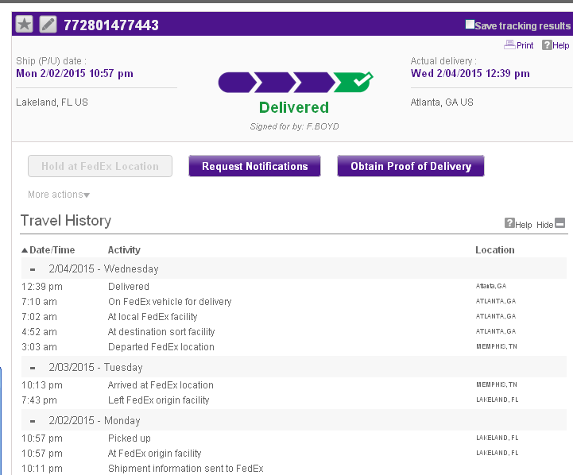

B

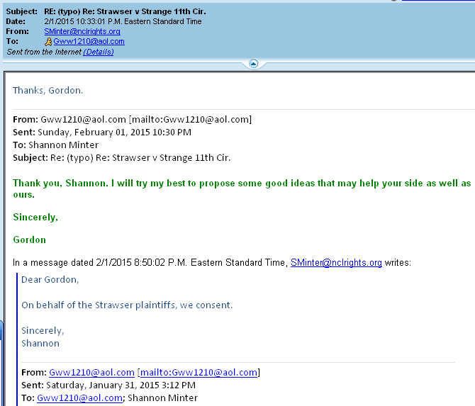

C

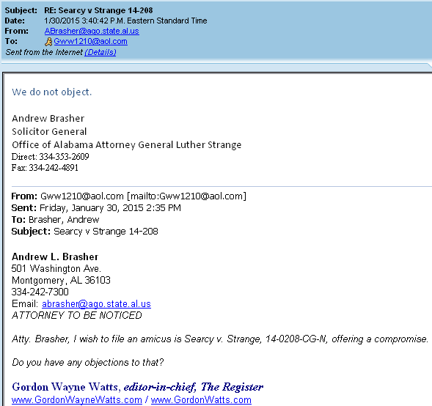

D

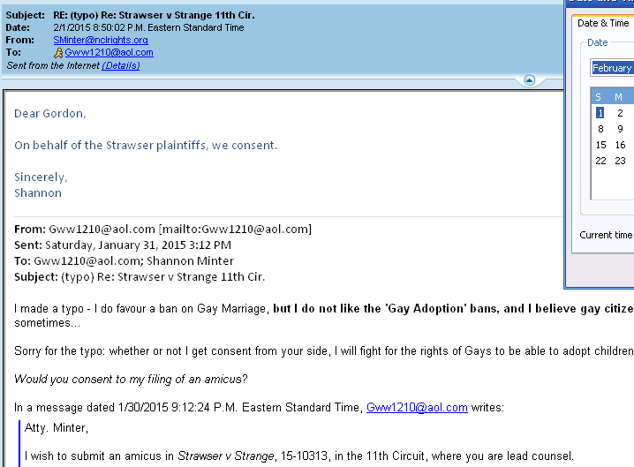

CERTIFICATE OF SERVICE
I hereby certify that I am serving a TRUE COPY of this APPENDIX (along with the motion, here) upon the clerk of the 11th CCA, who, after docketing it, will make it available to all participants who receive EF/CMF notification, and to all others who wish to pay a PACER fee for search/download. Additionally, am serving the parties, below, by email when I am able. I hope to post a TRUE COPY of these filings on my Open Source online docket, for free download, at the following two (2) URL's, as soon as practically possible; however, I am forgoing service by postal mail as a matter of economy.

http://www.GordonWatts.com/DOCKET-GayMarriageCase.html
and:
http://www.GordonWayneWatts.com/DOCKET-GayMarriageCase.html

/s/ _Gordon Wayne Watts_ Sat., Feb. 07, 2015___
Gordon Wayne Watts, Amicus

PARTIES:
US Courts of Appeals, Eleventh Circuit,  56 Forsyth Street, N.W.,  Atlanta, Georgia 30303,  Phone: (404) 335-6100 | Andrew L. Brasher, 501 Washington Ave., Montgomery, AL 36103  334-242-7300  ABrasher@ago.state.al.us  Cc: SMcLure@ago.state.al.us
Christine Cassie Hernandez  P.O. Box 66174, Mobile, AL 36660  251-479-1477  Christine@HernandezLaw.comcastbiz.net | Laura Elizabeth Howell, 501 Washington Avenue, Montgomery, AL 36104, PH: 334-242-7432  LHowell@ago.state.al.us
David Graham Kennedy  P.O. Box 556, Mobile, AL 36601  251-338-9805  David@KennedyLawyers.com | Algert S. Agricola , Jr.  60 Commerce Street, Suite 1400  Montgomery, AL 36104  334-834-5290; Fax: 334-834-5297  AAgricola@rdafirm.com
James W. Davis, Office of the Attorney General, 501 Washington Ave.  Montgomery, AL 36130-0152  334-353-1356 ; Fax: 334-353-8440  JimDavis@ago.state.al.us | Joseph Lenn Ryals, 60 Commerce Street, Suite 1400, Montgomery, AL 36104, PH: 334-834-5290  LRyals@rdafirm.com
Shannon Price Minter,  Email: sminter@nclrights.org  Direct: 415-392-6257  National Center For Lesbian Rights  870 MARKET ST STE 370  SAN FRANCISCO, CA 94102-3009 | Christopher F. Stoll,  Email: cstoll@nclrights.org  Direct: 415-392-6257  National Center For Lesbian Rights  870 MARKET ST STE 370  SAN FRANCISCO, CA 94102-3009
John E. Humphrey  Direct: 251-301-2966 (cell)  [NTC Pro Se]  9231 AMBER CT  MOBILE, AL 36695 | Heather Fann  Email: info@bfattorneys.net  BOYD, FERNAMBUCQ, DUNN & FANN, P.C.  3500 Blue Lake Drive, Suite 220  Birmingham, AL 35243  Telephone: (205) 930-9000  Facsimile: (205) 930-9010  Counsel for Plaintiffs-Appellees
James Strawser, JimStraw44@yahoo.com
Direct: 251-375-0238
[NTC Pro Se]
9231 AMBER CT
MOBILE, AL 36695

