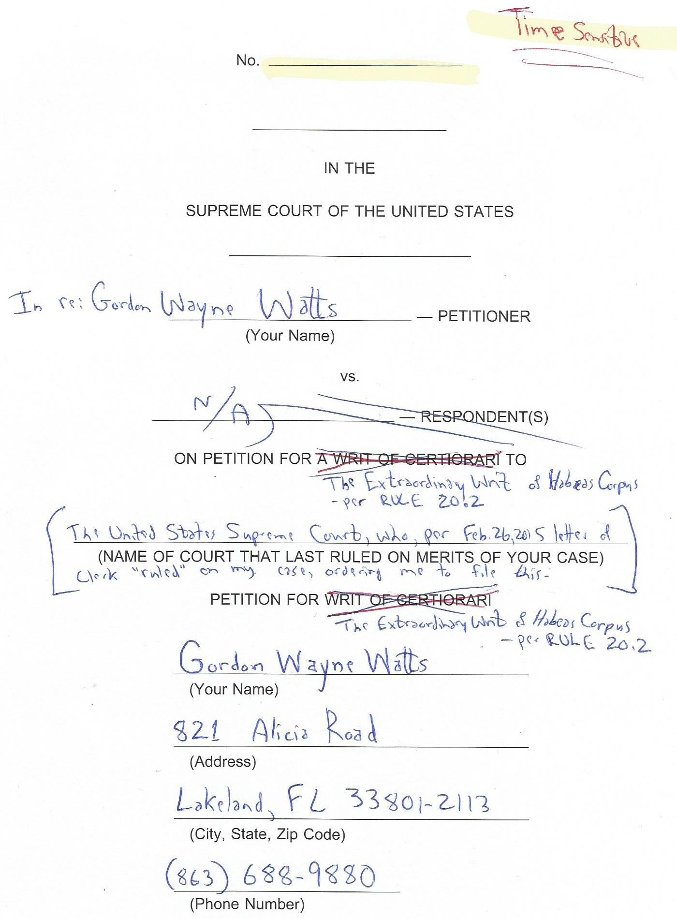
QUESTION(S) PRESENTED

- Whether Due Process is implicated when an indigent pro se litigant who can not afford an attorney barred in This Court, as RULE 37 requires, wishes to have access to Redress This Court regarding participation as an Amicus Curiae.
- Whether Equal Protection is implicated when other, otherwise equally-situated litigants gain access to This Court to file 'Friend of the Court' briefs, as compared to an indigent pro se litigant who can not afford an attorney barred in This Court, as RULE 37 requires.
- Whether case law, Common Law, and U.S. Constitutional Provision exists to support a basis for Habeas Corpus to issue to test this particular deprivation of liberty, namely lack of Due Process to access the courts, and Unequal Protection of indigent pro se litigants who wish to be a 'Friend of the Court' and participate in the Democratic Process of 1st Amendment Redress.

(a)
LIST OF PARTIES

All parties do not appear in the caption of the case on the cover page. A list of all parties to the proceeding in The Court whose judgment is the subject of this petition (This Honourable Court) is as follows:

Gordon Wayne Watts, Petitioner, in the case at bar: “In Re; Gordon Wayne Watts,” “Petition for the Extraordinary Writ of Habeas Corpus, per RULE 20.2,” no case number assigned as yet.

James Obergefell, et al., Petitioners, in Case #: 14-556

Richard Hodges, Dir., Ohio Department of Health, et al., Respondents, in Case #: 14-556

Valeria Tanco, et al., Petitioners, in Case #: 14-562

Bill Haslam, Governor of Tennessee, et al., Respondents, in Case #: 14-562

April DeBoer, et al., Petitioners, in Case #: 14-571

Rick Snyder, Governor of Michigan, et al., Respondents, in Case #: 14-571

Gregory Bourke, et al., Petitioners, in Case #: 14-574

Steve Beshear, Governor of Kentucky, et al., Respondents, in Case #: 14-574

(b)
TABLE OF CONTENTS

COVER PAGE.....................................................................................................(Not Numbered)
QUESTION(S) PRESENTED......................................................................................................a
LIST OF PARTIES.......................................................................................................................b
TABLE OF CONTENTS...............................................................................................................c
INDEX TO THE APPENDICES....................................................................................................c
OPINIONS BELOW: – N/A in Original Jurisdiction petitions such as this –
TABLE OF AUTHORITIES CITED...............................................................................................d

JURISDICTION...........................................................................................................................1

CONSTITUTIONAL AND STATUTORY PROVISIONS INVOLVED............................................1

STATEMENT OF THE CASE.................................................................................................2—3

REASONS FOR GRANTING THE WRIT (ARGUMENT).......................................................4—8

CONCLUSION.............................................................................................................................9

PROOF (CERTIFICATE) OF SERVICE.............................................................................10—12

PROOF (CERTIFICATE) OF COMPLIANCE............................................................................12

INDEX TO THE APPENDICES

APPENDIX A: Letter from Erik Fossum, dated 26 February 2015

APPENDIX B: Screenshot of U.S. Supreme Court online docket for Obergefell et al., v. Hodges, dated February 04, 2015

APPENDIX C: Links to court websites to verify selected citations

(c)
TABLE OF AUTHORITIES CITED

Cases Page Number

Bourke et al., v. Beshear, et al. (14-574, Cert. Granted).............................................................b
Brenner, et al., v. Armstrong, (No. 14-14061, 11th Cir., 2014)...........................................4—5, 8
DeBoer et al., v. Snyder, et al. (14-571, Cert. Granted)....................................................b, 7—8
Grimsley, et al., v. Armstrong (No. 14-14066, 11th Cir., 2014)...........................................4—5, 8
In Re: Gordon Wayne Watts (as next friend of Theresa Marie 'Terri' Schiavo),
No. SC03-2420 (Fla. Feb.23, 2005).......................................................................................4—5
In Re: Jeb Bush, Governor of Florida, et al. v. Michael Schiavo, Guardian: Theresa
Schiavo, No. SC04-925 (Fla. Oct.21, 2004)................................................................................5
Obergefell, et al., v. Hodges, et al. (14-556, Cert. Granted)...................................b, c, APX-B, 7
Schiavo ex rel. Schindler v. Schiavo ex rel. Schiavo, 403 F.3d 1223,
2005 WL 648897 (11th Cir. Mar.23, 2005)...................................................................................5
State ex rel. Deeb v. Fabisinski, 111 Fla. 454..............................................................................6
Tanco et al., v. Haslam, et al. (14-562, Cert. Granted)...........................................................b, 5
Whitmore v. Arkansas, 495 U.S. 149...........................................................................................6

Statutes and Rules

28 U. S. C. §§ 2241.....................................................................................................................1
28 U. S. C. §§ 2242.....................................................................................................................1
Rule 20.2, US Supreme Court.....................................................................................................b
Rule 20.4, US Supreme Court.................................................................................................1, 5
Rule 29, US Supreme Court......................................................................................................10
Rule 33.1(h), US Supreme Court..............................................................................................12
Rule 34.1, US Supreme Court.....................................................................................................9
Rule 34.2, US Supreme Court.....................................................................................................2
Rule 37 US Supreme Court...............................................................................................passim

Other

1 Bouv. Inst., n.601..................................................................................................................1, 7
Amendment 1............................................................................................................….1, passim
Amendment 5….............................................................................................................1, passim
Amendment 9.................................................................................................................1. passim
Amendment 14…...........................................................................................................1, passim
Due Process......................................................................................................................passim
Equal Protection.................................................................................................................passim
The Operation and Jurisdiction of the Florida Supreme Court, Gerald
Kogan and Robert Craig Waters, 18 Nova L. Rev. 1151.............................................................6

(d)
JURISDICTION
This case is an Original Jurisdiction petition, authorised by RULE 20.4 of This Court, Procedure on a Petition for an Extraordinary Writ of Habeas Corpus.

The jurisdiction of This Court is invoked under 28 U. S. C. §§ 2241 and 2242.

CONSTITUTIONAL AND STATUTORY PROVISIONS INVOLVED
The 1st, 5th, 9th, and 14th Amendments of the U.S. Constitution are involved, and the Statutory (or regulatory) provision of RULE 20 of This Honourable court is involved and under review in this petition. Also, Common Law, as cited in 1 Bouv. Inst., n.601, is involved:

“A l'impossible nul n'est tenu.” (No one is bound to do what is impossible.) or possibly: “The Law does not require that which is impossible.” 1 Bouv. Inst. n. 601.

1
STATEMENT OF THE CASE
Petitioner, Gordon Wayne Watts (hereinafter: 'Petitioner'), attempted to file an Amicus Curiae brief in This Court as he had successfully done in a similar case in the U.S. 11th Circuit Appeals Court, but he was advised by the Clerks' Office that pro se Amici were forbidden under RULE 37 of This Court. In response, Petitioner filed a motion for leave to proceed pro se contained within the body of a proposed amicus brief, as is commonly done when leave is sought, this past January 23, 2015 in 6¹/₈-by 9¹/₄-inch booklet format—and with Certificates of Compliance and Service as the rules require. The “January” brief was not immediately returned.
After consultation with various clerks of This Court, Petitioner was advised that his 'Rule 20' motion for leave did not comply with the Rules of This Court, and he was advised to strictly comply with the rules. In response, on Saturday, 14 February 2015, Petitioner filed a Petition for the Extraordinary Writ of Habeas Corpus, seeking relief—and sought to make it at or under 5-pages in order to avoid need for a table of contents or table of cited authorities, and qualify for the exception outlined in RULE 34.2.
On Thursday, 26 February 2015, Petitioner called The Clerk's Office to inquire about the progress of the “February” petition, and was told by clerk, Erik Fossum, that he would locate the petition and review it. Two days later, on Saturday, 28 February 2015, Petitioner received both his 'January' and 'February' petitions back, returned via First Class USPS Mail, along with a letter (APPENDIX-A) alleging that both petition were being returned because, inter alia, they needed to specify the type of relief being sought, needed a proper affidavit of indigency, and a “copy of the corrected petition must be served on opposing counsel,” along with a Certificate of Service.
The following weekday, Monday, 02 March 2015, Petitioner called the clerk's office to
2
inquire why the letter had alleged problems which seemed to be in compliance. Clerk Fossum was unavailable, but clerk Jake Travers instructed Petitioner to ignore the complaints that did not seem to apply and leave them alone if they appeared in compliance, and to only focus the complaints that seemed to identify a genuine problem with the “February” petition.
Shortly thereafter, Petitioner began reviewing his February filing, which was returned and seeing possible areas of improvement, is now filing this petition (hereinafter the 'March' petition) in the case sub judice.

3
REASONS FOR GRANTING THE WRIT (ARGUMENT)
PETITION PROPER: I am petitioning This Court for the Extraordinary Writ of Habeas Corpus to test the illegal deprivation of certain liberties guaranteed me by the U.S. Constitution. To justify the granting of any such writ, this petition will show that the Writ:

1.) Will be in aid of the Court’s appellate jurisdiction, due to helpful information contained in the proposed amicus: I'm the guy whose petition to proceed as Terri Schiavo's 'Next Friend' was almost granted, and defeated by a slim 4-3 margin in State Court (see proposed Amicus brief for proper citations—or see APPENDIX-C for official court websites), and as well, I was helpful to a Federal Appeals Court, as evidenced by the fact that while that court –and the district courts below – routinely denied all other Amici, they allowed me to proceed in Brenner v. Armstrong, 11th Cir., 2014, and Grimsley v. Armstrong, 11th Cir. 2014, where my briefs are the most recent items on docket. NOTE: The proposed Amicus is an 'improved version' of those that I filed in Federal Appeals Court, and thus may be in aid of This Court’s appellate jurisdiction.
2.) Exceptional circumstances warrant the exercise of the Court’s discretionary powers, which should be obvious in the proposed amicus: the 'Gay Marriage' debate is causing a lot of animosity and discontent, and the national divide is an obvious candidate for exceptional circumstances.
3.) Adequate relief cannot be obtained in any other form or from any other court: The deprivation of my liberty emanates from a Rule of This Court, and no other court has jurisdiction, here.
Statement of the “reasons for not making application to the district court of the district in which the applicant is held”: This District Court does not have jurisdiction to grant Injunctive relief when a rule of This Honourable Court has deprived me of liberties. The
4
relief sought is not from the judgment of a state court, so I have no need to set out specifically how & where I've exhausted available remedies there. Since this is a time-sensitive issue, I respectfully ask that The Clerk promptly distribute the documents to The Court for its consideration, since no brief in opposition is due ex parte proceedings. (“Habeas corpus proceedings, except in capital cases, are ex parte, unless the Court requires the respondent to show cause why the petition for a writ of habeas corpus should not be granted.” RULE 20.4(b))

Contentions in support of the petition:
*** If you entertained the petition to intervene by the guy who wanted to “marry his computer” (see e.g., Mr. Chris Sevier's petition in Tanco, et al., v. Haslam), surely you can countenance this most noble petition.
*** I'm the guy whose petition to save Terri Schiavo was defeated by a slim 4-3 margin, and getting 42.7% of my panel, doing even better than those of Jeb Bush (defeated 7-0) or Schiavo's blood family (defeated 2-1 in Federal Appeals court, getting only 33.3% of their panel). This implies that, perhaps, I might know something about law, and thus not be a waste of This Court's time.
*** In all four (4) recent Gay Marriage cases in the 11th Cir., my briefs are the most recent items on docket, and I've done extensive news coverage of each and every brief in the Brenner and Grimsley cases, which forced me study up, and thus, the proposed brief is an “upgraded version” of what was submitted in the court below. This implies that, perhaps, I might know something about 'Gay Marriage' case & statutory law, and thus be able to add something unique to the review of this perennially tough legal question—which can
only be possible if you Grant the Writ.
5
PETITION PROPER: This Petition seeks the Extraordinary Writ of Habeas Corpus, but since the clerks of this court have routinely told me that This Writ will not issue to test this particular deprivation of liberty (my inability to proceed pro se to file an amicus brief, due to Rule 37 of This Court), I must, perforce, show that, a Grant of This Writ is, indeed, the proper (and only) remedy.
PROOF: “Potentially, any deprivation of personally liberty can be tested by habeas corpus, and for that reason it is often called the Great Writ.” (The Operation and Jurisdiction of the Florida Supreme Court, Gerald Kogan and Robert Craig Waters, 18 Nova L. Rev. 1151, at 608. (Fla. 1994); Accord: State ex rel. Deeb v. Fabisinski, 111 Fla. 454, 461, 152 So. 207, 209 (Fla. 1933) Emphasis added). “The alleged harm must be actual or imminent, not 'conjectural' or 'hypothetical.'” Whitmore v. Arkansas, 495 U.S. 149, at 155, 110 S.Ct. At 1723. The alleged harm of inability to file an amicus in these time-sensitive cases, one of which has blanket consent from both sides for amici filers supporting either or neither party, is indeed “actual [and] imminent, not 'conjectural' or 'hypothetical.'” [See e.g., http://www.floridasupremecourt.org/pub_info/documents/juris.html for a link to The Operation and Jurisdiction of the Florida Supreme Court, Gerald Kogan and Robert Craig Waters, 18 Nova L. Rev. 1151, at 608 (Fla. 1994) to verify this strong claim.]
Since this may not be intuitive, imagine this: I am “in a prison” of the Court's making: I am unable to “venture out” to experiences the freedom to file an amicus brief pro se, as are others who are rich and can afford an attorney. Thus, Habeas Corpus is proper here: Moreover, as I am not trying to represent another person, what I seek is not illegal: I seek to represent myself and redress the courts.
The denial of access to The Courts hurts not only myself, but it also deprives This Court of potentially helpful information to solve the puzzle before it—and deprives The Nation of the
6
benefits thereby.
What's more, there's going to be a bum rush on the court of many litigants filing amici, since there's 'blanket consent' from both Defendants and Respondents in DeBoer, et al. v. Snyder, a highly-controversial (and thus popular) 'Gay Marriage' case. But, while many who can afford a lawyer are able to get access to The Courts, I am not: I can not afford a lawyer, and things are looking grim for me, as the time-deadline looms near.
Should This Court only be open to those who are rich and connected, and can thus have access to SCOTUS-barred lawyers?
The clerk's office has required me to obtain an attorney barred in This Honourable Court in order to proceed, but “The Law does not require that which is impossible.” 1 Bouv. Inst. n. 601. Therefore, the rule mandating this (Rule 37) is neither Constitutional nor reasonable: I have called, visited, or emailed hundreds of lawyers, and most aren't barred in This Court. Moreover, the few that are barred are either too busy to take on a “new case,” or already with a client in DeBoer, et al., and thus unwilling to take on a 2nd client. In fact, most SCOTUS-barred attorneys don't even know how to file a case, and merely wear their “bar” status as a status symbol, and do not have the time to learn “from the ground up” how to file. By contrast, I do know how to file: even though I clearly stated on the front cover of a proposed amicus that I was not a lawyer, my amicus was so accurately in compliance (looked like that of a real lawyer) that it was erroneously filed in Hodges, et al., v. Obergefell, and listed me as a party on the online docket. (See APPENDIX-B, the enclosed screen shot). This, alone, proves that I must have done something right. However, the clerks have said that all 40 of my 6⅛-by 9¼-inch booklet format briefs will be returned. While I initially was very mad that the clerks deprived me of my Due Process to access of the courts, I owe a public apology to all the (unnamed) merit's briefs clerks in This Court: had they submitted my brief, then, I would have
7
“made history,” as the 1st pro se amicus; however, it is good they stopped me in my tracks, because the brief attached is an “upgraded version” of the brief they rejected, and thus more complete & comprehensive in addressing this case: I made updates and am still slightly under the 9,000-word limit, even when counting total words, and not just those “not excluded.”
The only thing that prohibits my amicus curiae brief in DeBoer from “automatic acceptance” is the fact that I'm in very deep Credit Card debt (read: qualifies for in forma pauperis), due to the huge service & printing costs associated with my participation as an Amicus by right & with consent in Brenner and Grimsley, and thus can't afford to hire a lawyer to “rubber-stamp” the instant brief, as Rule 37 requires. Besides, Rule 37 is inconsistent with both the pro se apparatus (which allows an ax-murderer to proceed pro se) as well as R.12.6 (which entitles all parties to lower ct proceedings to file in this court, and not just lawyers accepted to This Court's bar). Am I not as important as an ax-murderer? The 1st, 5th, 9th, & 14th Amendments are clearly implicated in denial of a way for a poor litigant (such as myself) to participate.
The petitioners' brief were due on Friday, 27 February 2015, by 2:00 P.M. EST, and thus any “neutral” amici in support of neither party (as am I) are due by Friday, 06 March 2015, 2PM. Therefore, I would like to remind This Noble Court that, should it “grant the writ” after such deadline passes, and allow me to file an amicus in at least 1 of the 4 cases of the parties, listed on page (b), supra, The Clerk's Office has informed me that my amicus briefs would be timely (and not late) since the briefs are time-stamp when received by This Court.
Nonetheless, I would respectfully ask This Court to tarry not! Time is ticking on the deadlines as a global whole.

8
CONCLUSION
Thus, I move This Court, for good cause, to issue “all writs necessary” to aid your jurisdiction—including, of course, this writ.

Respectfully submitted, Date:
Gordon Wayne Watts, Amicus Curiae*
http://GordonWatts.com / http://GordonWayneWatts.com
821 Alicia Road, Lakeland, Florida 33801-2113
H: (863) 688-9880 ; W: 863-686-3411 ; 863-687-6141
E-mail: gww1210@aol.com ; gww1210@gmail.com

s/ _________________________________

Gordon W. Watts, PRO SE / PRO PER, in persona propia

* Watts, acting counsel of record, is not a lawyer. Per
RULE 34.1(f), Watts, appearing pro se, is listed.

9
No. _____________________

IN THE
SUPREME COURT OF THE UNITED STATES

In re: Gordon Wayne Watts — PETITIONER

PROOF (CERTIFICATE) OF SERVICE

I, Gordon wayne Watts, do swear or declare that on this date, Wednesday 04 March 2015, as required by Supreme Court Rule 29, I have served the enclosed MOTION FOR LEAVE TO PROCEED IN FORMA PAUPERIS and the PETITION FOR THE EXTRAORDINARY WRIT OF HABEAS CORPUS, as well as my proposed Amicus Curiae brief in the cases listed on page (b), on each party to the above proceeding or that party’s counsel, and on every other person required to be served, by depositing an envelope containing the above documents in the United States mail properly addressed to each of them and with first-class postage prepaid, or by delivery to a third-party commercial carrier for delivery within 3 calendar days.

( Motion for leave to proceed in forma pauperis and the Petition for the Extraordinary Writ of Habeas Corpus: Original + 10 Copies to This Court, and 1 copy each to all other parties )
( Amicus brief: 2 originals & 40 copies; 2 signed original certificates for The Court )

( 3 copies of brief & 1 copy of certificate for PARTIES, proper )
( 1 copy of brief & 1 copy of certificate for other AMICI )

The names and addresses of those served are as follows:

• Supreme Court of the United States, 1 First Street, N.E., Washington, DC 20543, ATTN: Clerk of the Court, (202) 479-3011, MeritsBriefs@SupremeCourt.gov

• Alphonse A. Gerhardstein, Counsel of Record for James Obergefell, et al., c/o: Gerhardstein & Branch Co. LPA, 432 Walnut St., Suite 400, Cincinnati, OH 45202, (513) 621-9100, AGerhardstein@GBLfirm.com

• Eric E. Murphy, Counsel of Record for Richard Hodges, Director, Ohio Department of Health, et al., c/o: State Solicitor, Office of the Attorney General, 30 East Broad Street, 17th Fl., Columbus, OH 43215-3428, (614) 466-8980, Eric.Murphy@OhioAttorneyGeneral.gov

• Douglas Hallward-Driemeier, Counsel of Record, Valeria Tanco, et al., c/o: Ropes & Gray LLP, 700 12th Street, N.W., Suite 900, Washington, DC 20005, (202) 508-4776, Douglas.Hallward-Driemeier@RopesGray.com

10
• Joseph F. Whalen, Counsel of Record, Associate Solicitor General, Office of the Attorney General, 425 Fifth Avenue North, Nashville, TN 37243, (615) 741-3499, Joe.Whalen@ag.tn.gov

• Carole M. Stanyar, Counsel of Record, for April DeBoer, et al., 221 N. Main Street, Suite 300, Ann Arbor, MI 48104, (313) 819-3953, CStanyar@wowway.com

• Aaron D. Lindstrom, Counsel of Record, Solicitor General, Michigan Department of Attorney General, P.O. Box 30212, Lansing, MI 48909, (517) 373-1124, LindstromA@Michigan.gov

• Daniel J. Canon, Counsel of Record, Gregory Bourke, et al., c/o: Clay Daniel Walton Adams, PLC, 101 Meidinger Tower, 462 South 4th Street, Louisville, KY 40202, (502) 561-2005 x216, Dan@JusticeKY.com

• Leigh Gross Latherow, Counsel of Record, Steve Beshear, Governor of Kentucky, c/o: VanAntwerp, Monge, Jones, Edwards & McCann, LLP, P.O. Box 1111, Ashland, KY 41105, (606) 329-2929, LLatherow@vmje.com

• Gene C. Schaerr, Counsel for Amicus, Idaho Governor C.L. "Butch" Otter, c/o: Law Offices of Gene C. Schaerr, 332 Constitution Avenue NE, Washington, DC 20002, (202) 361-1061, GSchaerr@gmail.com

• Gene Clayton Schaerr, Counsel for Amici, 76 Scholars of Marriage, c/o: 332 Constitution Avenue NE, Washington, DC 20002, (202)-361-1061, GSchaerr@gmail.com

• Jeffrey S. Trachtman, Counsel for Amici, Colage; Equality Federation, et al., c/o: Kramer Levin Naftalis & Frankel, LLP, 1177 Avenue of the Americas, New York, NY 10036, (212) 715-9100, JTrachtman@KramerLevin.com

• Chris Sevier, Counsel for Amicus, Chris Sevier, c/o: 9 Music Square South #247, Nashville, TN 37203, (615) 500-4411, GhostWarsMusic@gmail.com [Note to Clerk and all parties: Mr. Sevier's email address, which I found from filings in the U.S. District Court for the N.D. of Fla., in the Brenner/Grimsley cases, discussed in my merit's brief, is not listed on the SCOTUS docket, but I am including it for accuracy / completeness.]

• David C. Boyle, Counsel for Amicus, David C. Boyle, c/o: P.O. Box 15143, Long Beach, CA 90815, (734)-904-6132, dbo@BoylesLaw.org

• Lawrence J. Joseph, Counsel for Amici, Eagle Forum Education & Legal Defense Fund, Inc., c/o: 1250 Connecticut Ave., NW, Suite 200, Washington, DC 20036, (202) 699-1339, LJoseph@LarryJoseph.com

• Richard Thompson, Counsel for Amici, The National Coalition of Black Pastors, and Christian Leaders, c/o: Thomas More Law Center, 24 Frank Lloyd Wright Drive, P.O. Box 393, Ann Arbor, MI 48106, (734) 930-7145, RThompson@ThomasMore.org

*** Furthermore, I hereby certify that, contemporaneous to my service by FedEx 3rd-party

11

commercial carrier and/or USPS, I am also serving all parties, and all amici, by email, 1 copy of my brief and 1 copy of this certificate—and possibly also the court, if it is permitted protocol.

*** Furthermore, I hereby certify that, in addition to the foregoing and in addition to any availability of my brief that The Court may make available for download, I am also making both my brief and this certificate available for open-source (free) download, as soon as practically possible on the front-page news of The Register, whose links are as follows:

http://www.GordonWatts.com
and:
http://www.GordonWayneWatts.com

PROOF (CERTIFICATE) OF COMPLIANCE

Pursuant to Rule 33.1(h), I am hereby certifying that my amicus brief, which is being filed together with this petition seeking leave to file it, complies with the word limitations of This Court:

It has 10,043 “total” words, according to the program that I used to create it, Open Office, version 3.1.0, OOO310m11 (build:9399), Copyright 2000-2009 Sun Microsystems Inc. This is not under the 9,000-word limit imposed by Rule 33.1(g). However, when I exclude the parts excluded by Rule 33.1(d), namely: the questions presented, the list of parties in the cover page and the corporate disclosure statement, the table of contents, the table of cited authorities, the listing of counsel at the end of the document and the cover page, and the appendix, then the total word-count drops to 8,932, just under the 9,000-word limit imposed upon Amici of this type.

Therefore, my proposed Amicus Curiae brief (which is dated Sunday 01 march 2014) is in compliance with applicable Rules of This Court.

I declare under penalty of perjury that the foregoing is true and correct.

Executed on Wednesday, 04 March 2015

_____________________
(Signature)

12
INDEX TO THE APPENDICES

Instrument Docket/Tab#

Letter from Erik Fossum, dated 26 February 2015 APPENDIX A:

Screenshot of U.S. Supreme Court online docket for
Obergefell et al., v. Hodges, dated February 04, 2015 APPENDIX B:

Links to court websites to verify selected citations APPENDIX C:

Letter from Erik Fossum, dated 26 February 2015 APPENDIX A:

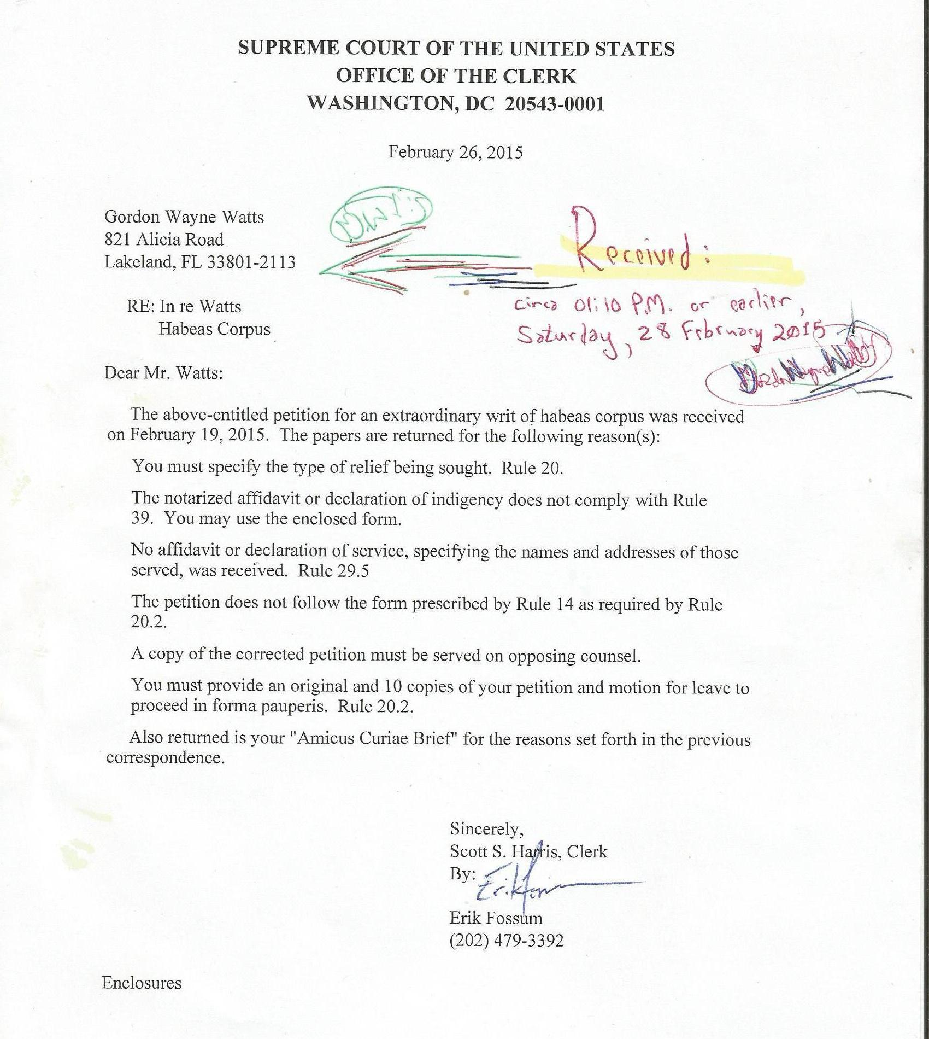

Screenshot of U.S. Supreme Court online docket for
Obergefell et al., v. Hodges, dated February 04, 2015 APPENDIX B:

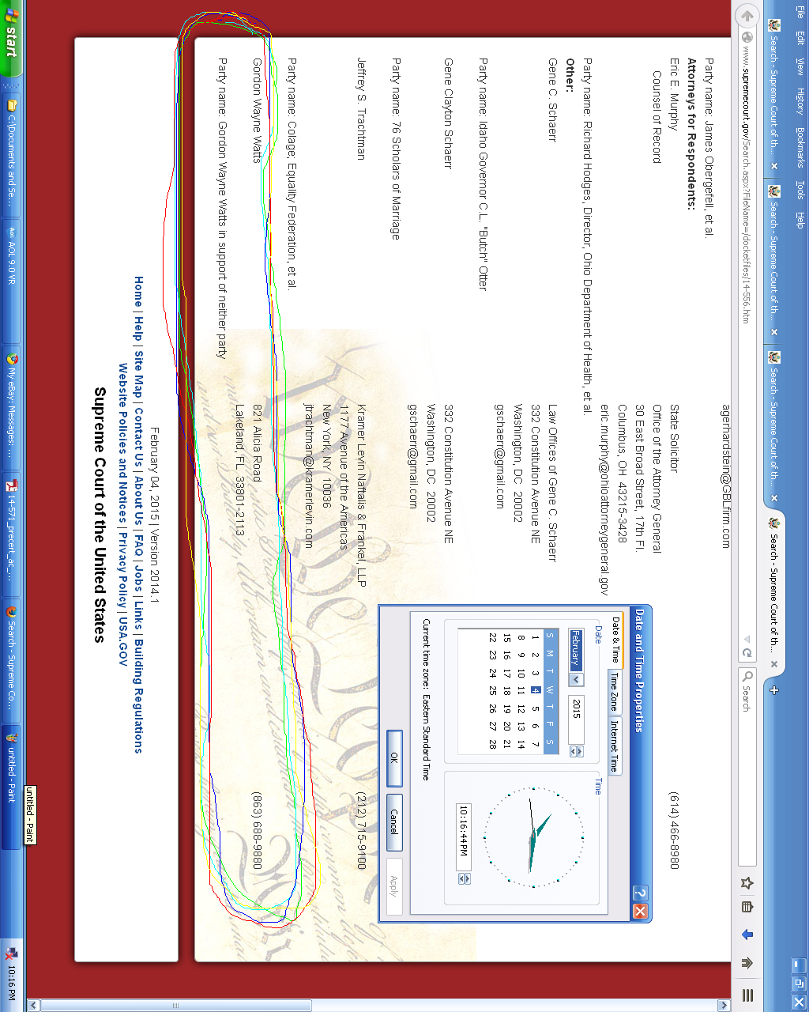

Links to court websites to verify selected citations APPENDIX C:

[1] In Re: GORDON WAYNE WATTS (as next friend of THERESA MARIE 'TERRI' SCHIAVO), No. SC03-2420 (Fla. Feb.23, 2005), denied 4-3 on rehearing. (Watts got 42.7% of his panel) http://www.floridasupremecourt.org/clerk/dispositions/2005/2/03-2420reh.pdf
[2] In Re: JEB BUSH, GOVERNOR OF FLORIDA, ET AL. v. MICHAEL SCHIAVO, GUARDIAN: THERESA SCHIAVO, No. SC04-925 (Fla. Oct.21, 2004), denied 7-0 on rehearing. (Bush got 0.0% of his panel before the same court) http://www.floridasupremecourt.org/clerk/dispositions/2004/10/04-925reh.pdf
[3] Schiavo ex rel. Schindler v. Schiavo ex rel. Schiavo, 403 F.3d 1223, 2005 WL 648897 (11th Cir. Mar.23, 2005), denied 2-1 on appeal. (Terri Schiavo's own blood family only got 33.3% of their panel on the Federal Appeals level) http://media.ca11.uscourts.gov/opinions/pub/files/200511556.pdf

