No. 14-8744

_______________________

In The
Supreme Court of the United States

______________________________________________

In re: Gordon Wayne Watts, Petitioner

On petition for The Extraordinary Writ of Habeas Corpus (per Rule 20.2) to

The United States Supreme Court

SUPPLEMENTAL BRIEF

Gordon Wayne Watts
821 Alicia Road
Lakeland, FL 33801-2113
Phone: (863) 688-9880

Date: Friday, 13 March 2015

QUESTION(S) PRESENTED

(Original Questions presented in petition on docket)

- Whether Due Process is implicated when an indigent pro se litigant who can not afford an attorney barred in This Court, as RULE 37 requires, wishes to have access to Redress This Court regarding participation as an Amicus Curiae.
- Whether Equal Protection is implicated when other, otherwise equally-situated litigants gain access to This Court to file 'Friend of the Court' briefs, as compared to an indigent pro se litigant who can not afford an attorney barred in This Court, as RULE 37 requires.
- Whether case law, Common Law, and U.S. Constitutional Provision exists to support a basis for Habeas Corpus to issue to test this particular deprivation of liberty, namely lack of Due Process to access the courts, and Unequal Protection of indigent pro se litigants who wish to be a 'Friend of the Court' and participate in the Democratic Process of 1st Amendment Redress.

(Supplemental Questions addressed in this Supplemental Brief)

- Whether the Justices would need access to proposed amicus brief in order to make an informed decision on the matter in the case at bar.
- Whether pro se amici can potentially be helpful to the Appellate Jurisdiction of This Honourable Court.

(a)

LIST OF PARTIES

All parties do not appear in the caption of the case on the cover page. A list of all parties to the proceeding in The Court whose judgment is the subject of this petition (This Honourable Court) is as follows:

Gordon Wayne Watts, Petitioner, in the case at bar: “In Re; Gordon Wayne Watts,” “Petition for the Extraordinary Writ of Habeas Corpus, per RULE 20.2,” in Case #: 14-8744

James Obergefell, et al., Petitioners, in Case #: 14-556

Richard Hodges, Dir., Ohio Department of Health, et al., Respondents, in Case #: 14-556

Valeria Tanco, et al., Petitioners, in Case #: 14-562

Bill Haslam, Governor of Tennessee, et al., Respondents, in Case #: 14-562

April DeBoer, et al., Petitioners, in Case #: 14-571

Rick Snyder, Governor of Michigan, et al., Respondents, in Case #: 14-571

Gregory Bourke, et al., Petitioners, in Case #: 14-574

Steve Beshear, Governor of Kentucky, et al., Respondents, in Case #: 14-574

(b)

TABLE OF CONTENTS

COVER PAGE...........................................................................................................(Not Numbered)
QUESTION(S) PRESENTED...........................................................................................................a
LIST OF PARTIES............................................................................................................................b
TABLE OF CONTENTS....................................................................................................................c
INDEX TO THE APPENDICES.........................................................................................................c
OPINIONS BELOW: – N/A in Original Jurisdiction petitions such as this –
TABLE OF AUTHORITIES CITED....................................................................................................d

JURISDICTION.................................................................................................................................1

CONSTITUTIONAL AND STATUTORY PROVISIONS INVOLVED..................................................1

STATEMENT OF THE CASE......................................................................................................2—3

Notice of one Scrivener's Error.........................................................................................................3
Supplements to “REASONS FOR GRANTING THE WRIT (ARGUMENT)”................................4—5

CONCLUSION..................................................................................................................................6

PROOF (CERTIFICATE) OF SERVICE......................................................................................7—8

PROOF (CERTIFICATE) OF COMPLIANCE (2 certificates)............................................................8

INDEX TO THE APPENDICES

APPENDIX A: Photo of Amicus Brief for which leave is being sought

APPENDIX B: March 09, 2015 Postmark on returned mail

APPENDIX C: Box with 41 court briefs and letter from clerk, received, Wed. 11Mar 2015

APPENDIX D: Scanned image of proposed Amicus Curiae brief of Gordon Wayne Watts

APPENDIX E: Letter from Assistant Clerk, Cynthia Rapp, dated March 9, 2015

(c)

TABLE OF AUTHORITIES CITED

Cases Page Number

Bourke, et al., v. Beshear, et al., (No. 14-574, Cert granted).........................................................(b)
DeBoer, et al., v. Snyder, et al., (No. 14-571, Cert granted)...........................................................(b)
In Re: Gordon Wayne Watts (as next friend of Theresa Marie 'Terri' Schiavo),
No. SC03-2420 (Fla. Feb.23, 2005) – denied 4-3 on motion for rehearing......................................2
In Re: Jeb Bush, Governor of Florida, et al. v. Michael Schiavo, Guardian: Theresa
Schiavo, No. SC04-925 (Fla. Oct.21, 2004) – denied 7-0 on motion for rehearing..........................2
Obergefell, et al., Hodges, et al., (No. 14-556, Cert granted)........................................................(b)
Schiavo ex rel. Schindler v. Schiavo ex rel. Schiavo, 403 F.3d 1223,
2005 WL 648897 (11th Cir. Mar.23, 2005) – denied 2-1 on appeal..................................................2
Tanco, et al., v. Haslam, et al., (No. 14-562, Cert granted)............................................................(b)

Statutes and Rules

28 U. S. C. §2241.............................................................................................................................1
28 U. S. C. §2242.............................................................................................................................1

Rule 15.8, US Supreme Court......................................................................................................3, 6
Rule 20.4, US Supreme Court......................................................................................................1, 6
Rule 29, US Supreme Court.............................................................................................................7
Rule 33.1, US Supreme Court.................................................................................................3—4, 8
Rule 33.2, US Supreme Court..........................................................................................................8
Rule 37, US Supreme Court....................................................................................................passim

Other

1 Bouv. Inst. n. 601............................................................................................................................................1

Due Process..............................................................................................................................................passim

Equal Protection.......................................................................................................................................passim

(d)

JURISDICTION
This case is an Original Jurisdiction petition, authorised by RULE 20.4 of This Court, Procedure on a Petition for an Extraordinary Writ of Habeas Corpus.

The jurisdiction of This Court is invoked under 28 U. S. C. §§ 2241 and 2242.

CONSTITUTIONAL AND STATUTORY PROVISIONS INVOLVED
The 1st, 5th, 9th, and 14th Amendments of the U.S. Constitution are involved, and the Statutory (or regulatory) provision of RULE 20 of This Honourable court is involved and under review in this petition. Also, Common Law, as cited in 1 Bouv. Inst., n.601, is involved:

“A l'impossible nul n'est tenu.” (No one is bound to do what is impossible.) or possibly: “The Law does not require that which is impossible.” 1 Bouv. Inst. n. 601.

1

STATEMENT OF THE CASE
Petitioner, Gordon Wayne Watts (hereinafter: 'Petitioner'), who has recently successfully filed Amicus Curiae briefs in several U.S. 11th Cir. 'Gay Marriage' cases, and who once almost won in state court as Theresa 'Terri' Schiavo's ''next friend,” doing better than Jeb Bush or Terri's own blood family, attempted to file an amicus brief in This Court pro se –due to inability to hire a lawyer to file, but was unable, as outlined in greater detail in the 'Statement of the Case' section of the petition in the case sub judice. [For the sake of brevity – The Statement of Case/Facts in Petitioner's Habeas petition, which is on docket in case #: 14-8744, is incorporated by reference herein as if fully set forth herein.]
In response to this problem, Petitioner, in the case at bar, submitted O+10 of the In Forma Pauperis motion, which apparently has been granted, O+10 of the Petition for the Extraordinary Writ of Habeas Corpus to test an alleged deprivation of liberty/redress regarding submission of a proposed brief, and O+O+40 (i.e., 2 originals and 40 copies, for 42 copies in total) of the proposed 6¹/₈- by x 9¹/₄-inch booklet format amicus briefs. (APX-A) This Court received said documents on Monday, 09 March 2015, as reflected by This Court's online docket: http://www.supremecourt.gov/Search.aspx?FileName=/docketfiles/14-8744.htm
Petitioner, once finished, trusted The Court to review the documents in question and yield an equitable and fair decision; however, on Wednesday, 11 March 2015 (APX-B), two days later, Petitioner received in the mail (APX-C), from This Court, 41 of the 42 copies of the proposed Amicus (APX-D), with a letter from the clerk's office (APX-E), apparently keeping one signed original, which worried Petitioner, due to the fact that Justices would be asked to make a decision without all the facts –or the ability to review proposed brief. That Wednesday, Petitioner spoke by phone with assistant clerk, Jake Travers, asking why proposed briefs were returned, and Mr. Travers informed him that Court would not file or accept 6¹/₈- by x 9¹/₄-inch booklet format amicus
2

briefs from persons who are not members of This Court's bar, pointing out, rather, that This Court's rules stipulated that proper protocol for adding additional information would be a supplemental brief, as proscribed in Rule 15.8 of This Court.
In response, Petitioner is now filing the instant “Supplemental Brief” in the case at bar, in an attempt to follow the proper protocol to bring to the attention of The Court relevant matter that he feels is not already being brought to its attention by the parties listed on page (b) of the instant brief, in order to be of considerable help to the Court, as Rule 37.1 outlines.

Notice of one Scrivener's Error:

This error was not seen when initially submitting this Habeas Petition, and is only now being caught, thus a correction is added to this Supplemental Brief:
On page 8 of the petition in this case, brief states: “I made updates and am still slightly under the 9,000-word limit, even when counting total words, and not just those “not excluded.””
However, this was in reference to the February 2015 revision of proposed Amicus Curiae brief of Gordon Wayne Watts. The March 2015 revision, which is what was submitted this last time, has 10,043 total words, as the Word Processor counts, and when excluding the parts excluded by Rule 33.1(d), namely: the questions presented, etc. (as stated in Certificate of Compliance), then the total word-count drops to 8,932, just under the 9,000-word limit imposed upon Amici of this type.

3

Supplements to “REASONS FOR GRANTING THE WRIT (ARGUMENT)”
Petitioner, who almost won in court as Terri Schiavo's next friend, and who participated vigorously pro se as an amicus in other 'Gay Marriage' cases before the 11th Circuit, may not be a lawyer, but he is no village idiot when it comes to law.
After Petitioner, Watts, reviewed numerous briefs on “both sides” of the issue, he saw that none of them offered a solution that would “work for all,” and so he crafted a well-argued brief (APX-D) that gives a solution to both the 'traditional marriage' advocates (who wish to keep the definition of marriage as 1 man and 1 woman), and also showed how solutions to 'Gay Rights' advocates were enacted in the past without changing the definition of marriage.
To that end, he included 2 originals + 40 copies of his proposed Amicus Curiae brief in his petition seeking leave to file in spite of RULE 37.1, which, he argued, places an unconstitutional restriction on access to the courts to poor people, who can't afford a lawyer permitted to file amici briefs. However, it never crossed his mind that The Court would return some of the documents. Every since the very beginning of time, it is well-established case-law (or Common Law, as the case may be) that any time a litigant seeks permission to file a brief that would normally not otherwise be permitted, the motion is filed with the brief—and as one document. (For example, RULE 37.2(b), of This Court, states: “The motion, prepared as required by Rule 33.1 and as one document with the brief sought to be filed, shall be submitted within the time allowed...”) Even though the “rules” prohibit the brief in question from being “filed,” it nonetheless is “tendered for review“ by This Court. (APX-D) And, the reasons are obvious: The Justices are not Psychic.
That argument may sound a bit 'simplistic,' but, in fact, Due Process demands that Judges and Justices have all the facts in order to make an informed decision. (Even though

4

this court's Justices are no doubt very intelligent, and have pure motives and a willing heart, nonetheless, they are not psychic: they, like all human judges, need facts in order to render an informed decision—to make just, fair, and accurate judgment.
To that end, Petitioner is including, in the proper protocol – and according to The Rules of This Court – a scanned image of the brief in question: See Appendix-D.
Some might say that petitioner is trying to 'get around' the rules, but that begs the question, and assumes that the rule being challenged is, in fact, equitable and constitutional. But: what if it is not? What if, at the end of the day, The Justices look at the amicus brief in question and say: “you know, this might be helpful to our understanding of the case,” but the ruling was already entered? Oops... too late!
The justices may look at the briefs and say “we don't want to hear from pro se litigants unless they're arguing their own cases,” or, perhaps, the Justices may say: “That Watts brief makes no sense, and should not be granted leave.”
But, even if This Noble Court rules against Petitioner, all this is asked are 2 things: (1) Actually read the petition and get the facts; and, (2) even if a decision is rendered that does not favour grant of the petition, Petitioner makes a reasonable request for an explanation: a “why” to explain the “what.”
Was the 'Watts' Amicus repetitive and unhelpful? If so, why?
Is Petitioner's proposed Amicus not a good solution both “both sides?” (If so, why not?)
Even if Petitioner's Amicus brief is helpful to This Court, would it set “bad precedent” to “open the door” to 'unprofessional' non-lawyers that would not be helpful to This Court? (If so, that begs the question: if it's such a 'bad' idea, then why do so many other courts countenance pro se amici?) “Things that make you go: 'hmm...'.”

5

CONCLUSION
When we look into the rules, we see that RULE 15.8 clearly states:
“Rule 15. Briefs in Opposition; Reply Briefs; Supplemental Briefs … 8. Any party may file a supplemental brief at any time while a petition for a writ of certiorari is pending, calling attention to new cases, new legislation, or other intervening matter not available at the time of the party’s last filing. A supplemental brief shall be restricted to new matter and shall follow, insofar as applicable, the form for a brief in opposition prescribed by this Rule.” [Editor's note: Habeas petitions are treated, under RULE 20, the same way as cert petitions.]

There indeed was an “intervening matter not available at the time of the party’s last filing,” namely Clerk, Cynthia Rapp (APX-E), for whatever reason, returning proposed brief, in contradiction to both Due Process and long-standing Common Law, thus depriving Justices of ability to make an informed decision. Thus, a supplemental brief is in order. Petitioner's brief, here, “shall be restricted to new matter,” and not get off topic: Here's the “supplemental” information to help This Court get the facts it needs: See the Appendices. Moreover, said amicus is front-page news of Petitioner's namesake blog, highly ranked in search engines, due to the fact that he almost won in court for Terri Schiavo –all by himself.
Here's the 'supplemental' information This Court needs to understand this matter fully.

Respectfully submitted, Date: Friday, 13 March 2015
Gordon Wayne Watts, Amicus Curiae*
http://GordonWatts.com / http://GordonWayneWatts.com
821 Alicia Road, Lakeland, Florida 33801-2113
H: (863) 688-9880 ; W: 863-686-3411 ; 863-687-6141
E-mail: gww1210@aol.com ; gww1210@gmail.com

s/ _________________________________

Gordon W. Watts, PRO SE / PRO PER, in persona propia

* Watts, acting counsel of record, is not a lawyer. Per
RULE 34.1(f), Watts, appearing pro se, is listed.

6

No. 14-8744

IN THE
SUPREME COURT OF THE UNITED STATES

In re: Gordon Wayne Watts — PETITIONER

PROOF (CERTIFICATE) OF SERVICE

I, Gordon wayne Watts, do swear or declare that on this date, FRIDAY, the 13th day of March 2015, as required by Supreme Court Rule 29, I have served the enclosed SUPPLEMENTAL BRIEF on each party to the above proceeding or that party’s counsel, and on every other person required to be served, by depositing an envelope containing the above documents in the United States mail properly addressed to each of them and with first-class postage prepaid, or by delivery to a third-party commercial carrier for delivery within 3 calendar days.

The names and addresses of those served are as follows:

• Supreme Court of the United States, 1 First Street, N.E., Washington, DC 20543, ATTN: Clerk of the Court, (202) 479-3011, MeritsBriefs@SupremeCourt.gov

• Alphonse A. Gerhardstein, Counsel of Record for James Obergefell, et al., c/o: Gerhardstein & Branch Co. LPA, 432 Walnut St., Suite 400, Cincinnati, OH 45202, (513) 621-9100, AGerhardstein@GBLfirm.com

• Eric E. Murphy, Counsel of Record for Richard Hodges, Director, Ohio Department of Health, et al., c/o: State Solicitor, Office of the Attorney General, 30 East Broad Street, 17th Fl., Columbus, OH 43215-3428, (614) 466-8980, Eric.Murphy@OhioAttorneyGeneral.gov

• Douglas Hallward-Driemeier, Counsel of Record, Valeria Tanco, et al., c/o: Ropes & Gray LLP, 700 12th Street, N.W., Suite 900, Washington, DC 20005, (202) 508-4776, Douglas.Hallward-Driemeier@RopesGray.com

• Joseph F. Whalen, Counsel of Record, Associate Solicitor General, Office of the Attorney General, 425 Fifth Avenue North, Nashville, TN 37243, (615) 741-3499, Joe.Whalen@ag.tn.gov

• Carole M. Stanyar, Counsel of Record, for April DeBoer, et al., 221 N. Main Street, Suite 300, Ann Arbor, MI 48104, (313) 819-3953, CStanyar@wowway.com

• Aaron D. Lindstrom, Counsel of Record, Solicitor General, Michigan Department of Attorney General, P.O. Box 30212, Lansing, MI 48909, (517) 373-1124, LindstromA@Michigan.gov

7

• Daniel J. Canon, Counsel of Record, Gregory Bourke, et al., c/o: Clay Daniel Walton Adams, PLC, 101 Meidinger Tower, 462 South 4th Street, Louisville, KY 40202, (502) 561-2005 x216, Dan@JusticeKY.com

• Leigh Gross Latherow, Counsel of Record, Steve Beshear, Governor of Kentucky, c/o: VanAntwerp, Monge, Jones, Edwards & McCann, LLP, P.O. Box 1111, Ashland, KY 41105, (606) 329-2929, LLatherow@vmje.com

Furthermore, I hereby certify that, contemporaneous to my service by FedEx 3rd-party commercial carrier and/or USPS, I am also serving all parties, and all known amici, by email—and possibly also the court, if it is permitted protocol.
Also, I hereby certify that, in addition to the foregoing and in addition to any availability of my brief that The Court may make available for download, I am also making available both this supplemental brief –and all other documents in this case for open-source (free) download, as soon as practically possible on the front-page news of The Register, whose links are as follows:
http://www.GordonWatts.com
and:
http://www.GordonWayneWatts.com

PROOF (CERTIFICATE) OF COMPLIANCE (proposed Amicus)
Pursuant to Rule 33.1(h), I am hereby certifying that my proposed amicus brief (a scanned image of which is in the appendices and also posted online on my namesake blog, listed immediately above), which I am asking for leave to be filed, complies with the word limitations of This Court: It has 10,043 “total” words, according to the program that I used to create it, Open Office, version 3.1.0, OOO310m11 (build:9399), Copyright 2000-2009 Sun Microsystems Inc. This is not under the 9,000-word limit imposed by Rule 33.1(g). However, when I exclude the parts excluded by Rule 33.1(d), namely: the questions presented, the list of parties in the cover page and the corporate disclosure statement, the table of contents, the table of cited authorities, the listing of counsel at the end of the document and the cover page, and the appendix, then the total word-count drops to 8,932, just under the 9,000-word limit imposed upon Amici of this type. Therefore, my proposed Amicus Curiae brief (which is dated Sunday 01 march 2014) is in compliance with applicable Rules of This Court.

PROOF (CERTIFICATE) OF COMPLIANCE (this Supplemental Brief)
The page-limit for extraordinary writs on 8½” x 11” format are 15 pages for a Supplemental Brief, such as this one, per Rule 33.2(b). Since the Exclusions in Rule 33.1(d) apply (“The word limits do not include the questions presented, the list of parties and the corporate disclosure statement, the table of contents, the table of cited authorities, the listing of counsel at the end of the document, or any appendix.”), therefore, I do not need to count the appendix below, and thus this brief is far under the 15-page upper limit imposed on Supplemental Briefs of this type.

I declare under penalty of perjury that the foregoing (including my both Certificate of Service and both Certificates of Compliance, above) is true and correct.

Executed on Friday, 13 March 2015.

_____________________
(Signature)

8

INDEX TO THE APPENDICES

Instrument Docket/Tab#

Photo of Amicus Brief for which leave is being sought Appendix: A –

March 09, 2015 Postmark on returned mail Appendix: B –

Box with 41 court briefs and letter from clerk, received, Wed. 11Mar 2015 Appendix: C –

Scanned image of proposed Amicus Curiae brief of Gordon Wayne Watts Appendix: D –

Letter from Assistant Clerk, Cynthia Rapp, dated March 9, 2015 Appendix: E –

Appendix: A – Photo of Amicus Brief for which leave is being sought

[Redacted – see below.]

Appendix: B – March 09, 2015 Postmark on returned mail

[Redacted – see below.]

Appendix: C – Box with 41 court briefs and letter from clerk, received, Wed. 11Mar 2015

[Redacted – see below.]

Appendix: D – Scanned image of proposed Amicus Curiae brief of Gordon Wayne Watts
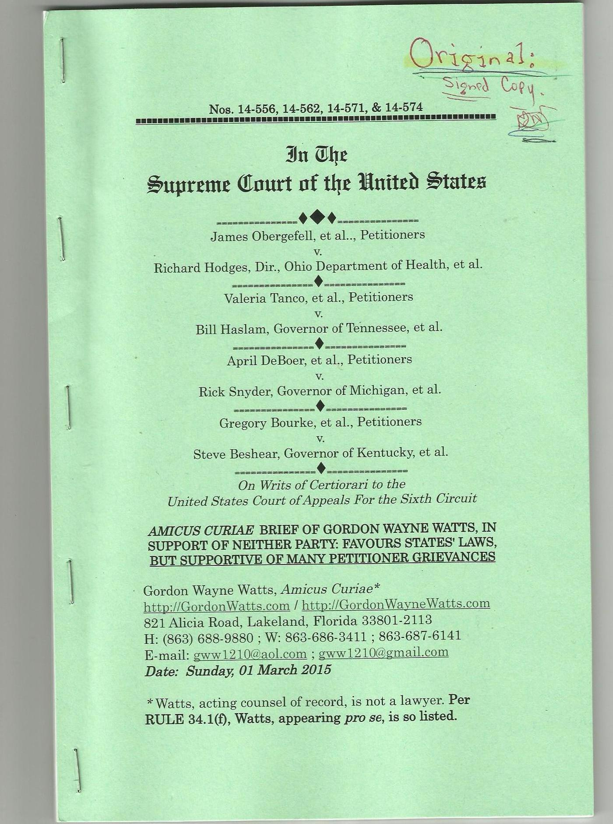
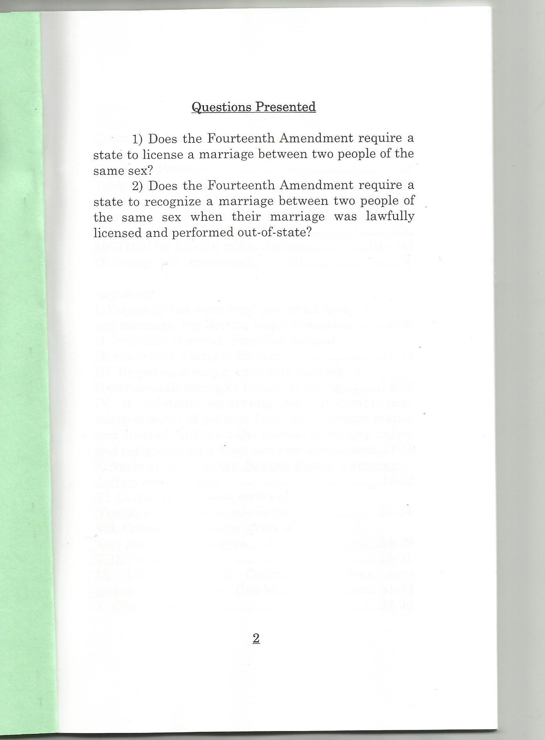

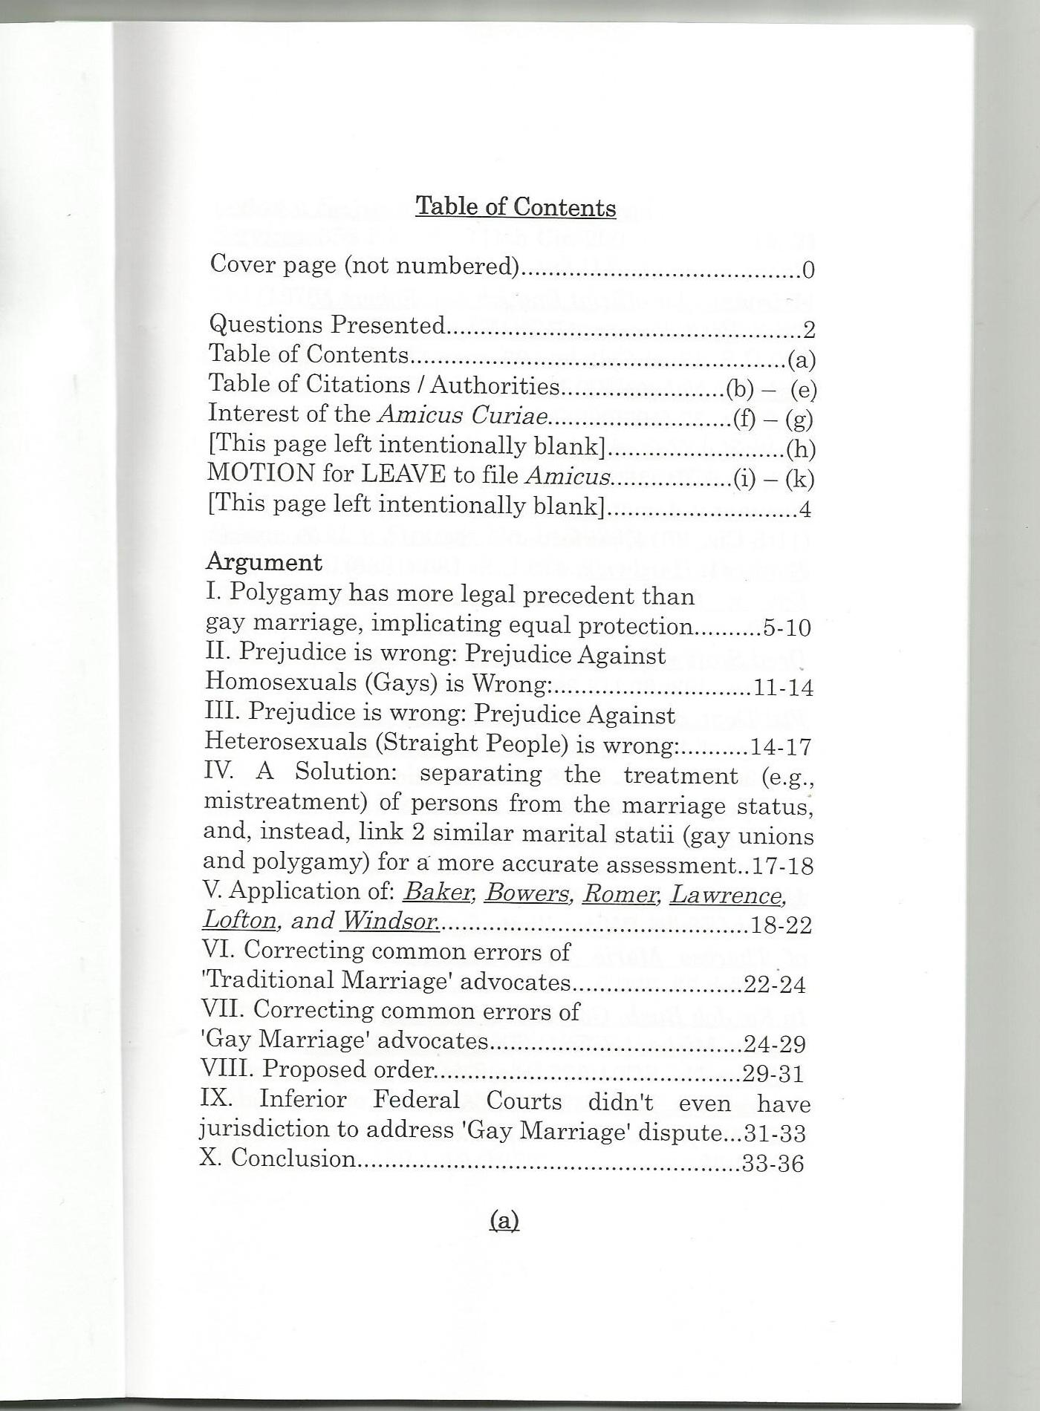
NOTE: This is a 'redacted' copy of my Supplemental Brief.

The reason that I'm redacting several of the appendices (including most of Appendix: D, a Scanned image of proposed Amicus Curiae brief of Gordon Wayne Watts) is simply because the original copy of this brief was 30.148 Megabytes in PDF format -due to a bunch of image files scanned in and added to the Appendix, and even in *.doc (Microsoft Word) format, it was 13.807 MB, which exceeds the limits for uploads on PR Web. (An exact quote from their upload module is as follows: “Issues

- Attachments cannot be larger than 3 MB.” (And, I add, the large file size makes it difficult to send as an e-mail attachment.)

Since you're viewing a 'redacted' copy (and not a 'TRUE COPY' as I filed with The Court, and served upon ALL parties -and even all Amici -as indicted in the Certificate of Service), I owe it to you to tell you “what's missing, and 'why'.”

The 'why' was already explained, but here's the 'what':

I'm redacting most of APX-D, and all of the other Appendices, i.e., APX-A, B, C, and E.

Lastly, if you want to get a 'TRUE COPY' of this Supplemental Brief, you may download it from either of the 2 official mirrors for The Register, my official news blog.

Alternatively, you may download and view a copy of the original Amicus Curiae brief, which was printed out and scanned in as images for APX-D; the Amicus in question is located at the same place.

Both briefs, in fact, all the filings -and a link to The Supreme Court's own docket -are available for your download. The official links are as follows:

http://www.GordonWatts.com

or:

http://www.GordonWayneWatts.com

To download & view case documents, reference the 'Lady Justice' twin ON THE RIGHT-HAND SIDE, and then look directly beneath her: the files are listed there. There are additional documents linked in the news coverage, also presently front-page news.

Gordon Wayne Watts
Editor-in-Chief, The Register

Appendix: E – Letter from Assistant Clerk, Cynthia Rapp, dated March 9, 2015

[Redacted – see above.]

