IN THE UNITED STATES COURT OF APPEALS
FOR THE ELEVENTH CIRCUIT
_____________________

Nos. 14-14061-AA,
14-14066-AA
_____________________

JAMES DOMER BRENNER,
et al., Plaintiffs-Appellees,
v.
JOHN ARMSTRONG,
et al., Defendants-Appellants.
________________________________________________/

No. 14-14066-AA
SLOAN GRIMSLEY,
et al., Plaintiffs-Appellees,
v.
JOHN ARMSTRONG,
et al., Defendants-Appellants.
________________________________________________/

BRIEF OF AMICUS CURIAE SPOOKY-SPOCK
IN SUPPORT OF NEITHER PARTY

BRUCE WAYNE* CLARK KENT

THE BAT-CAVE APPELLATE LAW FIRM Kal-El, Kent, and Krypton, LLC
Legion of Superheros Complex The Daily Planet
Suite 2 Legal Department
Gotham City, NY 10001 Metropolis, NY 10027

*Counsel of Record Web-design Department,
'Flash' Gordon Wayne Watts
Official websites:
Dated: Wednesday, January 07, 2015 www.GordonWatts.com
www.GordonWayneWatts.com

www.PRWeb.com/releases/2014/12/prweb12361433.htm
www.GordonWatts.com/DOCKET-GayMarriageCase.html
www.GordonWayneWatts.com/DOCKET-GayMarriageCase.html

IDENTITY AND INTEREST OF AMICUS CURIAE¹

Comes now, Spooky-Spock, and states his identity and interest in the case:

I am Spooky-Spock, and therefore, it is logical to conclude that I am the foremost Spooky-Spockologist, and therefore an expert in all areas of logic, reason, and, as such, I find it highly illogical for me to support either party, as both parties have made mistakes. Therefore, the arguments of Amicus, Gordon W. Watts, are incorporated by reference herein as if fully set forth herein. Since I need make no further arguments, I shall invoke the Fed.R.App.P. Rule 32.(a)(1)(C), cited by other Amicu, and which states: “Photographs, illustrations, and tables may be reproduced by any method that results in a good copy of the original; a glossy finish is acceptable if the original is glossy.”
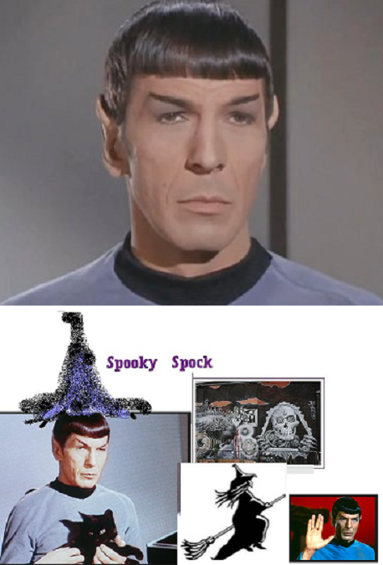
_______
¹ In accordance with Rule 29, Fed.R.App.P., comes now Spook-Spock, Amicus Curiae, as Friend of the Court, and hereby certifies: I have consulted with lead attorneys for all parties, seeking consent to filing of this amicus brief, and I state that said parties have consented to its filing. No party or party’s counsel authored this brief in whole or in part or financially supported this brief, and no one other than amicus curiae, its members, or its counsel contributed money intended to fund preparing or submitting said brief.

