UNITED STATES COURT OF APPEALS
FOR THE ELEVENTH CIRCUIT
OF THE 'HUMAN' PLANET 'EARTH'
Case Nos. 14-14061-AA, 14-14066-AA

JAMES BRENNER, et al.,
Plaintiffs-Appellees.
v.
JOHN ARMSTRONG, et al.,
Defendants-Appellants.

Appeal from the EARTH'S U.S. District Court
for the Northern District of Florida, No. 4:14-cv-107 (Hon. Robert L. Hinkle)

SLOAN GRIMSLEY, et al.,
Plaintiffs-Appellees.
v.
JOHN ARMSTRONG, et al.,
Defendants-Appellants.

Appeal from the EARTH'S U.S. District Court
for the Northern District of Florida, No. 4:14-cv-138 (Hon. Robert L. Hinkle)

BRIEF OF AMICI CURIAE
1,024 SCHOLARS OF THE KLINGON DEPARTMENT OF WAR
IN SUPPORT OF DEFENDANTS-APPELLANTS AND REVERSAL

January 07, 2015 Hon. Chancellor Martok
Chancellor of the Klingon High Council
Affiliation: House of Martok
Representing the The Klingon Empire
Home-world: Planet Qo'noS (earth spelling: 'Kronos'),
Beta Quadrant

Of Counsel: Amb. Gordon W. Watts, Earth Ambassador to Qo'noS
www.GordonWatts.com / www.GordonWayneWatts.com
www.PRWeb.com/releases/2014/12/prweb12361433.htm
www.GordonWatts.com/DOCKET-GayMarriageCase.html
www.GordonWayneWatts.com/DOCKET-GayMarriageCase.html
1
TABLE OF CONTENTS

Cover page................................................................................................................…...........................1

Table of Contents....................................................................................................................................2

ARGUMENT I. We are Klingons, and you are Humans: you will obey!................................2

CONCLUSION.........................................................................................................................................2

ARGUMENT I.
WE ARE KLINGONS, AND YOU ARE HUMANS: YOU WILL OBEY!

We are warriors! All we need is one argument: The homosexual behavior is without honor, and the Imperial Klingon Empire (IPE) will not tolerate any dishonor among our Earth subjects.

We notice that the Earth/Human Hippies were clever and innovative “word-warriors” and cited to Fed.R.App.P. Rule 32.(a)(1)(C) (Form of Briefs, Appendices, and Other Papers), which states that: “Photographs, illustrations, and tables may be reproduced by any
method that results in a good copy of the original; a glossy finish
is acceptable if the original is glossy.”

So, we will skip right to our conclusion by way of image communication:

CONCLUSION:

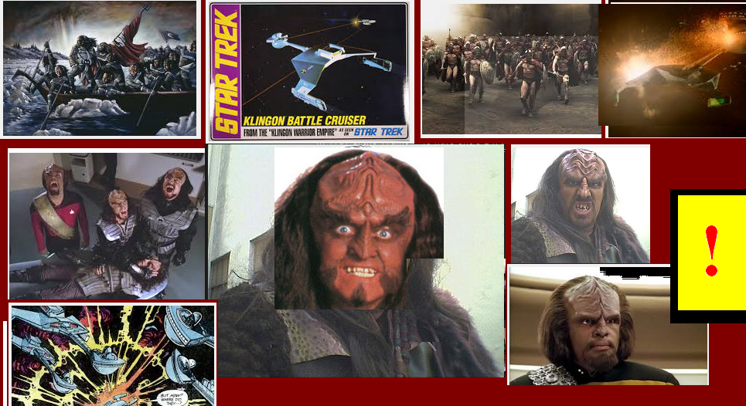
2

