GOP lawmakers need to grant Trump spending cuts request to free
up funding to address COVID-19/Coronavirus National Emergency

We are facing a national emergency with the COVID-19/Coronavirus epidemic, and do NOT need to use precious taxpayer dollars for special interest “Pork Barrel” spending. After careful review of recent budgets, most things (Medicare, Social Security, Defense, etc.) CAN'T be cut much—or at all. ( ..!!.. )
Friday, March 27, 2020 -Petition by Gordon Wayne Watts, Editor-in-Chief, The Register (A Conservative publication)
Updated: Sunday, April 26, 2020

(Sources Official GAO report: https://www.GAO.gov/assets/700/698089.pdf House Budget Committee:
https://budget.house.gov/sites/democrats.budget.house.gov/files/wysiwyg_uploaded/Screen%20Shot%202019-01-18%20at%209.24.39%20AM.png
The Register, cache-1: https://GordonWatts.com/proof-read___Letter-to-the-Prez_ATTACHMENTS_PDF.pdf
The Register, cache-2: https://GordonWayneWatts.com/proof-read___Letter-to-the-Prez_ATTACHMENTS_PDF.pdf << (See page 83ff of The Register's cache for summary, as linked here.)

Only ONE (1) 'sizable' thing we can cut in the current budget in outlays, e.g., spending: STUDENT DEBT, which comprises almost TEN (10%) PERCENT of total U.S. Debt, almost $2 Trillion ÷ $20 Trillion or so: “Today, FSA's [student debt] portfolio is nearly 10 percent of our nation's debt. [] Stop and absorb that for a moment. Ten percent of our total national debt.” Source: U.S. Dept of Education, Sec. of Education, Betsy DeVos, 11-27-2018 speech
LINK: https://www.ED.gov/news/speeches/prepared-remarks-us-secretary-education-betsy-devos-federal-student-aids-training-conference Fair use archives: https://GordonWatts.com/DeVos-speech_11-27-2018_PDF.pdf
Or: https://gordonWAYNEwatts.com/DeVos-speech_11-27-2018_PDF.pdf Conservatives have, for years—for decades—have complained about excess spending of taxpayer dollars to make or guarantee student loans: “If anything, increases in financial aid in recent years have enabled colleges and universities blithely to raise their tuitions, confident that Federal loan subsidies would help cushion the increase.” Source: “Our Greedy Colleges,” By Dr. William J. “Bill” Bennett, former Secretary of Education under President Ronald Reagan, The New York Times, 18 February 1987, LINK: https://www.NyTimes.com/1987/02/18/opinion/our-greedy-colleges.html

More recently, Conservative advocate Gordon W. Watts made the same calls for sanity: “Congress should pass a bill reversing the obscene increases in college loan limits as allowable by the College Access and Opportunity Act of 2005, a bill introduced by former Speaker John Boehner, which was the cause of this crippling and massive college debt, and benefited only the banks and universities. [] When colleges and universities knew students could take out “deep pockets” loans, they jacked up tuition in response to the additional money available, thereby fueling tuition inflation and proving former Education Secretary Bill Bennett’s hypothesis: When you subsidize anything, price goes up.” Source: "A Polk Perspective: Fix our bankrupt policy on student debt," By Gordon Wayne Watts, Guest columnist, The Ledger, August 04, 2016, LINK: https://www.TheLedger.com/opinion/20160804/a-polk-perspective-fix-our-bankrupt-policy-on-student-debt FAIR USE
CACHE #1: https://GordonWatts.com/TheLedger-Online-PDF-FairUse-cache-WATTS-GuestColumn-Thr04Aug2016.pdf FAIR USE CACHE #2: https://GordonWAYNEwatts.com/TheLedger-Online-PDF-FairUse-cache-WATTS-GuestColumn-Thr04Aug2016.pdf

“My prior column documented Ross’...opposition for use of tax dollars to make or guarantee said loans. But he never introduced legislation for [this]. Where has that gotten us? [] Collegiate debt, now almost $2 trillion, is almost 10 percent of total U.S. debt. I predict we will crash the U.S. dollar if we ignore “crazy Gordon” one more time.” Source: "Polk Perspective: Rescue taxpayers from mounting student debt," By Gordon Wayne Watts, Guest columnist, The Ledger, November 16, 2018, LINK: https://www.TheLedger.com/opinion/20181116/polk-perspective-rescue-taxpayers-from-mounting-student-debt
FAIR USE CACHE #1: https://GordonWatts.com/TheLedger-Online-PDF-FairUse-cache-WATTS-GuestColumn-Fri16Nov2018.pdf FAIR USE CACHE #2: https://GordonWAYNEwatts.com/TheLedger-Online-PDF-FairUse-cache-WATTS-GuestColumn-Fri16Nov2018.pdf

“On Nov. 16, 2018, The Ledger published my column decrying skyrocketing tuition and mounting student debt, paid for by our tax dollars. [] Apparently, in response to my column, U.S. Secretary of Education Betsy DeVos, in her speech 11 days later, repeated my complaints that “collegiate debt, now almost $2 trillion, is almost 10 percent of total U.S. debt.” I quote her: “Today, FSA's [student debt] portfolio is nearly 10 percent of our nation's debt. Stop and absorb that for a moment. Ten percent of our total national debt.” [] Apparently, this chain reaction even influenced the president to fall in line with conservative spending cuts: Forbes reported on March 19, 2019, that “Trump proposes limits on student loan borrowing.” [] Despite even getting the president's attention, nothing has changed. Lawmakers didn't grant his request, and President Donald Trump, distracted by other issues, has dropped this. Based on that, I maintain my initial prediction of a crash of the dollar if lawmakers refuse to cut
spending.” Source: "Polk Perspective: Offer relief for taxes dressed up as ’loans’," By Gordon Wayne Watts, Guest columnist, The Ledger, November 19, 2019, LINK: https://TheLedger.com/opinion/20191119/polk-perspective-offer-relief-for-taxes-dressed-up-as-loans FAIR USE CACHE #1: https://GordonWatts.com/TheLedger-Online-PDF-FairUse-cache-WATTS-GuestColumn-Tue19Nov2019.pdf FAIR USE CACHE #2: https://GordonWAYNEwatts.com/TheLedger-Online-PDF-FairUse-cache-WATTS-GuestColumn-Tue19Nov2019.pdf

Apparently, Secretary DeVos' copy-catting my complaints influenced even the President to repeat our warnings: “Trump Proposes Limits On Student Loan Borrowing,” By Zack Friedman, FORBES, Tue. March 19, 2019,
LINK: https://www.Forbes.com/sites/zackfriedman/2019/03/19/trump-proposes-limits-on-student-loans

Moreover, I can assure you that our GOP Lawmakers have seen my columns—multiple times (not counting my calls to their office to ask them to please grant President Trump's much-needed spending cuts request), and here is but one example, which was acknowledged by my Congressman's staff in this Sun, Dec 8, 2019 at 4:58 PM email:
Mirror 1: https://GordonWatts.com/RandomHigherEd-DIALOGUE-thread.pdf
Mirror 2: https://GordonWayneWatts.com/RandomHigherEd-DIALOGUE-thread.pdf

I asked my GOP lawmakers to grant Trump's spending request in my letter above, and in this letter to Rick Scott's office, dated Thu, Mar 12, 2020 at 4:57 PM:
Mirror 1: https://GordonWatts.com/WhyHasntRickScottGrantedTrumpsRequest.pdf
Mirror 2: https://GordonWayneWatts.com/WhyHasntRickScottGrantedTrumpsRequest.pdf

And again in my email to all my GOP lawmakers, dated Wed, Mar 25, 2020 at 6:33 PM:
Mirror 1: https://GordonWatts.com/EXCESS-spending-WARNINGS.pdf
Mirror 2: https://GordonWayneWatts.com/EXCESS-spending-WARNINGS.pdf

Yet, even after years (decades) of repeated warnings regarding overspending, NONE of my GOP lawmakers (with one partial exception) have heeded my warnings, acknowledged my requests, or enrolled legislation to the request of President Trump (and numerous other Conservatives). The sole exception was Rep. Ross Spano (R-FL-15), my Congressman, who, in “invited me to a personal one-on-one meeting July 30, 2019, as he has with other constituents. In attendance were myself, Rep. Spano, and two senior staff, Blaine Gravitt and James Jacobs. We spoke for 30 minutes about unfinished business in higher education.” Source: "Polk Perspective: Offer relief for taxes dressed up as ’loans’," By Gordon Wayne Watts, Guest columnist, The Ledger, November 19, 2019, linked above. Representative Spano asked me the bill number for Trump's spending cuts bill, but as no lawmaker had enrolled it, there WAS no bill number. More recently, when we spoke at the 2020 Strawberry Festival parade in Plant City (Fla), he said he would look at the Higher Ed budget Trump submitted—which was good, but too slow, in my humble opinion—to put an abrupt halt to rich, Liberal colleges and banks getting huge, Pork Barrel corporate handouts in the form of student loans made or backed by taxpayer dollars—which DON'T help students (they raise tuition to match increased borrowing abilities) and DON'T help taxpayers (as we can't afford to throw good money after bad—almost TEN PERCENT of U.S. Debt is Student Debt).

IN LIGHT OF THE COVID-19/CORONAVIRUS NATIONAL EMERGENCY, such wasteful Liberal Pork Barrel spending is even MORE dangerous, and needs to STOP.

I make this petition to ask true Americans and genuine, honest Conservatives EVERYWHERE to join my voice in calling for our GOP delegation of Federal Lawmakers (U.S. Senators & Members of Congress) to STOP Liberal “excess spending like a drunken sailor.” (Apologies to all drunken sailors...for the comparison!) BUT—before I make my petition for a SOLUTION, proper, it is only logical to ask “why” there was/is a PROBLEM, so here are my top-3 guesses:
- Rich, Liberal College/Bank mega-plex threatens to cut “campaign contributions” or “primary” lawmakers who don't vote for increased “Loan Limits” to student loans (which means obscenely high spending of our taxpayer dollars to make/back said loans) – because the poor college student (who must get an education) is a “conduit” or “pass through” of funding from taxpayers to the Liberal College/Bank mega-plex—and they depend on duped voters who will blame the student (“you took out the loan, you pay for it.”).
- Humans are a sinful, fallen race, in that included GOP lawmakers who support (and enact) sick, obscene excesses in unnecessary Liberal Pork Barrel spending to make “lobbyists” and “Liberal College” special interests happy.
- Lack of Student Loan Bankruptcy uniformity (something guaranteed by The U.S. Constitution, Art.I, Sec.8, Cl.4, the legendary “Uniformity Clause”) is missing, & without “threat of bankruptcy” to scare lenders, they don't think twice before loaning obscene amounts. Thus, Trump's request—without student loan bankruptcy—would force down lending “too suddenly.” Enrolled bills, S.1414 & H.R.2648, which fix this, AREN'T a “free handout” but rather a Constitutionally-guaranteed right—and would use Conservative Market Pressures to force down lending “gradually,” thus making Trump's spending cuts request “less sudden” and more of a political reality—to overcome obstacles (1) and (2) above. CAVEAT: Item (3) above is only a “theory” of Conservative writer, Gordon W. Watts, and author of this petition, but if anyone disagrees, please [[A]] explain why GOP lawmakers are tax-and-spend Liberals in their rude refusal to grant President Trump's spending cuts request, and [[B]] please tell me why you don't honour the U.S. Constitution, and [[C]] if you hate the U.S. Constitution, please leave this country, and never come back. *** Indeed, “bankruptcy uniformity,” as guaranteed by the U.S. Constitution's “Uniformity Clause (see above) is very moderate (no extreme Liberal Free Handout), especially now that “Free College” and “Loan Forgiveness” are being floated –and seriously being considered—such as the popular “Jubilee Forgiveness” described in the Holy Bibles of many claiming to be Christian: Deuteronomy 15:1-2a, Deut. 15:1-11, and Leviticus 25:13.--something God's people did every seven (7) years! IMPORTANT: Even in a “worst case” scenario, even if every student loan borrower filed for—and got—full bankruptcy discharge, this would cost taxpayers almost nothing: Thanks to Obama-era regulations, the Federal Government is now the SOLE lender (and SOLE OWNER!) of all current student loans, having purchased almost all of existing student loans. In plain English, this means that, as “Sole Owner” of almost all student loans, the Taxpayer Dollars OWN (and don't “guarantee”) the loans, thus do not need to “pay off” the loans: Taxpayers paid IN FULL these loans when the student took out the loan. In fact, besides the slight 'dip' in payments of students if forgiveness occurred (most aren't repaying these over-inflated price-gouged loans), the sudden shock of a “Loan Cancellation / Biblical Jubilee Forgiveness” would **shock** the lender (the U.S. Gov't) into lowering Loan Limits—thus saving TRILLIONS in taxpayer dollars! (A good thing!) *** The Register is Conservative, and we don't support 100% forgiveness, believing that people should pay if they are able. But, if total loan forgiveness has a strong argument, we don't see what the “problem” is with Bankruptcy Uniformity, as guaranteed by the U.S. Constitution, as implied by no less than Jesus' Golden Rule and the parable of the “Shrewd Manager” (LUKE 16), as well as bankruptcy in use as a Conservative Market Pressure to force down lending “gradually,” thus making Trump's spending cuts request “less sudden” and more of a political reality.

CONCLUSION: Regardless of your views on my novel theories above, if you're a true Conservative, then please “sign” my petition as described below, and if you don't support President Trump's spending cuts requests (by your actions, not mere 'words'), then you're not a Conservative—only a RINO (Republican in Name Only) fake, and need to leave, and never come back. – It's your move...

HOW TO 'SIGN' THIS PETITION:
Contact your Member of Congress https://www.House.gov/representatives/find-your-representative and your U.S. Senator https://www.Senate.gov/general/contact_information/senators_cfm.cfm and [[#1]] CALL, and [[#2]] email them, and [[#3]] contact me to let me know of your results, and [[#4]] SHARE this petition, asking others to do the same. Here are four (4) examples—and you may also contact them on social media:
(1) Sen. Marco Rubio (R-FL) Ph: (202) 224-3041 And: https://www.Rubio.Senate.gov/public/index.cfm/contact
(1) https://www.Facebook.com/SenatorMarcoRubio And: https://Twitter.com/SenRubioPress
(2) Sen. Rick Scott (R-FL) (202) Ph: 224-5274 And: https://www.RickScott.Senate.gov/contact_rick
(2) https://www.Facebook.com/RickScottSenOffice And: https://twitter.com/SenRickScott
(3) Rep. Ross Spano (R-FL-15) Ph: (202) 225-1252 And: https://Spano.house.gov/contact
(3) https://www.Facebook.com/RepRossSpano And: https://Twitter.com/RepRossSpano
(4) Rep. Greg Steube (R-FL-17) Ph: (202) 225-5792 And: https://Steube.House.gov/contact
(4) https://www.Facebook.com/RepGregSteube And: https://www.Twitter.com/RepGregSteube

SELECTED “CONSERVATIVE CREDENTIALS for petition author, Gordon Wanye Watts:

PRO-LIFE:
[1] In Re: GORDON WAYNE WATTS (as next friend of THERESA MARIE 'TERRI' SCHIAVO), No. SC03-2420 (Fla. Feb.23, 2005), denied 4-3 on rehearing. (Watts got 42.7% of his panel) https://www.FloridaSupremeCourt.org/clerk/dispositions/2005/2/03-2420reh.pdf
[2] In Re: JEB BUSH, GOVERNOR OF FLORIDA, ET AL. v. MICHAEL SCHIAVO, GUARDIAN: THERESA SCHIAVO, No. SC04-925 (Fla. Oct.21, 2004), denied 7-0 on rehearing. (Bush got 0.0% of his panel before the same court) https://www.FloridaSupremeCourt.org/clerk/dispositions/2004/10/04-925reh.pdf
[3] Schiavo ex rel. Schindler v. Schiavo ex rel. Schiavo, 403 F.3d 1223, 2005 WL 648897 (11th Cir. Mar.23, 2005), denied 2-1 on appeal. (Terri Schiavo's own blood family only got 33.3% of their panel on the Federal Appeals level) https://Media.ca11.UsCourts.gov/opinions/pub/files/200511556.pdf

PRO-MARRIAGE:
[1] https://www.PRWeb.com/releases/2014/12/prweb12361433.htm
[2] https://www.StreetInsider.com/Press+Releases/Controversial+U.S.+Supreme+Court+rule+is+challenged+in+court/10400849.html
[3] https://GordonWatts.com/DOCKET-GayMarriageCase.html
[4] https://GordonWayneWatts.com/DOCKET-GayMarriageCase.html
Was the ONLY non-lawyer permitted to file in the recent “Gay Marriage” case:
LINK: https://GordonWatts.com/GayMarriageSuit/Order-on-Citro-and-Watts-motions.pdf
OR: https://GordonWayneWatts.com/GayMarriageSuit/Order-on-Citro-and-Watts-motions.pdf

PRO-SECOND AMENDMENT:
LINK: https://GordonWatts.com/Campaign.html#SECOND_AMENDMENT_ISSUES
OR: https://GordonWayneWatts.com/Campaign.html#SECOND_AMENDMENT_ISSUES
[Note: Watts is not running for office; this is an archived page.]

FISCALLY CONSERVATIVE: Calling for both tax and spending cuts in this petition and elsewhere.

CONSTITUTIONALLY CONSERVATIVE: Supports ALL of the U.S. Constitution—in this petition & elsewhere—not just the “popular” parts.

MORAL “Rights & Wrongs” CONSERVATIVE: I sue TEN (10) “Liberal Activist” state judges in Federal Court for Civil Rights abuses—Federal Court reinstates my lawsuit against them:
Mirror 1:
https://GordonWatts.com/MortgageFraudCourtDocs/Doc28_ORDER_Watts-v-CirCt-et-al_1_19-cv-03473-RMD-SEC_PDF.pdf
Mirror 2:
https://GordonWayneWatts.com/MortgageFraudCourtDocs/Doc28_ORDER_Watts-v-CirCt-et-al_1_19-cv-03473-RMD-SEC_PDF.pdf
Watts v. Circuit Court of Cook County, Illinois et. al. (1:19-cv-03473, N.D. ILLINOIS, Federal District Court)
IN THE UNITED STATES DISTRICT COURT FOR THE NORTHERN DISTRICT OF ILLINOIS, EASTERN DIVISION
Online Docket mirror 1: https://GordonWatts.com/MortgageFraudCourtDocs/DOCKET-MortgageFraudCase.html#Federal
Online Docket mirror 2: https://GordonWayneWatts.com/MortgageFraudCourtDocs/DOCKET-MortgageFraudCase.html#Federal

PRO-TRUMP: * “So, you think you know the real Donald Trump?”
Link: https://www.Facebook.com/notes/gordon-wayne-watts/so-you-think-you-know-the-real-donald-trump-fact-checked-wsnopes-truth-or-ficti/10153829730395248
Archive: https://Web.Archive.org/save/https://www.Facebook.com/notes/gordon-wayne-watts/so-you-think-you-know-the-realdonald-trump-fact-checked-w-snopes-truth-or-ficti/10153829730395248
Cache 1: https://GordonWatts.com/SoYouThinkYouKnowTheRealDonaldTrump_FactChecked_PDF.pdf
Cache 2: https://GordonWayneWatts.com/SoYouThinkYouKnowTheRealDonaldTrump_FactChecked_PDF.pdf
* “Top 10 Reasons to vote for TRUMP”
Link: https://www.Facebook.com/notes/gordon-wayne-watts/trump-has-problems-but-10-reasons-hell-probably-get-myvote/10153431667925248
Archive: https://Web.Archive.org/web/20161129022010/https://www.facebook.com/notes/gordon-wayne-watts/trump-has-problems-but-10-reasons-hell-probably-get-my-vote/10153431667925248
Cache 1: https://GordonWatts.com/Top-10_Reasons-to-vote-for-TRUMP_PDF.pdf
Cache 2: https://GordonWayneWatts.com/Top-10_Reasons-to-vote-for-TRUMP_PDF.pdf

Now, quit staring at my credentials, and get in touch with your Federal Lawmakers—early and often—being polite BUT FIRM in DEMANDING TRUMP'S SPENDING CUTS BE ENACTED INTO LAW!!.. and let me know your progress. WARNING: If we don't stop EXCESS LIBERAL PORK-BARREL SPENDING, then we will [[a]] CRASH THE DOLLAR; and, [[b]] be unable to fund genuine, unexpected, emergencies, such as the COVID-19 Coronavirus emergency—or any other funding needs that arise.

You may contact me as follows: Gordon Wayne Watts, Editor-in-Chief, The Register, a Christian and Conservative blog
Social Media: https://Facebook.com/GordonWayneWatts & https://YouTube.com/GordonWayneWatts
and: https://Twitter.com/Gordon_W_Watts
Flagship mirrors of The Register: http://GordonWatts.com and https://GordonWayneWatts.com G.W. Watts///

LINKS to this page—Stable PDF format:
https://GordonWayneWatts.com/Petition-TRUMPspendingCUTS.pdf
And: https://GordonWatts.com/Petition-TRUMPspendingCUTS.pdf
WORD *.doc: https://GordonWatts.com/Petition-TRUMPspendingCUTS.doc
And: https://GordonWayneWatts.com/Petition-TRUMPspendingCUTS.doc
HTML Web-page: https://GordonWatts.com/Petition-TRUMPspendingCUTS.html
And: https://GordonWayneWatts.com/Petition-TRUMPspendingCUTS.html
Wayback Archive:
https://Web.Archive.org/web/20200327111231/http://gordonwaynewatts.com/Petition-TRUMPspendingCUTS.html

Published Friday, March 27, 2020 ; Updated on Sunday, 26 April 2020 to correct minor typos / add clarity to a few points + MEMES below...

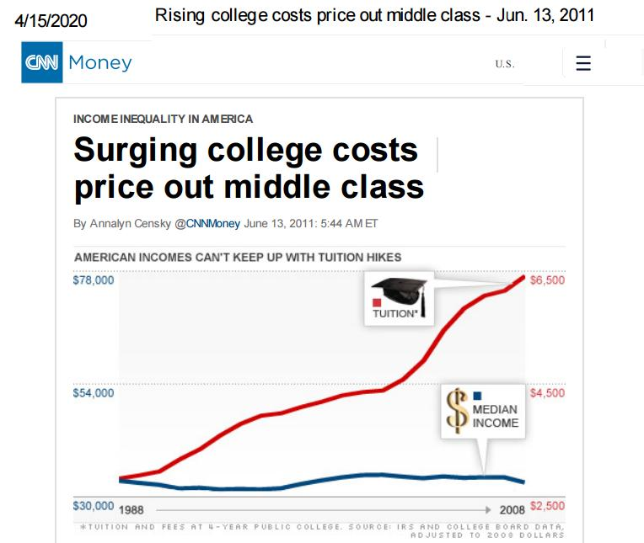

As portrayed on the left axis, median income has hovered around $33,000 since 1988. Meanwhile, college tuition and fees -- portrayed on the right axis -- have more than doubled.

NEW YORK (CNNMoney) -- What do you get when college costs skyrocket but incomes barely budge? Yet another blow to the middle class.

"As the out-of-pocket costs of a college education go up faster than incomes, it's pricing low and medium income families out of a college education," said Mark Kantrowitz, publisher of financial aid sites FinAid.org and FastWeb.com.

The numbers confirm what most middle class families already know -- college is becoming so expensive, it's starting to hold them back.

The crux of the problem: Tuition and fees at public universities, according to the College Board, have surged almost 130% over the last 20 years -- while middle class incomes have stagnated.

Small quote used under “Fair use” legal standards for commentary, criticism, research, etc., and from: “INCOME INEQUALITY IN AMERICA: Surging college costs price out middle class,” By Annalyn Censky @CNNMoney, CNN Money, June 13, 2011: 5:44 AM ET, LINK: https://Money.CNN.com/2011/06/13/news/economy/college_tuition_middle_class/index.htm

NOTE: That article was from 2011 – it is much worse now!.. Tuition increases because lawmakers refuse to reduce spending, as Pres. Trump requested and colleges blithely raise prices, confident that federal subsidies – paid for by our tax dollars – will make this possible!

See also this graph used under Fair Use from MyBudget360:
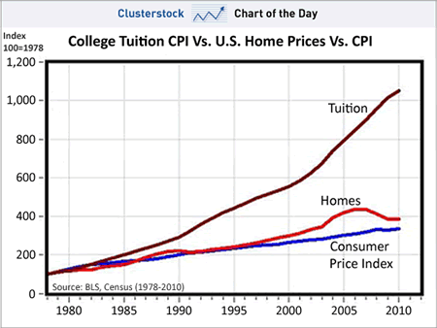
Source: “Is college worth the money and debt? The cost of college has increased by 11x since 1980 while inflation overall has increased by 3x. Diluting education with for-profits. and saddling millions with debt.,”Posted by mybudget360 in banks, college, economy, education, government, student loans, wall street, Image Direct link: http://www.MyBudget360.com/wp-content/uploads/2012/01/college-tuition.gif
Article Link: http://www.MyBudget360.com/is-college-worth-it-money-and-debt-cost-of-college-and-student-loan-debt-for-profit-education

Below is a little artwork I (Editor, Gordon Wayne Watts) made by grabbing a few images and making my own MEME:

The “U.S.A. TITANIC” vs. the 'Icebergs of Overspending'
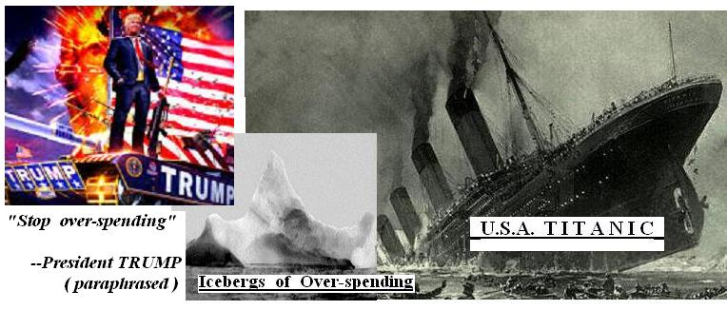
Over-spending (Crash of the U.S. Dollar) – and skyrocketing tuition (which results when colleges raise tuition because of taxpayer-paid Student Loan subsidies) – Hurts taxpayer – and students – BOTH of these happen when “Liberal R.I.N.O.” (Republican in Name Only) GOP lawmakers – and even more liberal Democrats refuse to grant President Trump's common-sense spending cuts request, documented above. CRASH of the DOLLAR – coming soon to a theatre near you – if
lawmakers don't grant Trump's request. YOU HAVE BEEN WARNED.

You may contact me as follows: Gordon Wayne Watts, Editor-in-Chief, The Register, a Christian and Conservative blog
Social Media: https://Facebook.com/GordonWayneWatts & https://YouTube.com/GordonWayneWatts
and: https://Twitter.com/Gordon_W_Watts
Flagship mirrors of The Register: http://GordonWatts.com and https://GordonWayneWatts.com G.W. Watts///

